Landscape-scale forest restoration decreases vulnerability to drought mortality under climate change in Southwest US ponderosa forest
Lisa A. McCauley^{1*}, John. B. Bradford², Marcos D. Robles¹, Robert K. Shriver³, Travis J. Woolley¹, Caitlin A. Andrews²

Appendix 1
Table A.1. Stand-level metrics under each scenario. BA- Basal Area (m2/ha) of all tree species; TPH - Trees per hectare of all tree species; QMD - Quadratic mean diameter (cm) of Ponderosa Pine trees; SDI - Stand density index
Scenario | BA | TPH | QMD | SDI
No Thinning | 29.5 (8.4) | 1383 (732) | 23.6 (4.17) | 263.1 (82.4)
4FRI | 17.3 (4.6) | 969 (570) | 32.0 (7.8) | 147.6 (70.2)
4FFRI-I | 9.7 (2.6) | NA* | 38.5 (6.8) | NA*
*The 4FRI-I scenario is not a treatment planned by USFS so the TPH and SDI stand-level metrics provided by the USFS as part of the 4FRI implementation plan are not available. BA and QMD were estimated for use in our model and are included.

Table A.2. Coefficients from the previously established model using FIA plots, observed values from the FIA sites, and observed values from our study sites
 |  | Coefficients |  |  | Observations from FIA sites |  | Observations from this study sites*
Variable | Units | Mean | 90% CI |  | Mean | StDev | Mean | StDev
intercept |  | 2.214 | 1.818 | 2.62
SWA_{MEAN} | cm | 0.000438 | -0.149 | 0.148 | 17.1 | 5.36 | 12.3 | 5.45
TEMP_{MEAN} | C | -0.144 | -0.285 | -0.001 | 13.4 | 2.13 | 14 | 1.44
Basal Area (BA) | m²ha⁻¹ | -1.188 | -1.636 | -0.749 | 22.6 | 14.3 | 29.5 | 8.36
SWA_{8YRMAX} | cm | 0.151 | 0.031 | 0.277 | -0.51 | 1.43 | -0.63 | 0.29
TEMP_{7YRMAX} | C | -0.155 | -0.274 | -0.035 | 0.59 | 0.36 | 0.11 | 0.02
SWA_{3YRMAX} | cm | 0.122 | 0.051 | 0.195 | 2.02 | 1.76 | 1.84 | 0.71
SWA_{MEAN}*BA |  | 0.352 | 0.115 | 0.598 | 389 | 284 | 371 | 209
TEMP_{MEAN}*BA |  | 0.368 | 0.032 | 0.705 | 306 | 213 | 413 | 122
SWA_{8YRMAX}*BA |  | -0.127 | -0.219 | -0.033 | -12.5 | 33.1 | -18.7 | 10
TEMP_{7YRMAX}*BA |  | 0.13 | -0.001 | 0.261 | 14.2 | 15.5 | 3.4 | 1.2
Tree DBH | inches | 0.045 | 0.039 | 0.05 | 11.3 | 7.01 | 9.3 | 1.6
* observed values from this study are using contemporary BA values and climate from 1970-2010

Table A.3. Median values of the mortality rates (and GCM ranges of mortality rates) for all the scenarios/time period and the differences between them.
RCP | Scenario 1 | Median value Scenario 1 (GCM range) | Scenario 2 | Median Value Scenario 2 (GCM range) | Average difference Scenario 1 - Scenario 2 *
4.5 | 2020-2059 Current BA | 1.4% (1.2-1.5%) | 1970-2010 | 1.0% (NA) | 0.456%
4.5 | 2060-2099 Current BA | 1.7% (1.4-1.9%) | 1970-2010 | 1.0% (NA) | 0.784%
4.5 | 2020-2059 4FRI BA | 0.97% (0.9-1.8%) | 1970-2010 | 1.0% (NA) | -0.026%
4.5 | 2060-2099 4FRI BA | 1.3% (0.6-1.2%) | 1970-2010 | 1.0% (NA) | 0.338%
4.5 | 2020-2059 4FRI-I BA | 0.8% (.5-1.5%) | 1970-2010 | 1.0% (NA) | -0.257%
4.5 | 2060-2099 4FRI-I BA | 1.1% (0.7-1.7%) | 1970-2010 | 1.0% (NA) | 0.111%
4.5 | 2060-2099 Current BA | 1.7% (1.4-1.9%) | 2020-2059 Current BA | 1.4% (1.2-1.5%) | 0.315%
4.5 | 2060-2099 4FRI BA | 1.3% (0.6-1.2%) | 2020-2059 4FRI BA | 0.97% (0.9-1.8%) | 0.367%
4.5 | 2060-2099 4FRI-I BA | 1.1% (0.7-1.7%) | 2020-2059 4FRI-I BA | 0.8% (.5-1.5%) | 0.374%
4.5 | 2020-2059 Current BA | 1.4% (1.2-1.5%) | 2020-2059 4FRI BA | 0.97% (0.9-1.8%) | 0.490%
4.5 | 2020-2059 Current BA | 1.4% (1.2-1.5%) | 2020-2059 4FRI-I BA | 0.8% (.5-1.5%) | 0.720%
4.5 | 2060-2099 Current BA | 1.7% (1.4-1.9%) | 2060-2099 4FRI BA | 1.3% (0.6-1.2%) | 0.433%
4.5 | 2060-2099 Current BA | 1.7% (1.4-1.9%) | 2060-2099 4FRI-I BA | 1.1% (0.7-1.7%) | 0.656%
8.5 | 2020-2059 Current BA | 1.5% (1.3-1.7%) | 1970-2010 | 1.0% (NA) | 0.572%
8.5 | 2060-2099 Current BA | 2.4% (1.8-3.9%) | 1970-2010 | 1.0% (NA) | 1.703%
8.5 | 2020-2059 4FRI BA | 1.1% (0.8-1.4%) | 1970-2010 | 1.0% (NA) | 0.110%
8.5 | 2060-2099 4FRI BA | 2.4% (1.5-4.4%) | 1970-2010 | 1.0% (NA) | 1.555%
8.5 | 2020-2059 4FRI-I BA | 0.9% (.6-1.7%) | 1970-2010 | 1.0% (NA) | 0.110%
8.5 | 2060-2099 4FRI-I BA | 2.4% (1.4-4.7%) | 1970-2010 | 1.0% (NA) | 1.732%
8.5 | 2060-2099 Current BA | 2.4% (1.8-3.9%) | 2020-2059 Current BA | 1.5% (1.3-1.7%) | 1.174%
8.5 | 2060-2099 4FRI BA | 2.4% (1.5-4.4%) | 2020-2059 4FRI BA | 1.1% (0.8-1.4%) | 1.532%
8.5 | 2060-2099 4FRI-I BA | 2.4% (1.4-4.7%) | 2020-2059 4FRI-I BA | 0.9% (.6-1.7%) | 1.850%
8.5 | 2020-2059 Current BA | 1.5% (1.3-1.7%) | 2020-2059 4FRI BA | 1.1% (0.8-1.4%) | 0.457%
8.5 | 2020-2059 Current BA | 1.5% (1.3-1.7%) | 2020-2059 4FRI-I BA | 0.9% (.6-1.7%) | 0.581%
8.5 | 2060-2099 Current BA | 2.4% (1.8-3.9%) | 2060-2099 4FRI BA | 2.4% (1.5-4.4%) | 0.145%
8.5 | 2060-2099 Current BA | 2.4% (1.8-3.9%) | 2060-2099 4FRI-I BA | 2.4% (1.4-4.7%) | -0.028%
*To avoid non-linear averaging that would occur if we calculated differences between scenarios/time periods using posterior averages, we calculated the differences between GCMs assuming a fixed parameter set, and iteratively drawing parameter sets from the posterior distribution. We then averaged differences in GCMs across all the iterations and reported the GCM with the median difference as the 'Average Difference'. Thus, the average difference value may not equal the difference between Median Value #1 and Median Value #2.

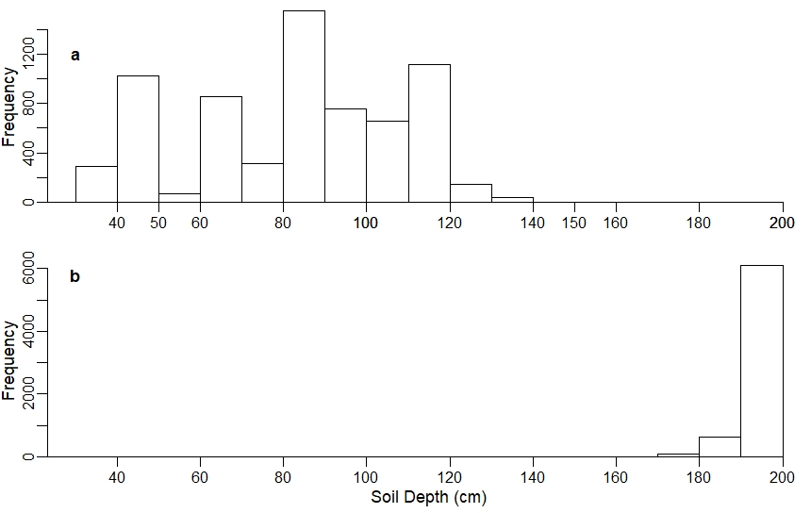
Figure A.1. Distribution of soil depths for a) the USFS soils data and b) the gridded soils data showing that the gridded soils data used in our models over-estimated the soil depths and thus, the soil water availability (SWA).

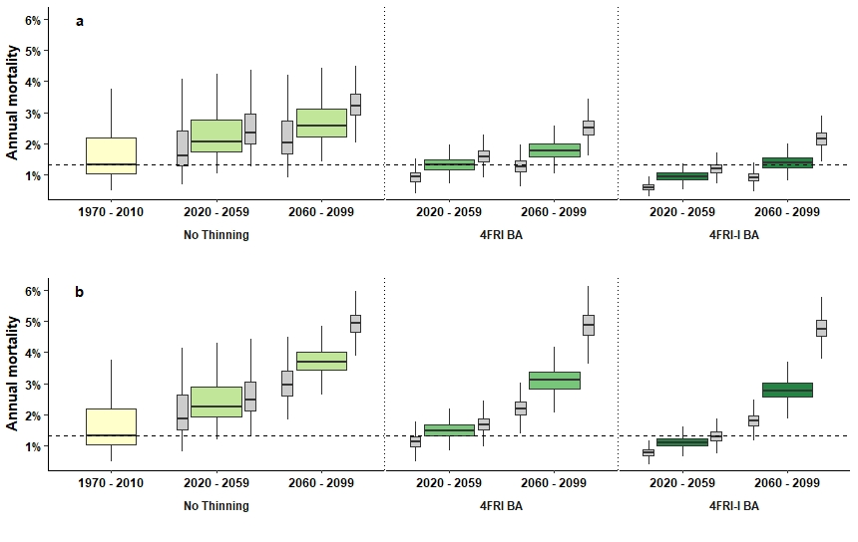
Figure A.2. Distributions of annual mortality as predicted using the USFS soils data for all scenarios and time periods in a) RCP 4.5 and b) RCP 8.5. The wider, green boxes represent the distribution of values from the median GCM and the thinner, grey boxes to the left and right of the wider boxes represent the range in values from the minimum and maximum GCMs, respectively. The dashed line represents the median value for annual mortality in the contemporary period (1970-2010). This figure pairs with Figure 4.

