Water Access Sites
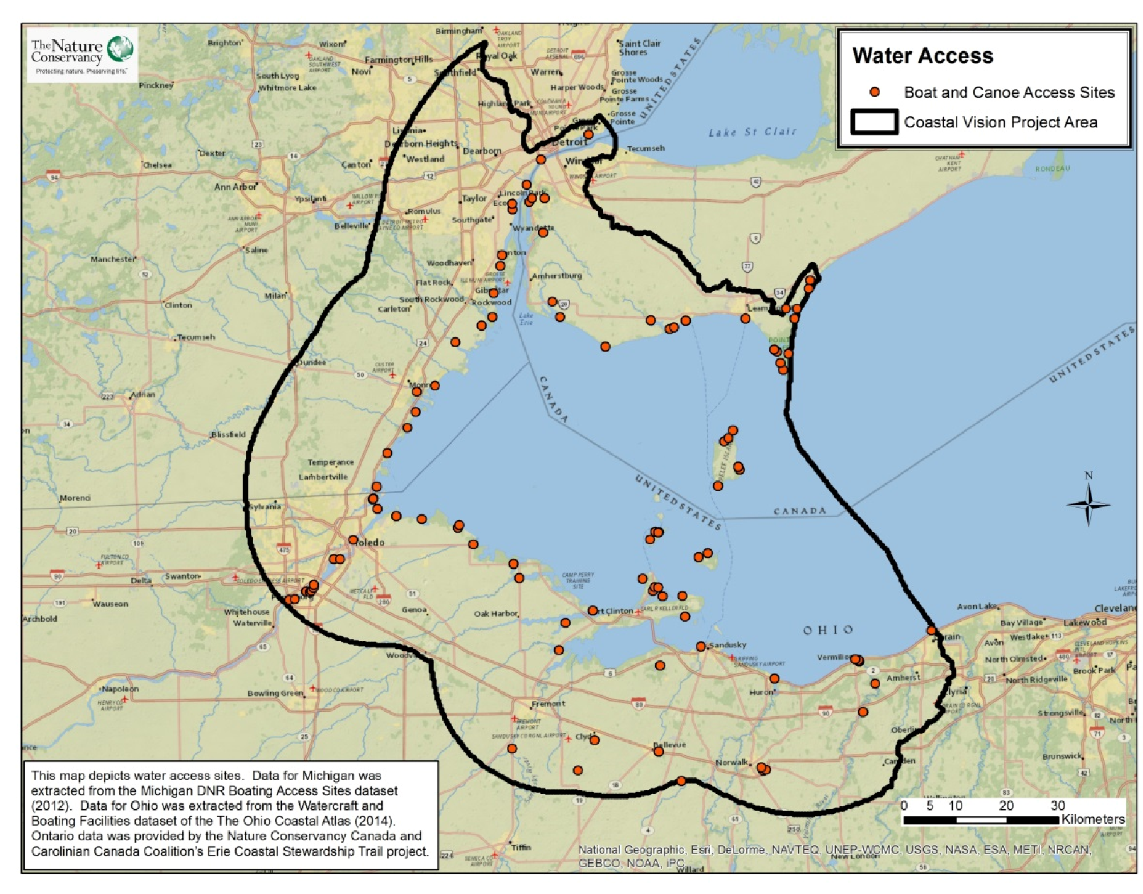
Take Home Points
- Access to water is an important recreational value to many people in the region.

- Recreational boating opportunities attract visitors from across the country to the WLEB.

- Over 2.56 million boats are registered in the region.

- The data layer identifies areas important to watercraft users who don’t utilize marinas.

Water Access Sites: Public water access sites are indicated by orange points on the map. The study area is outlined in black.

How are water access sites in Lake Erie connected to ecological and social values?
Access to water is an important recreational value to many people in the region. Water access sites provide individuals a variety of opportunities to recreate on the water, from boating and fishing to canoeing and kayaking. Recreational boating attracts visitors and other sportsmen from across the country to the Western Lake Erie Basin (WLEB). Boating comprises a significant segment of the recreational use of the WLEB, with the Great Lakes Commission estimating that 2.56 million boats were registered in Michigan, Ohio and Ontario alone¹. In total, over one-third of all boats registered in the U.S. call a Great Lakes state home. Pleasure-craft users average $15,626 in annual spending related to boating, directly supporting over 107,000 jobs throughout the Great Lakes². The economic value of public access ramps can be very high⁴. The water access sites data layer was included in the Marxan analysis to highlight areas within the WLEB that are considered valuable by boaters, canoeists, and kayakers who do not typically utilize marinas.
Related Ecological data layer(s): Walleye Lake Habitat, Migratory Bird Stopover Habitat
Water access sites data layer
The WLECCV team compiled this data layer from a number of state and provincial sources. Marinas and private facilities were generally excluded. In total, 100 public water access sites were identified and included in the Marxan analysis.

Data sources and potential limitations
Data for Michigan was extracted from the Michigan DNR Boating Access Sites dataset (2012). Data for Ohio was extracted from the Watercraft and Boating Facilities dataset of the Ohio Coastal Atlas (2014). Ontario data was provided by the Nature Conservancy Canada and Carolinian Canada Coalition’s Erie Coastal Stewardship Trail project (data received October 2014). It is possible that some public water access sites were not represented in the source data.
References and links
- http://glc.org/files/docs/2007-rec-boating-economic-punch.pdf
- http://www.greatlakes-seaway.com/en/recreational/cruising-the-seaway/cruises_facts.html and http://glc.org/files/docs/2007-recboating-economic-punch.pdf
- http://www.glerl.noaa.gov/data/now/wlevels/dbd/
- Harding, D., J. Wiggin, E. Mahoney, D. Bordner, D. Stynes, M. Thomas, and F. Lupi. 2009. Florida Boating Access Facilities Inventory and Economic Study including a Pilot Study for Lee County. Executive Summary. Florida Fish and Wildlife Conservation Commission. Tallahassee, Florida. iv + 20 p. http://myfwc.com/media/1162723/About_Econ_BAFI_Summary.pdf

Contact
Gust Annis
The Nature Conservancy
gannis@tnc.org

