Spawning Sites
Take Home Points
- Walleye, lake whitefish, and lake sturgeon are important native migratory fish

- Preserving spawning areas is a key for maintaining populations

- Lake Erie is the most popular sport fishing destination in the Great Lakes basin

- Walleye spawning areas are used as a proxy for sport fish spawning areas in the WLEB

- The LEBCS established a goal of having 2 populations of each migratory fish species present in the WLEB by 2030.
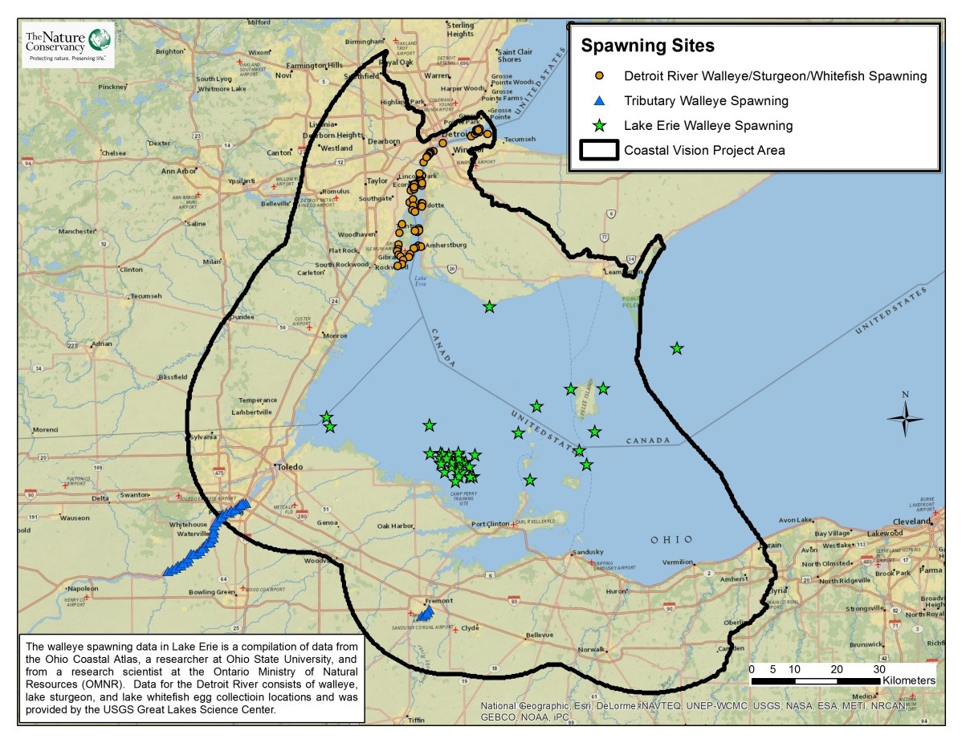
Spawning Sites. Spawning locations for walleye, lake whitefish, and lake sturgeon.

Fish spawning sites in relation to regional ecological and social values
This data layer includes spawning sites in three categories recognizing the importance of these distinct areas for different species or populations of fish. Walleye (Sander vitreus) spawning sites are mapped separately for the nearshore area of the Western Lake Erie Basin (WLEB) and in tributaries. Detroit River spawning sites are mapped as important to three species including walleye, lake whitefish (Coregonus clupeaformis), and lake sturgeon (Acipenser fulvescens). All three species are important native migratory fish. Walleye are important native predators and as migratory fish they aid in the migration of other species like mussels. Walleye, like many native fish, spawn in tributaries and in shallow, rocky shoals in the lake. The stability of migratory fish populations is therefore threatened by dams and other obstructions that prevent fish from completing their migration from the lake to upstream areas¹. Within the lake, spawning success can be affected by boats passing overhead, which disturbs spawning fish by increasing water movement, and by kicking up sediments that can interfere with spawning success and egg survival². Taking care to minimize boating disturbance in order to maintain healthy fish populations allows for the proper functioning of the ecosystem and also directly benefits boaters themselves; Lake Erie is the most popular sport fishing destination in the Great Lakes basin, and would collapse immediately if walleye and other sport fish populations crashed. According to a survey by the USFWS, approximately 646,000 Great Lakes anglers focused their efforts on Lake Erie in 2011, and nearly a third of these visitors came in search of sauger and walleye³. Walleye, along with yellow perch (Perca flavescens), also account for 80% of the CA$33 million Canadian commercial fishing industry⁴. Lake whitefish, once virtually extirpated from the WLEB, have recently been documented as spawning in the Detroit River. Their return to the system provides a good indicator of recovery. Lake sturgeon is a large, charismatic species listed as either threatened or endangered by 19 or the 20 states within its original range in the United States. Sturgeon spawn in the gravel beds of fast flowing streams, such as the Detroit and St. Clair Rivers and, prior to widespread construction of dams and other barriers, spawned in several other WLEB tributaries. The WLECCV project uses walleye, lake whitefish, and lake sturgeon as a proxy for migratory fish and incorporates their spawning areas in recognition of the importance of these habitats for supporting a healthy ecosystem and strong fishery in Lake Erie.
Spawning sites data layer
Fish spawning sites are identified by the Lake Erie Biodiversity Conservation Strategy (LEBCS) as an important target for conservation in the WLEB; the LEBCS sets forth a goal of having at least two viable populations of each migratory fish species present in each basin of Lake Erie. This data layer is a compilation of data from the Ohio Coastal Atlas, the USGS Great Lakes Science Center, a researcher at Ohio State University, and from a research scientist at the Ontario Ministry of Natural Resources (OMNR) (See “Data Sources”). Data obtained from the Ohio Coastal Atlas was originally gathered by the Ohio Department of Natural Resources Sandusky Fisheries Research Unit. Spawning data received from the OMNR represent areas where OMNR scientists have suggested spawning areas exist based on walleye tagged in the area during spawning seasons in past years. There were 170 spawning sites identified within the study area. Detroit River spawning sites were attributed with the number of species found (maximum of 3) at each site and then summing these numbers for all sites within a 10 hectare planning unit. For tributaries and nearshore spawning sites, values were derived by summing the number of spawning sites within each 10 hectare planning unit.
Data sources and potential limitations
Data for Ohio were downloaded from the Ohio Coastal Atlas website. Additional data for Ohio was provided by Cassie May, a PhD student at Ohio State University⁵. Data for Ontario were received from Dr. Yingming Zhao with the Ontario Ministry of Natural Resources⁶. Data for the Detroit River were provided by Dr. Edward Roseman and Jason Fischer at the USGS Great Lakes Science Center⁷. It would be ideal to include other migratory species in this analysis to ensure that the LEBCS goal for all migratory fish species is considered during the analysis; such data is currently not available for the WLEB, although a current mapping project underway at The Nature Conservancy may make it available in the future. This data layer includes many spawning locations in the WLEB, but it should be noted that unknown spawning areas may exist beyond the currently recorded areas.
Related Human Well-being Layers: Recreational Fishing, Commercial Fishing, Boating

References and links
- Pearsall, D., P. Carton de Grammont, C. Cavalieri , C. Chu, P. Doran, L. Elbing, D. Ewert, K. Hall, M. Herbert, M. Khoury, D. Kraus, S. Mysorekar, J. Paskus and A. Sasson. (2012). Returning to a Healthy Lake: Lake Erie Biodiversity Conservation Strategy. Technical Report. A joint publication of The Nature Conservancy, Nature Conservancy of Canada, and Michigan Natural Features Inventory. 340 pp. with appendices.
http://www.conservationgateway.org/ConservationByGeography/NorthAmerica/wholesystems/greatlakes/Pages/lakeerie.aspx
- Asplund, T. 2000. The effects of motorized watercraft on aquatic ecosystems. Wisconsin Department of Natural Resources, Bureau of Integrated Science Services and Wisonsin-Madison Water Chemistry Program. http://files.dnr.state.mn.us/aboutdnr/reports/boating/impacts_mississippi_2004/references/asplund_2000.pdf
- U.S Department of the Interior, U.S. Fish and Wildlife Service, and U.S. Department of Commerce, U.S. Census Bureau. 2011 National Survey of Fishing, Hunting, and Wildlife-Associated Recreation. www.census.gov/prod/2012pubs/fhw11-nat.pdf
- http://www.mnr.gov.on.ca/en/Business/GreatLakes/2ColumnSubPage/STEL02_173913.html#Commercial_Fisheries
- Cassie May, Graduate Student, PhD, Ohio State University.
- Dr. Yingming Zhao, Research Scientist, Aquatic Research and Development Section, Ontario Ministry of Natural Resources.
- Dr. Edward Roseman, Research Fishery Biologist, USGS Great Lakes Science Center.

Contact
Gust Annis
The Nature Conservancy
gannis@tnc.org

