Hunting Areas
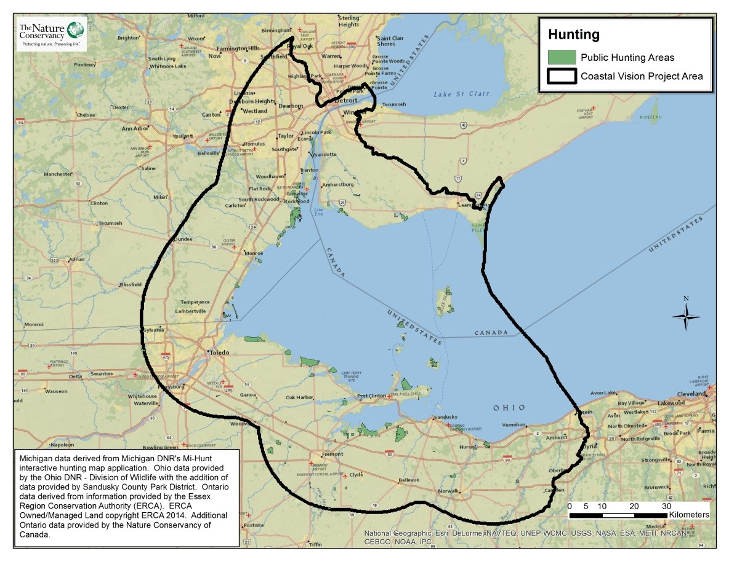
Take Home Points
- There are rich hunting grounds for white-tailed deer, small game, and waterfowl within the WLEB.

- Hunting is used as the primary wildlife management technique throughout the region.

- This data layer shows publically- accessible hunting locations across the WLEB
Hunting Areas. Public lands open to hunting are shown in green. The WLEB study area is outlined in black.

Hunting in relation to social and ecological values
In Michigan, Ohio, and Ontario combined, there were an estimated 1.97 million hunters who took part in one of the 2011 hunting seasons¹. In the same year, an estimated $4.65 billion were spent on hunting related activities across the region². The WLEB is home to rich hunting grounds for white-tailed deer, small game and waterfowl³. This was not always the case however, as wildlife populations were drastically altered in the early 1900’s by habitat conversion and overhunting. In response, Ohio restricted all deer hunting until 1943, when rebounding deer populations allowed for the state’s first modern day gun-season in three counties⁴. In 1956, the state opened all 88 counties to hunting, with a total of 3,911 deer harvested, which pales in comparison to the state’s harvest of 218,910 in 2012-13⁵. Hunting is an important wildlife management technique, allowing state officials to regulate the number and type of prey hunted to prevent species from dominating, which can decrease biodiversity. The WLEB also has excellent waterfowl hunting opportunities due to its location on the intersection of the Mississippi and Atlantic Flyways. Turkey and small game hunting are also very popular with sportsmen across the region. Michigan, Ohio and Ontario have all designated state-owned property for hunters to utilize during open hunting seasons. The hunting data layer was included in this analysis to identify areas important to hunters within the WLEB.
Related Ecological layers: Migratory Bird Stopover Habitat

Hunting Areas data layer
The WLECCV team compiled this data layer from a number of state- and provincial-level sources. Only those public lands which are explicitly listed as being open to hunting are included in this layer. In total, 29,184 acres of public hunting lands in 142 parcels were identified and included in the Marxan analysis.
Data sources and potential limitations
Public hunting areas in Michigan were derived from Michigan DNR's Mi-Hunt interactive hunting map application and attributed to state and federal land polygons in the CARL lands layer (June 2007; accessed February 2008). Hunting areas in Ohio were identified using information provided by the Ohio DNR's “Ohio Wildlife Areas” website and then attributed to state and federal land polygons contained in the same CARL lands layer. Several properties were digitized using information on the Sandusky County Park District’s website. Canadian hunting areas were select by identifying areas within the Canadian parks and recreation dataset where hunting is allowed; this dataset was obtained through Nature Conservancy of Canada (personal communication; see Parks & Recreation factsheet for dates and details) and the Essex Region Conservation Authority, which provided data specifically for conservation lands (received March 2014). Ontario’s public hunting areas were identified from information provided by the Essex Region Conservation Authority (ERCA; personal communication)⁶. Some minor verification was required to ensure that the data layer reflected the proper parcels. Additional data for Ontario was provided by the Nature Conservancy of Canada (received November 2014).
References and links
- http://www.michigan.gov/dnr/0,4570,7-153-10366-121641--,00.html (MI data); http://www2.ohiodnr.gov/news/post/late-season-deerhunting-opportunities-available-in-ohio (OH data); http://www.mnr.gov.on.ca/stdprodconsume/groups/lr/@mnr/@fw/documents/report/stdprod_109164.pdf (ON data)
- http://www.nssf.org/PDF/research/HuntingInAmerica_EconomicForceForConservation.pdf (MI and OH data), http://www.ofah.org/hunting/we-are-hunters-economy (ON data)
- http://www.qdma.com/uploads/pdf/WR2012.pdf
- http://www2.ohiodnr.gov/news/post/ohio-hunters-harvest-more-than-75-000-deer-during-weeklong-gun-season
- http://www.dnr.state.oh.us/Portals/9/pdf/pub304.pdf
- Information from ERCA is ERCA Owned/Managed Land copyright ERCA 2014. The location and characterization of these sites as shown are approximate and are subject to change. Copyright ERCA 2012.

Contact
Gust Annis
The Nature Conservancy
gannis@tnc.org

