Current and Restorable Coastal Wetlands
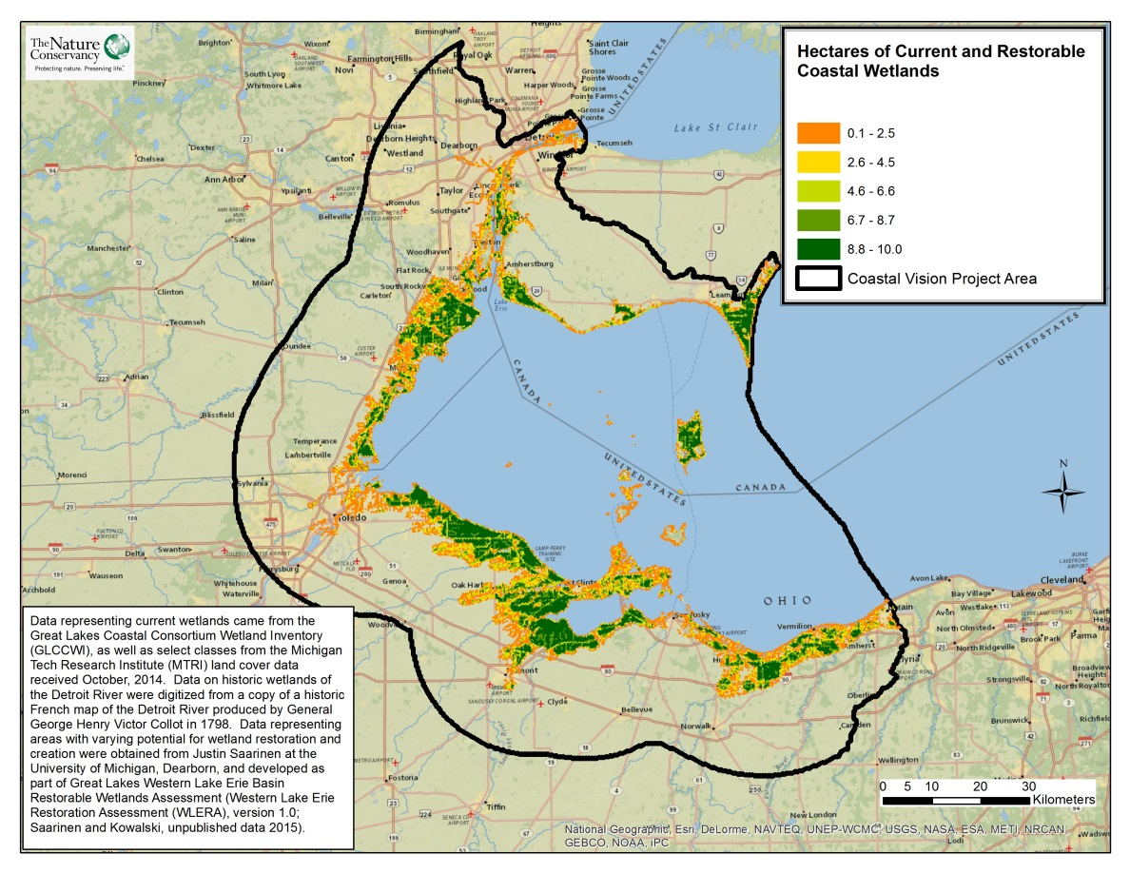
Take Home Points
- Coastal wetlands provide ecological benefit by serving as a natural habitat for a variety of species, and by filtering the drinking water supply for over 11 million people.

- Coastal wetlands benefit the fishing and birdwatching industries, as well as serving as natural buffers against waves, winds and flooding.

- The LEBCS established the goal of a 10% increase in coastal wetlands, from 2011 levels, by 2030.

Current and Restorable Coastal Wetlands. This map shows areas with existing wetlands and potential for wetland restoration. Areas with the potential to be restored to wetlands are displayed on a gradient from green to orange, with green indicating areas with the highest density of restorable land and orange indicating the lowest density of restorable land. The WLEB analysis area is outlined in black.

Coastal wetlands in relation to regional ecological and social values
Coastal wetlands provide habitat for birds, spawning fish, and a diversity of amphibians, reptiles, insects, and plants. They are the most biodiverse habitats in Lake Erie, and provide critical stopover and breeding habitat for local migratory birds. Wetlands are also crucial spawning habitat for fish, and serve as buffers for coasts in the face of erosion-inducing storm surge. Finally, wetlands filter nutrients and sediment out of runoff that otherwise threatens Lake Erie water quality. These functions are essential for maintaining the nutrient and material cycles of Lake Erie and for maintaining the health of its biota¹. Residents of the Western Lake Erie Basin depend on these wetland functions to improve water quality and help provide for recreation opportunities that support the regional economy. The robust fish and bird populations supported by coastal wetlands provide for a recreational fishing industry worth US$1.4 billion (2012), for commercial fisheries worth over $4.6 million (2012) on the U.S side and $33 million (2012) in Ontario², and for annual birdwatching revenues that are estimated at $26 million (2011)³. By filtering runoff, wetlands additionally contribute to the health of beach-goers and swimmers while simultaneously helping to maintain a supply of fresh drinking water to over 11 million people⁴. Coastal wetlands play a critical role in serving as buffers against storm waves, winds and flooding, all of which are increasing due to intensifying storm events. The Western Lake Erie Coastal Conservation Vision Project recognizes the ecological and socioeconomic value of wetland habitats and uses this data layer to ensure that existing wetlands and areas with potential for wetland restoration are included in the analysis.

Current and restorable coastal wetlands data layer
The Lake Erie Biodiversity Conservation Strategy (LEBCS) established a 2030 goal of increasing coastal wetland area, as of 2011, by 10%⁵. The Western Lake Erie Coastal Conservation Vision analysis uses this data layer of current and potential coastal wetlands to determine optimal areas for restoration and creation of wetland habitat. This will aid in determining where to increase wetland habitat to achieve the LEBCS goal. The data layer shows current coastal wetlands and areas with some suitability for restoration to coastal wetland along the Western Lake Erie coast from the Detroit River in Michigan to Sandusky, Ohio. The current and restorable coastal wetlands data layer was created by combining data from four primary sources representing data on existing, former, or potential wetland areas.
Related Human Well-being layers: Recreational Fishing, Commercial fishing, eBird, Parks & Recreation, Drinking Water
Data sources and potential limitations
Data representing areas with varying potential for wetland restoration and creation were obtained from Justin Saarinen at the University of Michigan, Dearborn, and Kurt Kowalski of the US Geological Survey and developed as part of the Western Lake Erie Wetland Restoration Assessment (WLERA)⁶. The WLERA data did not exist for the Detroit River or anywhere in Ontario. For the Detroit River and Ontario, we compiled wetland polygons from The Great Lakes Coastal Wetland Consortium (GLCWC)⁷ and select land cover classes (wetland classes, agriculture, and fallow field) from the Michigan Tech Research Institute (MTRI) coastal land cover dataset⁸; we restricted the data to elevations less than 176 meters because elevations above that have very low inundation frequencies and thus aren’t suitable for restoration to coastal wetlands. In addition, data on historic wetlands of the Detroit River⁹ were used to indicate suitable areas for wetland restoration after removing currently developed land.
The GLCWC data – as of this writing – must be requested from Don Uzarski, PI of the Great Lakes Coastal Wetland Monitoring Program. We used the “complete polygon coverage” file, as augmented by the Michigan Natural Features Inventory during the creation of the LEBCS. Products developed with this data should acknowledge the following groups: U.S. Geological Survey Water Resources Division, Environment Canada Canadian Wildlife Service-Ontario Region, Michigan Natural Features Inventory, and Ontario Ministry of Natural Resources.
References and links
- Pearsall, D., et al. 2012. Returning to a Healthy Lake: Lake Erie Biodiversity Conservation Strategy. Technical Report. A joint publication of The Nature Conservancy, Nature Conservancy of Canada, and Michigan Natural Features Inventory. 340 pp. with Appendices.
http://www.conservationgateway.org/ConservationByGeography/NorthAmerica/UnitedStates/michigan/Pages/lakeerie.aspx
- http://www.lakeerieimprovement.org/wp-content/uploads/2012/02/leia-strategic-plan-final-12-17-2012.pdf
- http://ohioseagrant.osu.edu/research/economic/?ID=R/ME-033#benefits
- http://www.lakeerieimprovement.org/wp-content/uploads/2012/02/leia-strategic-plan-final-12-17-2012.pdf
- Pearsall, D., et al. 2012. Returning to a Healthy Lake: Lake Erie Biodiversity Conservation Strategy. Technical Report. A joint publication of The Nature Conservancy, Nature Conservancy of Canada, and Michigan Natural Features Inventory. 340 pp. with Appendices. http://www.conservationgateway.org/ConservationByGeography/NorthAmerica/UnitedStates/michigan/Pages/lakeerie.aspx
- Saarinen JA, Kowalski KP. 2015. Western Lake Erie Restoration Assessment (WLERA), version 1.0. Unpublished data.
- Michigan Tech Research Institute (MTRI) land cover data received October, 2014 (http://geodjango.mtri.org/coastal-wetlands/). Citation: Bourgeau-Chavez, L.L., Endres, S.L., , Battaglia, M.J., Miller, M.E,Banda, E.C., Laubach, Z.M., Higman, P., Chow-Fraser, P. and Marcaccio, J. 2015. Development of a bi-national Great Lakes coastal wetland and land use map for resource management using multidate radar and optical satellite imagery.
- Historic wetlands of the Detroit River were digitized from a copy of a historic French map of the Detroit River produced by General George Henry Victor Collot in 1798.

Contact
Doug Pearsall
The Nature Conservancy
dpearsall@tnc.org

