Coastal Terrestrial Biodiversity Significance
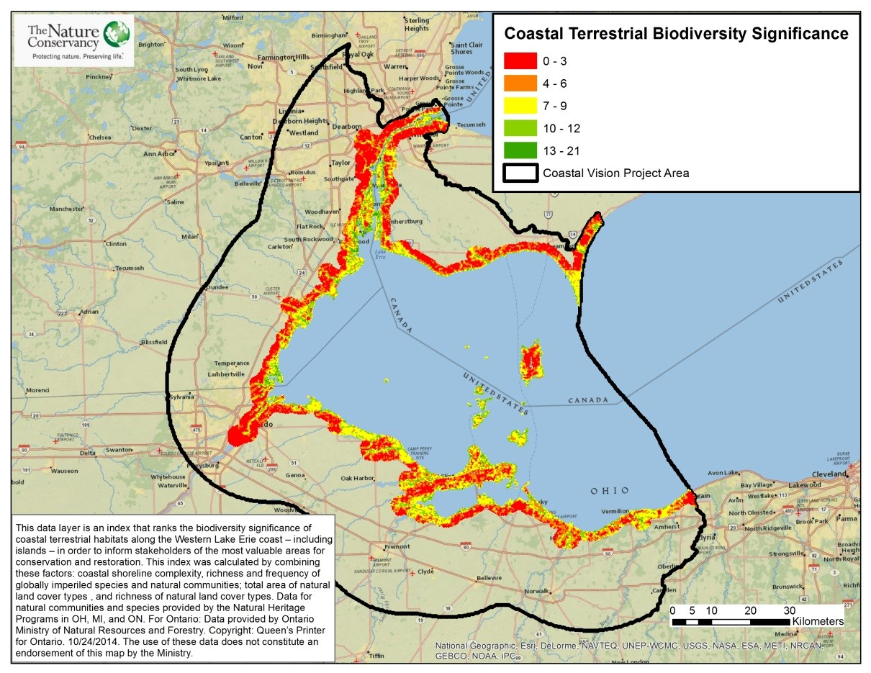
Take Home Points
- Coastal terrestrial systems provide opportunities for recreational, residential and industrial use.

- Development and shoreline hardening threaten these systems with habitat loss and fragmentation

- The LEBCS established a goal of having 40% of the coastal terrestrial system in natural landcover by 2030.

Coastal Terrestrial Biodiversity Significance: This map shows the significance of coastal areas along Lake Erie for biodiversity conservation, with most significant areas in green and least significant areas in orange. The WLEB analysis area is outlined in black.

Coastal terrestrial biodiversity in relation to regional ecological and social values
The coastal terrestrial system includes the area within roughly 2km of the Lake Erie shoreline; this area is critical habitat for migratory shorebirds, rare plants, reptiles and amphibians, including the eastern white-fringed orchid (Platanthera leucophaea), eastern fox snake (Pantherophis gloydi), and elusive clubtail (Stylurus notatus). This system is composed of small and isolated communities of forested wetland, emergent marsh, beach-dune systems, oak savanna communities, alvar (limestone bedrock) communities and upland forest. The beaches and aesthetic value of the coastal terrestrial system make it important for residential, industrial, and recreational uses. Swimmers frequent its beaches, and its aesthetics add value to coastal property and to tourism along the coast. However, development, shoreline hardening, and other human activities threaten the species and communities of this system with habitat loss and fragmentation. The WLECCV seeks to identify opportunities for conservation to benefit both the natural coastal habitat and the people that depend on it.
Related Human Well-being layer(s): Beaches, Parks & Recreation, Water Access Sites

Coastal terrestrial biodiversity significance data layer
The Lake Erie Biodiversity Conservation Strategy (LEBCS) established a goal of having 40 percent of the coastal terrestrial system in natural landcover by 2030¹. This data layer is an index that ranks the biodiversity significance of coastal terrestrial habitats along the Western Lake Erie coast – including islands – in order to inform stakeholders of the most valuable areas for conservation and restoration. Similar to an index used in the LEBCS, this index was calculated by combining these seven factors: coastal shoreline complexity, richness of globally imperiled species and natural communities, frequency of globally imperiled species and natural communities, total area of natural land cover types, and richness of these natural land cover types.
Data sources and potential limitations
Natural land cover data for the coastal terrestrial system in the U.S. and Canada were obtained from the Great Lakes Coastal Wetland Mapping project. Data for globally imperiled species and natural communities were obtained from the Natural Heritage programs in OH, MI, and Ontario (for Ontario, data were provided by Ontario Ministry of Natural Resources and Forestry; copyright: Queen’s Printer for Ontario. 10/24/2014. The use of these data does not constitute an endorsement of this product by the Ministry). Shoreline classes were obtained from the National Oceanic and Atmospheric Administration.

References and links
- Pearsall, D., P. Carton de Grammont, C. Cavalieri , C. Chu, P. Doran, L. Elbing, D. Ewert, K. Hall, M. Herbert, M. Khoury, D. Kraus, S. Mysorekar, J. Paskus and A. Sasson. (2012). Returning to a Healthy Lake: Lake Erie Biodiversity Conservation Strategy. Technical Report. A joint publication of The Nature Conservancy, Nature Conservancy of Canada, and Michigan Natural Features Inventory. 340 pp. with appendices. http://www.conservationgateway.org/ConservationByGeography/NorthAmerica/wholesystems/greatlakes/Pages/lake erie.aspx
- Michigan Tech Research Institute. 2014. Great Lakes Coastal Mapping Project. Land cover data obtained for Lake Erie on October 13, 2014.
- National Oceanic and Atmospheric Administration, Medium Resolution Shoreline dataset: http://www.glerl.noaa.gov/data/char/glshoreline.html

Contact
Doug Pearsall
The Nature Conservancy
dpearsall@tnc.org

Based on Element Occurrence records obtained from Natural Heritage programs in Ontario, Michigan, and Ohio with Global Imperilment Ranks of G1-G3 and had been observed more recently than 1982.
Forest, Shrub, Water, Aquatic Bed, Wetland, Schoenoplectus, Typha, Phragmites, Wetland Shrub, Forested Wetland, using the Great Lakes Coastal Wetland Mapping data (Michigan Tech Research Institute 2014)

