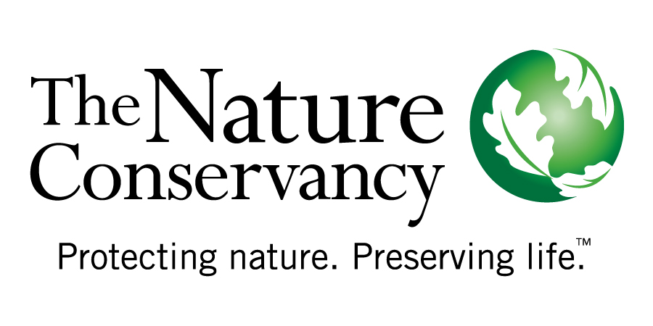
  - Resilient Nature, Resilient People

Global Climate Change Program
adaptation@tnc.org
http://conserveonline.org/workspaces/climateadaptation

http://conserveonline.org/workspaces/climateadaptation

http://conserveonline.org/workspaces/climateadaptation

http://conserveonline.org/workspaces/climateadaptation

WATERFUNDS: Protecting Communities &
Ecosystems in a Changing Climate

The Cauca River flows quietly through southwest Colombia, gathering strength from a myriad of streams that feed into it from the peaks high above. From its origin, the river stretches more than 1,300 kilometers before emptying into the Magdalena River and flowing to the Caribbean. A million people rely on the regular delivery of clean water from this watershed. This is just one of nine important watersheds in this region.
People in these watersheds rely on access to fresh water for economic prosperity as well as crop cultivation and drinking water. Among the most fertile valleys in the world, the East Cauca Valley supports the production of cotton, soy, sorghum and coffee – and some of the most productive sugar cane plantations in Colombia. The sugar cane industry alone employs tens of thousands of valley residents and is a primary source of income for the area.
The East Cauca Valley and its residents face a formidable challenge. In the coming decades, climate change is expected to alter both temperature and precipitation patterns, changing the amount and timing of water flows, increasing sedimentation, changing vegetation composition and reducing the ability of the soil to absorb and release water throughout the year. As a shifting climate alters water flows, the reliability of available water during the dry seasons could become a serious concern in terms of both agricultural production and drinking water supply.
ECOSYSTEM-BASED ADAPTATION
Fortunately, Cauca Valley residents are already collaborating on an innovative approach to managing water resources to address the threats posed by climate change. This approach, an example of ecosystem-based adaptation, focuses on making people and communities more resilient to climate change while restoring biodiversity and ecosystem services.
Through a partnership with The Nature Conservancy, Colombia’s sugarcane association, local government and grassroots organizations throughout the East Cauca Valley watershed have established the Agua por la Vida water fund. In this model, which was based on other water funds in Ecuador and Colombia, downstream water users agree to pay into a common fund and use the interest generated by the fund to support upstream restoration and conservation work around critical streams and riverbanks.
When watershed habitats are intact and healthy, they provide a natural system for buffering water supply and regulating water flows. Because these natural systems also can play an important role in reducing the impacts of climate change, the water fund model has strong potential as a climate adaptation strategy.
Using historical weather data, the most current climate projections and hydrologic models, scientists are already analyzing how climate change is likely to impact the Cauca Valley watershed. With this information, upstream and downstream residents, water managers, sugar cane growers, local landowners, and other water users – are collaborating to design new ecosystem-based water management strategies that allow for changing conditions that could be far different than today.
Ecosystem-based strategies to improve water quality and buffer water supply also have the benefit of increasing productivity for local farmers and providing an alternative to costly water treatment. These strategies include restoring forested areas to assure water flows, protecting boundaries around conservation lands to prevent cattle from grazing near vulnerable riverbanks, and developing programs that provide alternative sources of income to replace farming on critical lands. As the climate changes, strategies that help slow erosion, offset the effects of irregular water flow and reduce sedimentation can be adapted to target the most severely threatened areas.
While successful water funds already exist across Latin America, the Cauca Valley is the first place where climate adaptation is being built into the fund’s management plan. Applying lessons learned through Agua por la Vida, The Nature Conservancy will incorporate climate change adaptation into existing water funds and develop other climate-resilient water funds across Latin America. Also being considered are climate-resilient water funds in Asia and Africa.
The effects of a changing climate are already being experienced in the Cauca Valley and elsewhere, but a window of opportunity exists to begin preparing for the future. Connecting communities to their natural resources – and various water users with one another – is our best chance of ensuring the long-term security of vital watershed resources and buffering the people who live there from the most harmful climate change impacts.

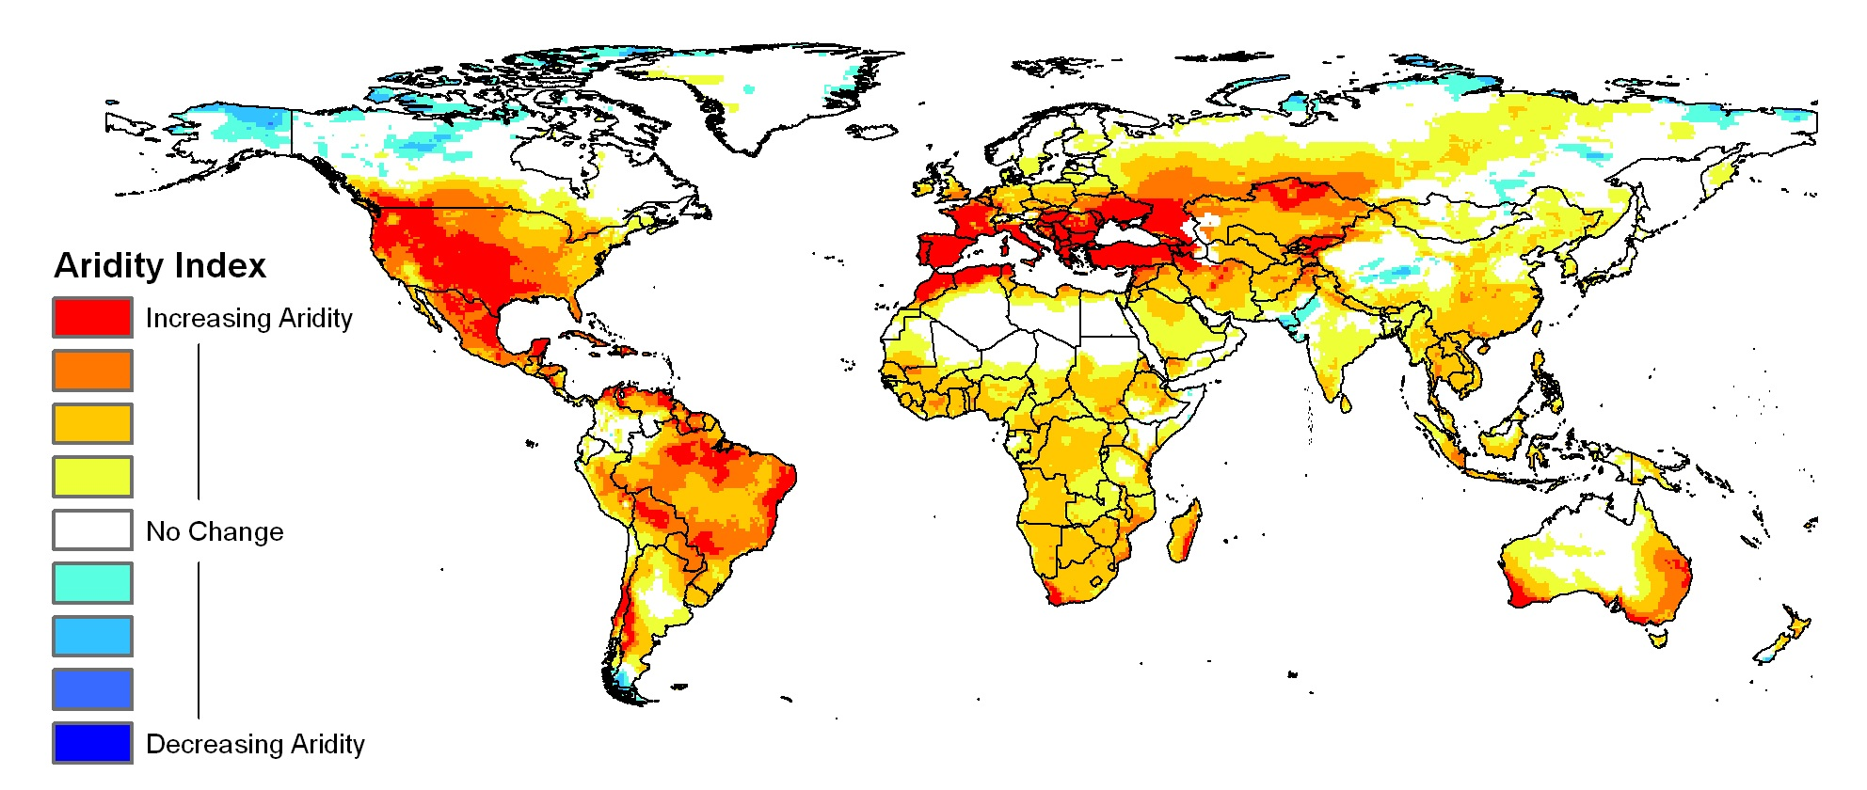

Future projected change in aridity during 2060, based on the average of sixteen climate models. Red to yellow colors represent increasing aridity (increasing dryness) and blue colors represent decreasing aridity. From research by Dr. Evan Girvetz, The Nature Conservancy Global Climate Change Program and the Climate Wizard (http://ClimateWizard.org).

