The Nature Conservancy’s Threat Ranking System
Dan Salzer (14 February 2007)

This document describes the scoring system used in both the traditional TNC 5S threat ranking system (where individual stresses are assigned severity and scope ranks) and the alternative threat ranking system where severity and scope ranks are assigned directly to the source of stress.

There are four basic threat rank combinations that are needed:
Type I: How to combine the base level variables (e.g., Severity X Scope) to assess a single threat to a single target.

Type II: How to roll-up assessments of the impact of different threats to a single target. For example, if Forest Target A is threatened by invasive species, logging, and grazing, what is the overall threat status for Forest Target A?

Type III: How to roll-up assessments of the impact of one threat across multiple targets. For example, if industrial development affects Forest Target A, Freshwater Target B, and Grassland Target C, what is the overall ranking of this threat?

Type IV: How to roll-up threat assessments for multiple targets into an overall threat status for a project. For example, Conservation Project X has threat assessment results for four conservation targets; what is the overall threat status of Conservation Project X?

Type I Threat Calculation
Traditional 5S Threat method
Stress Ranking - Each stress is ranked Very High, High, Medium or Low. The rank of each stress is typically a combination of the Severity and Scope ranking for the stress. The stress rank is calculated automatically from the matrix below.
For example, if the Scope of the stress is Very High and the Severity of the stress is Medium the overall rank of the stress is Medium.
Users can directly enter an alternative stress rank in the "User Override" cells.
 |  | Scope
 |  | 4-Very High | 3-High | 2-Medium | 1-Low
Severity | 4-Very High | 4-Very High | 3-High | 2-Medium | 1-Low
Severity | 3-High | 3-High | 3-High | 2-Medium | 1-Low
Severity | 2-Medium | 2-Medium | 2-Medium | 2-Medium | 1-Low
Severity | 1-Low | 1-Low | 1-Low | 1-Low | 1-Low

Source of Stress Ranking – Each source is ranked Very High, High, Medium or Low. A source rank is a combination of the Contribution ranking for the source and the Irreversibility ranking for the source. The source rank is calculated automatically from the first matrix below; for example, if the Irreversibility of the source is Very High and the Contribution of the source is Medium the overall rank of the source is High. Users can directly enter an alternative source rank in the "Override" cells.
 |  | Contribution
 |  | 4-Very High | 3-High | 2-Medium | 1-Low
Irreve-rsibility | 4-Very High | 4-Very High | 3-High | 3-High | 1-Low
Irreve-rsibility | 3-High | 4-Very High | 3-High | 2-Medium | 1-Low
Irreve-rsibility | 2-Medium | 3-High | 2-Medium | 2-Medium | 1-Low
Irreve-rsibility | 1-Low | 3-High | 2-Medium | 1-Low | 1-Low

Combining Stress and Source Ranks – The source rank calculated from the first matrix is combined with the stress rank (which was calculated from the Stress Ranking matrix.) This combination is done in the threat matrix. There is no user override option for the result.

 |  | Source
 |  | 4-Very High | 3-High | 2-Medium | 1-Low
Stress | 4-Very High | 4-Very High | 4-Very High | 3-High | 2-Medium
Stress | 3-High | 3-High | 3-High | 2-Medium | 1-Low
Stress | 2-Medium | 2-Medium | 2-Medium | 1-Low | 1-Low
Stress | 1-Low | 1-Low | 1-Low | 1-Low | 1-Low

Alternative Threat method
The alternative threat ranking method assigns Severity, Scope, and Irreversibility directly to the sources of stress. The following two matrices show how Severity and Scope are combined to create a Threat Magnitude rank, which is then combined with the Irreversibility Rank to deliver an Overall Threat Rank.
 |  | Scope
 |  | 4-Very High | 3-High | 2-Medium | 1-Low
Severity | 4-Very High | 4-Very High | 3-High | 2-Medium | 1-Low
Severity | 3-High | 3-High | 3-High | 2-Medium | 1-Low
Severity | 2-Medium | 2-Medium | 2-Medium | 2-Medium | 1-Low
Severity | 1-Low | 1-Low | 1-Low | 1-Low | 1-Low

The Overall Threat Rank is calculated by integrating Threat Magnitude and a third rating variable (in this case Reversibility):
 |  | Irreversibility
 |  | 4-Very High | 3-High | 2-Medium | 1-Low
Magnitude | 4-Very High | 4-Very High | 4-Very High | 4-Very High | 3-High
Magnitude | 3-High | 4-Very High | 3-High | 3-High | 2-Medium
Magnitude | 2-Medium | 3-High | 2-Medium | 2-Medium | 1-Low
Magnitude | 1-Low | 2-Medium | 1-Low | 1-Low | 1-Low

Type II, III and IV Threat Roll-Ups

The TNC CAP Framework contains an explicit rule-based procedure for conducting Type II , III and IV roll-ups of threat rankings. The procedure begins by ranking threats on several variables and then using a Type I rule-based roll-up to combine these variables to produce an overall rank of Very High, High, Medium, or Low for each threat on each focal target as described above.

The next step is to create a matrix of threats and focal targets as shown in the table below. Multiple threats to individual targets and multiple target threat scores are summed together using the 3-5-7 rule:
- 3 High ranked threats are equivalent to 1 Very High-ranked threat;
- 5 Medium ranked threats are equivalent to 1 High-ranked threat;
- 7 Low ranked threats are equivalent to 1 Medium-ranked threat
Once multiple threats scores are summed together, the overall threat status for a single target, for a threat, and the overall threat status for the whole project is calculated using the 2-prime rule. This rule requires the equivalent of two Very High rankings (e.g., one Very High and at least three High rankings) for the overall ranking to be Very High and the equivalent of two High rankings for the overall ranking to be High.
For example, in the second row for the Housing threat, there are 3 High rankings (which equals 1 Very High) and 1 Very High ranking. Thus, the overall Threat Rank is Very High. Likewise, in the Upper Watershed Column, there are 6 High rankings, which equal 2 Very High rankings. Thus, the overall rank for this target is Very High. In the TNC Excel Workbook, these rankings are calculated automatically.
In the example below, the bottom row contains the overall threat ranking for each target (a Type II roll-up). The far right-hand column contains the rankings for each threat across targets (a Type III roll-up). And finally, the cell in the lower right-hand corner contains the overall ranking for the project (a Type IV roll-up), which is calculated by rolling up the far-right hand column using the 2-prime rule.
Active Threats Across Systems | Vernal pool grasslands | Lower Floodplain | Upper Floodplain: Chinook Salmon | Upper Watershed | Ione Chaparral | Blue Oak Woodland | Overall Threat Rank (Type III)
Farms | High | High | High | High | - | Very High | Very High
Housing | High | High | - | High | Medium | Very High | Very High
Groundwater withdrawal | - | High | Very High | - | - | - | High
Levee and dike construction | - | High | Very High | - | - | - | High
Mining | - | - | Medium | - | Medium | - | Medium
Industrial development | - | - | - | - | High | High | High
Fire suppression | Medium | - | - | High | Medium | High | High
Invasive/alien species: Plants | High | Medium | - | - | Medium | Medium | High
Invasive/alien species: Animals | - | Medium | Medium | High | - | - | Medium
Forestry practices | - | - | - | High | - | - | Medium
Operation of drainage systems | - | - | - | High | - | - | Medium
Grazing | Medium | - | - | - | - | Medium | Medium
Recreational vehicles | - | - | - | Low | Medium | - | Low
Agricultural runoff | - | Medium | - | - | - | - | Low
Overfishing or overhunting | - | - | Low | - | - | - | Low
Threat Status for Targets (Type II) | High | High | Very High | Very High | High | Very High | VERY HIGH
 |  |  |  |  | Overall Project Rank (Type IV)

Majority Rank Override Rule – An adjustment to the Overall Project Threat Status in certain circumstances
The "2 Prime" rule is more sensitive to threats that affect multiple targets within a project than it is to threats that affect only one target. Unfortunately, in cases where targets are threatened by multiple unrelated threats, the Threat Status of a project may not be ranked high enough. For example, assume a project had targets A, B, and C that were threatened independently at a "Very High" level by threats X, Y, and Z. Under the "2 Prime" rule the Critical Threat rank of each threat would be "High" and, using the "2 Prime" rule again, the three High ranks would yield a High Threat Status for the project.
To adjust ranks upward in cases such as the example above, the "majority rank override" rule would kick in. This rule states that if a majority (more than 50%) of the targets within a project have a Very High (or High, or Medium...) threat, then the Threat Status of the project would be Very High (or High, or Medium...).
Occasionally, the "2 Prime" rule yields a higher rank than the "majority rank override" rule. The matrix ensures that in all cases, the higher rank is selected.
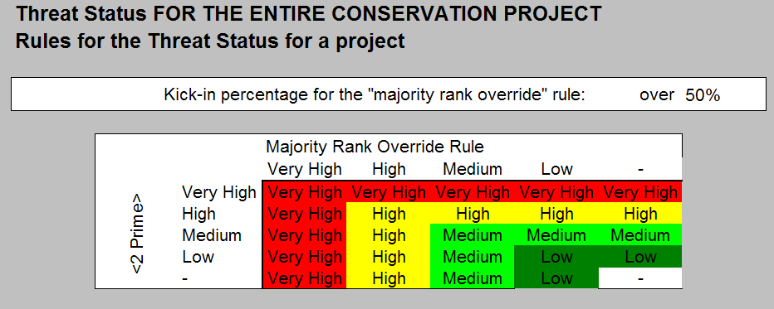

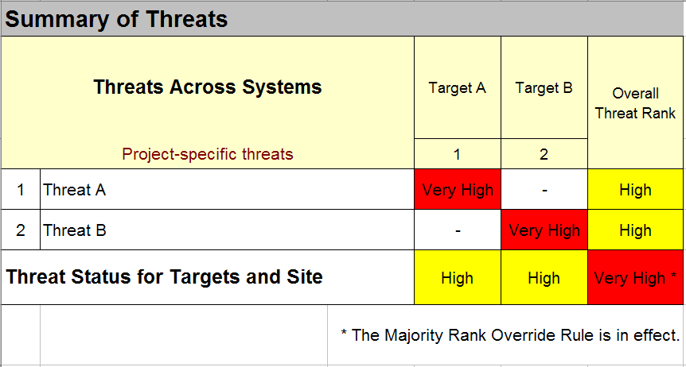
Example showing where the majority rank override delivers the overall Project-Level Threat Score

