Participatory Conservation Planning Manual

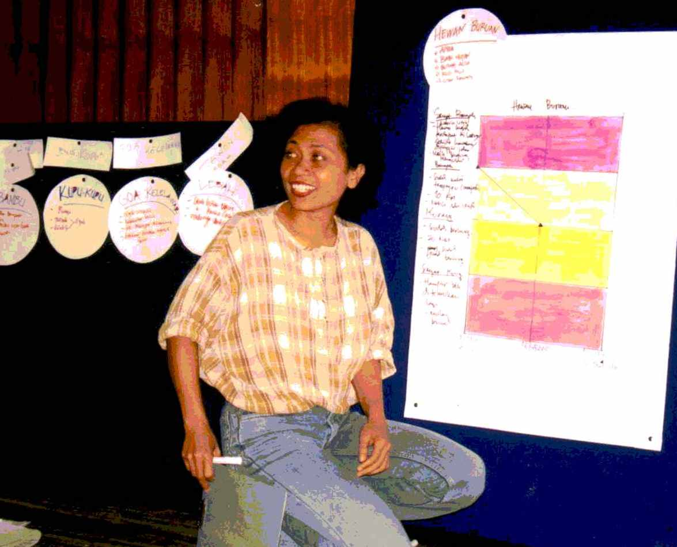

May 2004


Conservation Training and Resource Center
Applied Biology Building, Lantai 2
SEAMEO BIOTROP
Jl. Raya Tajur Km 6, Bogor
Telp: 62-251-336 020 Fax: 62-251-356 078
dibyo_tm@cbn.net.id

AUTHORS AND ACKNOWLEDGEMENTS

This adaptation of the conventional Site Conservation Planning (SCP) methodology was developed by the Lore Lindu SCP Team, which comprised Ismet Khaeruddin, Daryatun, Effendi, Zarlief, and Duncan Neville.

Special thanks are due to Maya Gorrez for assistance in developing the tool and training staff in its use, to Michelle Libby for emphasizing stakeholder relationships, and, of course, to all colleagues at the Lore Lindu Field Office who provided support and occasionally acted as guinea-pigs during the development process. Funding was provided by USAID through the NRM2 program. Special thanks go to the communities for freely sharing their thoughts with us as patient and enthusiastic participants in the SCP process.

The methodology has been field tested in Lore Lindu National Park, Komodo Marine National Park, and in Berau District, East Kalimantan. The process was reviewed by a peer review team comprising Herry Djoko Susilo, Minto Basuki, Helmi (PHKA); Agus Rahmat, Faizal, Herman Hariyanto (Tadulako University); Tomy Yulianto, Suaib (CARE); Jora Young, Jenny Ericcson, Titayanto Pieter, and Mark White (The Nature Conservancy). It draws on the strengths of the SCP in eliciting qualitative information through a structured process, but adapts the methodology for use in rural (and other) communities.

In 2003 Participatory Conservation Planning was offered as one of the courses provided by the Conservation Training and Research Center, involving a number of Indonesian NGO and forestry department agencies in first training then carrying out PCP at locations across Indonesia. Some of the recommendations arising from the evaluation workshop in January 2003 are included here. Our thanks are given to all the 20 participants from 9 organisations who helped in field-testing PCP.

The methodology outlined here is not prescriptive, it is a work in progress which can easily be adapted to suit other locations and needs. Please feel free to adapt it to your specific needs; we value input from other field practitioners.
PARTICIPATORY CONSERVATION PLANNING:
A METHODOLOGY FOR COMMUNITY CONSULTATION

INTRODUCTION

In conservation, as in any other field, good planning is essential to success. A wide variety of appropriate tools exist, one of which is Site Conservation Planning (SCP), a methodology developed by The Nature Conservancy over several years and many sites. Site Conservation Planning is a tool which identifies the most important natural components of an area – by focussing on these the tool helps in the development of effective and efficient conservation strategies. It also assists in an analysis of the human context for conservation, and develops indicators to measure and improve on the effects of management strategies. A range of documents describing Site Conservation Planning, and the 5S Framework (systems, stresses, sources, strategies, success) which guides it, can be found at ConserveOnLine (www.conserveonline.org).

One of the strengths of SCP is its adaptability: by recording information and assumptions clearly it can be repeated on a regular basis, and can be updated to accommodate an improving knowledge base. By involving partners and stakeholders, it also results in strategies which are more likely to succeed.

In Indonesia, and many other areas where community interest in protected areas is highest – say where traditional land use rights exist, or where local economies are dependent on natural resources – it is a common criticism that local communities are not involved in the decision making process. As the largest stakeholders, a group who can make or break conservation in an area, they must be involved in the planning process.

At Lore Lindu National Park, Central Sulawesi, we adapted the standard SCP tool specifically to involve local communities in the planning process. By maintaining the overall structure of the SCP methodology, but adapting the presentation to suit rural conditions, we have developed a tool that fully engages participants in establishing priorities and in identifying potential conservation strategies. To distinguish this approach from the conventional SCP, this process has been called Participatory Conservation Planning (PCP).

The strength of this adapted SCP methodology is that it asks managers to view conservation from the human context, by asking communities what they most value about a preserve (systems). The process involves communities in analyzing changes to these systems, and the underlying stresses and sources that cause them. The wider understanding that communities have also helps in a detailed analysis of the stakeholders, and in designing strategies which are more likely to achieve measurable success.

The output of this process is a plan which can be used as the basis for reserve management and is readily understood and approved by major partners. The process itself also engages partners and communities, and introduces the major concepts of conservation.
Although in the first instance used at Lore Lindu National Park, the process could also be used away from protected areas, wherever a consultative approach to resource management is required.

Participatory Conservation Planning draws on some common participatory rural appraisal techniques, and is designed so that the resulting information can be recorded on the standard SCP sheets with minimum modification.

Major assumptions in using this tool are that:
- Community support and acceptance is the most important factor in designing successful management strategies: the early identification of acceptable strategies, and the elimination of unacceptable ones, is a valuable management objective;
- The use of qualitative data in the PCP analysis is a strength, allowing discussions to be inclusive, involving a range of people with varying levels of technical skills, rather than the exclusive preserve of ‘experts’. It also allows for issues to be resolved on the basis of existing information, and can easily be reviewed when more detailed information becomes available; and
- In general, major threats identified by expert ecologists will act on a wide range of systems across a protected area, so the same threats will also be acting on the systems identified by communities, and vice-versa. Comparison with the conventional SCP analysis indicates that this assumption is valid, and that the PCP methodology generates similar results.

However, PCP alone is not an alternative to a complete ecological analysis, and should be seen only as one component of a more detailed management plan.

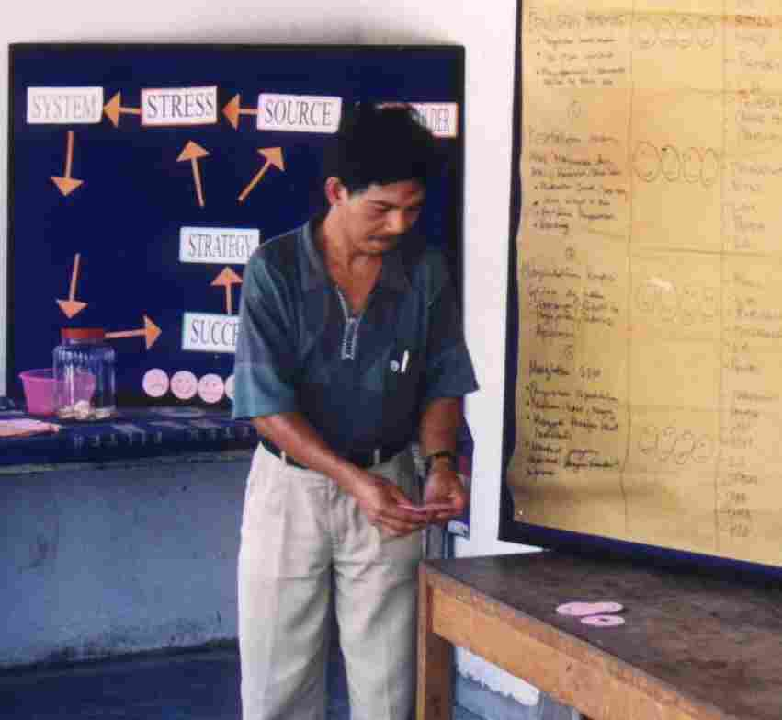

The Site Conservation Planning Framework

SYSTEMS
STRESSES
SOURCES
STRATEGIES
Biodiversity Health
Threat Abatement
Restoration
SUCCESS
Threat Status
Figure 1. Representation of the Site Conservation Framework
STAKEHOLDERS

There are 6 core elements of the Site Conservation Planning Framework:

Systems: the elements of biodiversity at a site, and the natural processes that maintain them, that will be the focus of site planning and around which strategies will be developed. The intent of target identification is to develop a short effective list of species, communities, or large-scale ecological systems whose protection will capture all the biodiversity at the site.

Stresses: the types of degradation and impairment afflicting a target(s) at a site.

Sources: the proximate agents generating the stresses. Together, the sources and the stresses they cause to the conservation targets comprise the Threats to the biological systems.

Stakeholders: the social, cultural, political, and economic constraints and opportunities presented by stakeholders (those that affect and are affected by conservation), and the potential for the participation of those stakeholders.

Strategies: the types of conservation activities deployed to abate sources of stress (threat abatement) and to reduce the impact of persistent stresses (through management and restoration).

Measures of Success: metrics of conservation impact through focused monitoring of biodiversity health and threat abatement.

METHODOLOGY

The Participatory Conservation Planning methodology is described in detail over the next few pages. A few notes on implementation are also valuable:

Goals
Although the PCP methods are very flexible, it’s important to establish goals from the start – do you want a complete community action plan, or just to collect ideas for possible conservation interventions? Is this the start of a longer engagement process, or a one-off activity? A clear statement of goals will inform the structure of the whole process.

Time
The consultation process is flexible : we felt two days was the optimum time to enable issues to be discussed in sufficient depth, yet did not demand too much time from participants – they have a living to make too! However, our purpose was to gain general ideas for park management strategies, if we wanted to develop a detailed site-plan, then the time allowed could be increased to three days, or four days spread out over two weeks.

Location
The consultation should be held in a large room, with space for 30 people to sit, and sufficient wall space to hang charts and working papers. It should be free of disturbance, and preferably in the target community, perhaps within sight of the protected area.

Participants
Selection of participants depends on the location, which might be as broad as a whole province, or as narrow as a single village. The tool is flexible enough to be used at most levels with some adaptation to circumstances. The optimum number of participants is about 20-25; focus on getting the right people in the room. In rural communities we invite a range of participants from all levels of village life, including village heads and women, the wider the cross-section of people involved the more stimulating the resulting discussion.

Where there are locally knowledgeable ecologists, historians, social scientists, foresters, or other experienced persons, they should be invited.

Team
A team of four people is sufficient to carry out the methodology. The team should include a team leader, a scribe, and two facilitators, but these roles can be interchangeable. To maintain interest, it helps to alternate facilitators during the consultation. The team should be selected carefully, as their role is not to provide answers, but to help participants develop their own answers – this is a rare skill.

PREPARATION IS KEY – the PCP team should be extremely proficient in using the tool, and should have made at least two dress rehearsals (one to a live audience) before attempting a community consultation. If they don’t do this they will not be prepared for the full range of discussion the process generates.

Equipment
The process can be conducted with a minimum of equipment. Cards and arrows should be cut to shape beforehand, if available felt-fronted boards are extremely useful - cards can be prepared with Velcro stickers so they can be moved or replaced during discussions. Otherwise pens, sticky tape, and flip-chart papers are the main pieces of equipment. Maps of the area should be hung up if available. A white-board is also useful.

Recording
All results are copied immediately into notebooks, and results photographed whilst still in place. Original consultation boards are retained, where possible, until the process has been fully recorded. The scribe should also take note of interesting conversations and side-bar discussions which can useful in interpreting results later.

Atmosphere
Remember, almost all the participants in this exercise are volunteers. Above all they should enjoy it! This may be the opportunity to develop long-term friends and supporters amongst local communities, make the most of it.

STAGE I | INTRODUCTION | 30 minutes

Objective: To build trust between the parties and to explain the objectives of the consultation process.

Process: Guided discussion

A short discussion facilitated by the PCP Team Leader, covering the following points:

- Introduction to your organization.
Operate on the principle that your organization is an unknown entity, and explain its work, vision and mission, give a local office address, and contact person.

- Introduction to participants.
Everyone in the consultation should give their name, and a sentence about themselves. This process should include the PCP team members too, and helps if they prepare a few amusing anecdotes.

- Discussion of the role of communities in protected area management.
Local communities are the most important stakeholders in most protected areas, as they have the greatest level of interaction with the resources. Their support can make or break a management plan, and they are likely be impacted by any management strategies.

- Introduction to PCP as a process to ensure community participation.
PCP is described as a method to focus thoughts on key aspects of the protected area, which values community views and inputs, to produce findings that can be presented to the protected area management body.

- Goal and Objectives of the consultation.
State the general goal and specific objectives of the process. At some stage results will be presented to the communities, this should be agreed now.

- Identification of site
Agree on the geographical area under consideration, use maps or develop sketch maps of the site and hang in a prominent position.

- Discuss the consultation agenda, and reach a consensus on the timetable.
All participants should commit to the time frame for activities, and the times specified for breaks.

Notes :
This introductory session sets the tone for the whole workshop. It should emphasize participation, respect for all views, and should avoid focusing on conflicts between communities and the protected area (or management agency). Facilitators should ask, not answer, questions, and the overall feeling should be of learning together.

STAGE II | SYSTEMS (Conservation Targets) | 140 minutes

Objective: To identify 4-6 biological or ecological systems that represent community priorities, and to collect information and descriptions of these systems.

Process: Metaplan analysis

- Metaplan cards are distributed to all participants, who are asked to write on one or more separate cards things they most value about the reserve, its ecosystem functions, or its natural resources.

Key Question: What is most important to you in the reserve?
- The cards are collected, and stuck on a board, according to apparent/logical groupings. A total of about 60 cards is manageable.
- Narrow all the ideas down to 4-6 target Systems by having the group prioritize among the different systems through discussion. A name is developed for each group of cards, then written on a circular ‘Systems card’. It helps to balance the systems across a range of scales :

Scale | Example systems
Species | - Hornbill (charismatic species)  - Rare species
Communities | - Seagrass beds  - Bamboo thickets  - Coral reef
Landscapes | - Montane Forest  - Lake  - Watershed system  - Savanna grassland
Resources | - Water sources  - Rattans  - Coffee Gardens  - Fish

- A description for each of these 4-6 prioritized Systems is developed, and written down on the Systems card. Systems must be defined very clearly. To assist in this, the eight systems are reviewed and discussed by all participants.
Notes:
Systems that are chosen do not always correspond with biological or ecological systems, and are very unlikely to correspond with conservation objectives – examples might be ‘traditional lands’, or ‘water sources’ – but THIS DOES NOT MATTER! Often the threats acting on these systems are the same as those acting on, say, charismatic species, and we should remember that the aim of the process is to establish WHAT THE COMMUNITY VALUE MOST about the protected area. This is the basis for their participation in a management strategy.

In communities with low literacy skills, systems have been represented by pictures or cartoons.

Sometimes systems may be referred to as ‘elements’, which may produce clearer understanding.

Materials:

Material | Description |  | No. required
Metaplan cards | 15 x 10 cm | White rectangles | 60
Pens | Marker-type |  | 30
Pins |  |  | 500
Boards  (Or use flipcharts) | 100 x 75 cm | Felt-covered | 10
Card circles | 20 cm diameter | White card | 20

RATTAN

Climbing palm we harvest from the forest for sale, for use in the home, and as a vegetable when young.

Figure 1. Example Systems card

STAGE III | VIABILITY | 60 minutes

Objective: To determine the current condition of the priority systems and perceptions of trends in their condition.

Process: Develop timelines for each system

- For each system in turn, request participants to grade each system’s condition using a (prepared) chart. The chart has four colored zones on it: poor = red; fair = yellow; good = light green; very good = green. A slider is located at three positions representing 10 years ago (T-10), the present (T) and 10 years into the future (T+10).
- The group ranks the overall condition of the target by moving the slider up or down the color gradients. Start first with the current condition, then the condition at T-10, before leading to a discussion of conditions in the future. This positions/scores of each target are plotted and labeled on the chart.

Key Questions: What is the current condition of the system in comparison to the past? Is a resource harder to obtain – more distance to walk, more hours’ effort? Is the system only degraded locally but still abundant in the wider area? Are particular varieties of plant in short supply? Is the animal seen/eaten more often or less often? What will the condition be in 10 years if no steps are taken ? etc.
- A line is then drawn between the points for each target. Having three points of reference in time will show a trend in the condition of the targets as perceived by the communities. The results are discussed and agreed on for each system. A cross-check can be made using maps of the protected area, photographs, or satellite photographs (perhaps time sequenced?).
- The resulting charts are pinned up in a prominent position for later reference. Indicators of system quality defined in this process are useful for developing indicators of successful management strategies later on.

Notes:
This activity serves to remind everyone that there is a problem, and to stimulate them to think about the reasons for it. It leads naturally into an analysis of stresses and sources.

Materials:

Material | Description |  | No. required
Charts w/ sliders | Hard card, previously prepared | Velcro backed | 8

Good
Fair
Very Good
T -10
T
(Present)
T +10
Current condition is good (green) but declining rapidly over time.
Slider
Poor
SYSTEM - RATTAN

Figure 2 : Example Timeline Chart

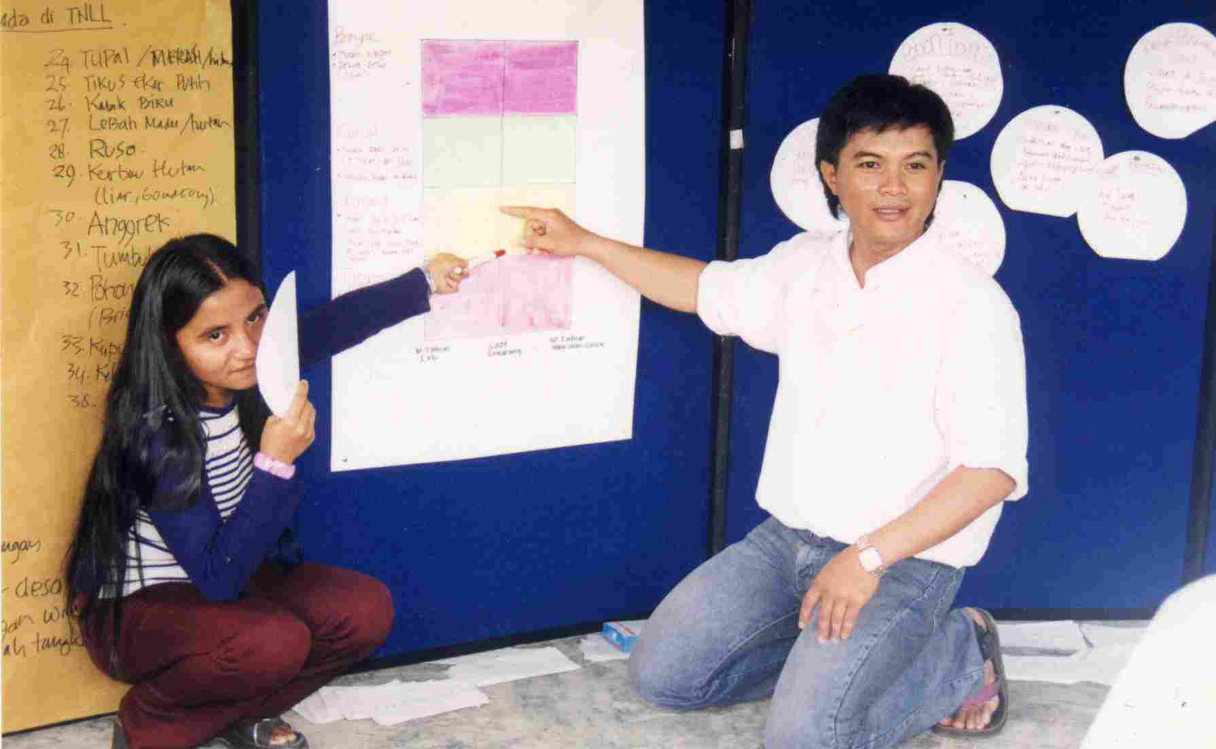

STAGE III | STRESSES and SOURCES | 180 minutes

Objective: Determine critical threats by identifying and ranking the stresses and corresponding sources that are acting to degrade each system.

Process: Develop situation diagrams for each system

IDENTIFICATION OF STRESSES AND SOURCES

- Divide the participants into 4 working groups, each addresses 2 distinct Systems. If possible, each group should have a facilitator working with them to aid discussion.
- On a flipchart or board, place a circular Systems card. Participants debate stresses acting to degrade this system, which are written on yellow cards and placed in a circle around the System card.

Key Questions: What is happening to this system within the conservation area or site? What actions are impacting the system?

- After stresses are completed, Sources of stress are developed, written on red cards and placed in a circle next to the stress they cause.

Key Questions: What activities or forces are causing those stresses? What activities have caused these effects in the past? What activities are likely to increase in the future?

Notes : We have found that it is initially difficult for groups to distinguish between Stresses and Sources. It may help to run through one or two examples with the group beforehand. The facilitator plays a key role in the discussion.

It is useful to have working definitions beforehand, we used :
Stress – damage or degradation of a system that reduces its capacity to exist and to grow;
Source – an activity that causes a stress, or factors which drive that activity.

At this stage almost any identified Sources should be accepted (e.g. Local unemployment, poor rice harvests, etc.) as all of these may be factors that could be addressed by management strategies. The ranking process later will ensure only the major sources are addressed.

It’s also useful to have the Timeline chart on display, to remind participants of the rate of change they are trying to describe. Maps can also help to indicate the scale of changes occurring, and geographic reasons for them (e.g. proximity to a road).

Example stresses | Example sources of stress
Habitat destruction | Conversion to agriculture  Logging (local unemployment; high price of timber; illegal activities by forest guards)
Population decline | Over-harvesting, hunting
Habitat degradation/disturbance | Grazing by domestic animals  Selective logging  Recreational use
Habitat fragmentation | Road construction
Flooding | Forest clearance
Decline in fish size | Over-fishing, use of illegal nets

RANKING OF STRESSES AND SOURCES

- Participants estimate the extent of damage a Stress is currently causing to a System. Different sized arrows, are used to indicate relative size of impacts, with larger arrows representing larger Stresses.

Key Questions: Which among the identified Stresses do you think causes the most damage to the System? Which causes the least? Are there geographic differences across the site? Which are you most concerned about? Which are you the least concerned about?
- The contribution of the Source is visualized and ranked using the same technique.

Key Questions: Which among the associated Sources contributes the most to a particular Stress? Which contributes the least? Do sources act across the whole range of the System, or they localized ? Are the same Sources acting on a range of Stresses?
- After about 120 minutes, workgroups present their findings to the floor for discussion and consensus. Changes in the diagrams are likely to occur, particularly in estimates of impacts (arrow size).
- During this process the facilitator attempts to standardize language and terms, so that identical Stresses and Sources are referred to in the same terms.
- Stresses and Sources are written up on a threat score matrix (example below) which is produced for each of the Systems.
- Cumulative scores are developed using a threat ranking matrix. There will be between 20-30 identified threats, since many of the threats are similar the facilitator should aim to combine them where possible, perhaps by expanding the language slightly. The aim should be to produce a list of about 20 threats. This process might be carried out by the facilitators during a break, or overnight, as could be rather tedious for participants.
- Critical Threats are the highest ranked sources that cause the highest ranked stresses across the priority systems. Strategies which act to mitigate these threats would be have the most effective conservation action.

Notes :
We wanted this to be a visual process, yet still maintain a quantitative aspect. The combination of color cards helps to differentiate between Stresses and Sources, and the different sized arrows allow for an easier, visual, comparison between abstract factors.

In Figure 3 the perceived impact of forest clearance on young rattan shoots is higher than on adult plants, this reflects the view of women participants who collect young rattan close to the village where forest clearance has more impact. This difference in impact should be accepted since it will contribute to a wider discussion on resource use.

Materials:

Material | Description |  | No. required
Stress cards | yellow card, oblong | Velcro backed | 80
Source cards | red card, oblong | Velcro backed | 80
Arrows | Very wide, wide, medium, narrow |  | 50 each
Matrix | For ranking calculations |  | 2

Very wide = very high wide = high medium = medium narrow = low
Score : 4 3 2 1

Figure 3 : Example Stresses and Sources Diagram (simplified)

RATTAN
Climbing palm we harvest for sale, for use in the home, and as a vegetable when young.
Reduction in mature plants
Forest clearance
Forest clearance
Harvesting for food
Reduction in young plants
Commercial use
Domestic use
4
2
3
2
4
3
1

Table 1: Example Threat Score Matrix for System- RATTAN

System | Stress | Score | Source | Score | Threat Score
RATTAN | Reduction in young plants | 2 | Harvesting for food | 3 | 6  (=3 x 2)
 | Reduction in young plants | 2 | Forest Clearance | 3 | 6
 | Reduction in mature plants | 4 | Forest Clearance | 2 | 8
 | Reduction in mature plants | 4 | Commercial use | 4 | 16
 | Reduction in mature plants | 4 | Domestic use | 1 | 4

Table 2: Example Threat Ranking Matrix per System.

 |  | SYSTEMS |  |  |  |  |  | Level of Threat
 |  | Rattan | Water | Timber | Hunted animals | e | f
SOURCES | Harvesting for food | 6 | - | - | 6 |  |  | 12
SOURCES | Commercial use | 8 | - | 16 | - |  |  | 24
SOURCES | Domestic use | 4 | - | 4 | 12 |  |  | 20
SOURCES | Forest Clearance | 14 | 12 | 8 | - |  |  | 34
SOURCES | i
SOURCES | j
SOURCES | k
SOURCES | l
SOURCES | m
SOURCES | Level Of Impact | 32 | 12 | 28 | 18

Notes :
This table is still under construction. Once all the boxes are filled in, then Sources can be ranked and the Critical Threats will be those with the highest scores. At the moment Forest Clearance is the highest ranking threat.

The Level of Impact is the sum of all scores impacting a particular System. It is useful in pinpointing systems experiencing the largest threat, and can be cross-referenced to the Timeline activities earlier. So far, the System most under threat is Rattan.

The final rankings are normally comparable to ‘expert’ analysis using the traditional SCP tool.

STAGE IV | STAKEHOLDERS | 180 minutes

Objective: To identify groups or individuals contributing to stresses or sources, or likely to be impacted (positively or negatively) by conservation actions.

Process: Create a situation diagram showing stakeholder relationships to critical threats.

- Make a card for each of top 6 critical threats (more if time allows).
- Divide the group into four, each group takes 1-2 critical threat to discuss. For each critical threat, the group should list all stakeholders involved. A card should be used to represent the stakeholder.
- Position the stakeholder next to the critical threat, using an arrow to indicate the level of contribution to the threat.
- It helps to describe the motivation pushing the stakeholder to act. This can be written on a smaller card which is stuck below the stakeholder card.
- It is important to lead a detailed discussion at this stage, and to retain notes for future use. Some surprising issues can arise, and some could be confidential in nature, for example names of government officials involved in timber trading.
Notes:
By focusing on several key stakeholders we can use limited resources for better conservation results. For particular individual systems, one single stakeholder may contribute the major threat (e.g. only one family collect turtle eggs), and could be addressed separately.
For literate groups, it is also effective and time-efficient to work directly on the recording form, as given in the appendix – Stakeholder Form.

Materials:

Material | Description |  | No. required
Stakeholder cards | blue card, oval | Velcro backed | 20
Motivation cards | pink card, oblong | Velcro backed | 20
Arrows | Very wide, wide, medium, narrow |  | 30 each

Very wide = very high impact wide = high medium = medium narrow = low
Score : 4 3 2 1

Figure 4 : Example Stakeholder Diagram

Local elite (sale of land to immigrants) government official
Immigrants
Local farmers
Forest clearance
Local government official
3
4
3
Subsistence farming
Long-term incomes (cacao)
Better life
ett
r opp
rtunities
Land ownership
Personal enrichment
2
Long-term incomes (cacao)
Long-term incomes (cacao)

Table 3: Example Stakeholder Analysis

THREAT : FOREST CLEARANCE

STAKEHOLDERS | MOTIVATION
- Local Elite  - Immigrants  - Local Government Official  - Local farmers | - Personal enrichment  - Better life  - Long-term income through cacao planting  - Land ownership  - Long-term income through cacao planning  - Subsistence farming  - Long-term income through cacao planting
STRATEGY

Initially list a whole range of strategies for ranking as a next step

STAGE IV | STRATEGIES | 180 minutes

Objective: To formulate strategies aimed to mitigate the critical threats acting on the priority systems.

Process:

- Participants review each situation diagram – showing system, stresses acting on that system, and sources of stress – and describe the effects of the key stakeholder actions on each system. These are described verbally for 5 minutes each (max.).
- The facilitator refers to Table 2 (Threat Ranking Matrix), and asks participants to confirm that the key factors are being addressed.

- Participants are divided into 4 groups, each group takes two Critical Threats or Systems each, and brainstorms a variety of conservation action strategies to resolve the issues. Brainstorm – no strategies are rejected, all are written down. Discuss potential strategies and define them very clearly. Use about 30 minutes for this activity.

Key Questions: How can key threats be addressed? How can we influence stakeholder actions? What agencies should be active and are not? What outcomes are desired? How can the condition of the important systems be improved? Will the community be supportive?
- Each group presents its strategies to the floor, and each strategy is discussed with reference to the following criteria:
- What effect will the strategy have on the threat?
- Will other agencies play a large roll in making the strategy successful (leverage)?
- Is there a strong lead person or lead organization?
- How easy is the strategy to implement?
- Are resources (funds and others) available to implement it?
Alternatively, criteria more relevant to local conditions might be developed.
The facilitator might find the following table useful to formalize this process:

Table 4. Matrix to rank conservation strategies
Strategy | Impact on threat | Leverage | Lead person  /Institution | Ease of implementation | Resources | TOTAL SCORE
Strategy a | 0-4 | 0-4 | 0-4 | 0-4 | 0-4 | 0-20
Strategy x

- Strategies are ranked according to score.
- There are three other vital factors to consider when selecting strategies for action, and the facilitator should ensure these are discussed:
- Pick strategies which will give early results – this will reinforce the enthusiasm of participants and strengthen networks.
- Has this strategy ever been tried before, and what were the results? If it was unsuccessful what was the reason, and have any important factors changed?
- Its better to pick simple projects to start with – complex projects require larger resources, take longer to achieve success, and have higher risk of failure.
- Finally, select chosen strategies, write them on a Strategy Card, and pin them on the situations diagrams at the appropriate location.
- A record of strategies and their relationships to stresses should be made. A suggested matrix is presented in the Appendix.
Notes:
The development of strategies does not have to take place immediately at a community consultation – sometimes this can produce very general strategies, ones that are difficult to implement, or ones for which there are no resources available. Strategies could be developed by the relevant institution, and then taken back to the community to review before implementation. This decision depends on the capacity and confidence of the organization conducting this PCP process.
If a more visual process is required, then the Strategy Cards can be filled in earlier in the process, perhaps directly by the small groups. A discussion will indicate whether strategies are viable and effective – discard those that are not.

You may find that this Participatory Conservation Planning methodology raises many unanswered questions – please remember RESEARCH is also a valuable strategy!

Materials:

Material | Description |  | No. required
Flipchart |  |  | 1
Marker pens | Various colors |  | 5
Strategy Cards | As below |  | 25

Figure 5 : Example Situation diagrams with Strategies

Local elite (sale of land to immigrants) government official
Immigrants
Local farmers
Forest clearance
Local government official
3
4
3
Subsistence farming
Long-term incomes (cacao)
Better life
ett
r opp
rtunities
Land ownership
Personal enrichment
2
Long-term incomes (cacao)
Long-term incomes (cacao)
Land sales are reviewed and approved by village council

RATTAN
Climbing palm we harvest for sale, for use in the home, and as a vegetable when young.
Reduction in mature plants
Forest clearance
Forest clearance
Harvesting for food
Reduction in young plants
Commercial use
Domestic use
4
2
3
2
4
3
1
Villagers manage exclusive harvest areas

STAGE VI | MEASURES OF SUCCESS | 60 minutes

Objective : To assign indicators of success for each listed strategy, and to develop programs for monitoring these indicators.

Process: Guided discussion

- The facilitator presents the situation diagrams with Strategies to the group. For each strategy the group establishes the following points:
- What is the goal for this strategy in regard to system or threat abatement?
- What are the indicators that this goal is being achieved, either in changes to the system, or in reduction of activities producing threats?
- What methods can be used to measure these indicators?

A focused discussion should result, and the facilitator may find it useful to display and fill in the following matrix as the discussion progresses:

Table 5 : Example matrix for Measures of Success
Strategy : Villagers manage exclusive rattan harvesting areas
Goals (System/Threat) | Indicators | Methods for Monitoring
System : rattan stocks are stabilized | - number of plants  - steady harvest volume | - transect surveys  - harvest records
Threat : reduce extraction by outsiders | - number of rattan groups operating  - village operating license from forestry department | - reports from village rattan collectors  - village records
Strategy : x
Etc. | Etc.

Key Questions : What is the simplest thing we could measure to indicate System quality? Can we easily count resource units or resource size, or is an alternative indicator required? How could we measure this change? Who could do this work? When should it be done? How could we check that tasks have been completed ? Who is responsible for doing this? How does it feedback into the implementation process?

Notes:
Monitoring is an extremely important part of project implementation, and proper attention to indicators will play a large part in keeping a project on track throughout its implementation.

A completed monitoring plan may not be the goal of your consultation, or may be something you would rather develop once it has been decided which strategies to implement. This step could be done effectively at a later date with the same participants.

The process as outlined above is rather brief – an implementation agency could better use this only as the basis for developing a more detailed monitoring plan. The important features of this plan should be simplicity and accuracy – complicated monitoring uses too many resources, and communities are not likely to give up much time for non-productive activities.

Further reading on Measures of Success is available at www.Conserveonline.org or www.bsponline.org .

FINAL WORDS

We, the Lore Lindu Field Office PCP Team, hope you’ve enjoyed reading this methodology, and we hope you enjoy putting it into practice even more. Please let us know how you get on.

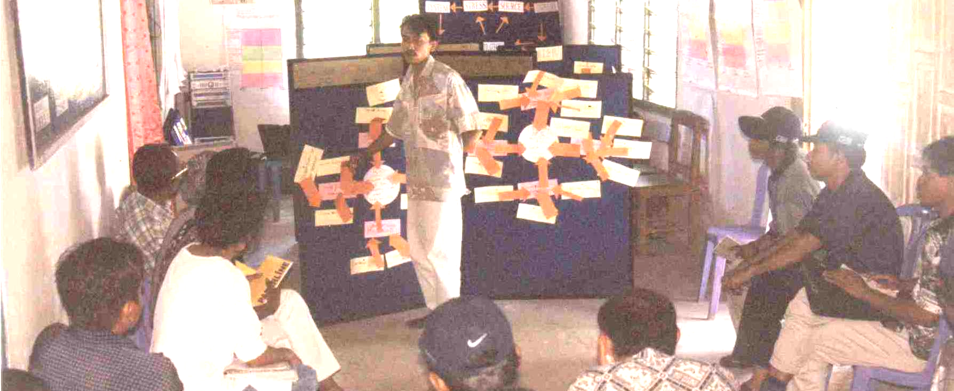

Location: ……………………….

Scribe: …………………..……….

Date:……………………….
FORM
PARTICIPANTS

Name | Address | Employment | Age | M/F

Location: ………………………….

Scribe: ……………………………….

Date:………………………….
FORM
SELECTION OF TARGETS

No | System | Description | No. of cards
1

2

3

4

5

6

Systems not prioritized:

7

8

9

10

Location: ………………………….

Scribe: ……………………………….

Date:………………………….
FORM
TIMELINE

System: |  |  |  | System:
T - 10 | T | T+10 |  | T - 10 | T | T+10
System: |  |  |  | System:
T - 10 | T | T+10 |  | T - 10 | T | T+10

Location: ………………………….

Scribe: ……………………………….

Date:………………………….
FORM

SCORING CRITICAL THREATS

System | Stress (a) | Weight | Source (b) | Weight | Score  (a x b)

FORM

RANKING CRITICAL THREATS
Location: ………………………….

Scribe: ……………………………….

Date:………………………….

 |  | System |  |  |  |  |  |  |  | SCORE
THREAT (SOURCE OF STRESS)
 | Threat Score for system

Location: ………………………….

Scribe: ……………………………….

Date:………………………….
FORM
STAKEHOLDER

THREAT/SYSTEM:
STAKEHOLDER | MOTIVATION

Location: ……………………

Scribe: ……………………….

Date:…………………………..
FORM
RANKING STRATEGIES

SCORE
(0-20)
Organ-isational resources | (0-4)
Ease of Implemen-tation | (0-4)
Lead Individual/  Organisation | (0-4)
Levarage | (0-4)
Effect on the Critical Threat | (0-4)
STRATEGY

Location: …………………………..

Scribe: …………………………

Date:……………………………
FORM

MONITORING METHODOLOGY

Strategy:
System Goals: | Indicators of Success: | Monitoring methodology:
Threat Goals:
Other Goals:

Strategy:
System Goals: | Indicators of Success: | Monitoring methodology:
Threat Goals:
Other Goals:

Strategy:
System Goals: | Indicators of Success: | Monitoring methodology:
Threat Goals:
Other Goals:

The SCP method works on 8 systems – we have found 4-6 systems to be the ideal number for the PCP methodology, providing adequate cover but not being too time-consuming.

