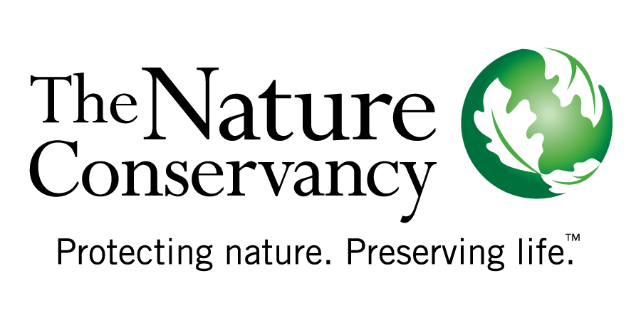
Annotated Outline of a Planning Process Charter for Proteced Areas
Based on best practices from practitioners
Draft: December, 2008
Compiled by Cristina Lasch

What is this document for and where did it come from?
This document intends to provide a point of reference for teams who are embarking in a protected area planning process, and who would like to establish their initial process expectations in writing.

The ideas presented in this document are based on the applied experience of conservation and natural resource management teams from various parts of the World, who have found it useful to clarify expectations before beginning a planning process.

How should we use this document?
This document should be seen as a point of reference, and teams are encouraged to decide which topics merit inclusion and the level of detailed deemed necessary for clear communication.

If you decide to write a planning process charter, you will find it useful for communicating basic project information to new stakeholders you need to involve in the process once you have started. It can also be a useful reference for team coordination and clarification of team member roles and responsibilities, throughout the process.

A good practice is to keep this document alive by incorporating changes when new agreements are reached by the team that promotes the planning process, and to share an updated version with all members of the core planning team.
How is this document set up?
The document presents topics which have been included in a planning process charter, with some additional guidance on what teams might want to consider to support effective collaboration and communication throughout a planning process.
Annotated Outline of a Planning Process Charter:
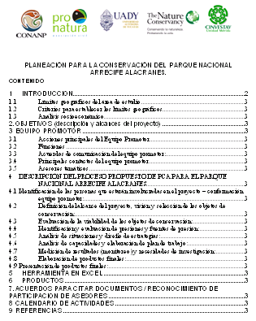
First Page - this generally has the logos of the institutions who will be leading the planning process (the core planning team), the title of the document “Planning process charter for Site X”, and the table of content.

Here we provide an example of what the first page of the team charter from the Alacranes Reef National Park planning process looks like.

1. Introduction – this can include:
  - Process objective: Why are we interested in having a plan for the site or conservation topic (i.e. recently decreed area, wide ranging species needing protection, site network, etc.)?
  - Recognize existing plans: Are we aware of previous planning exercises in this region?
  - How this effort relates to existing plans: What is the value added of this process in the region?
  - Project values: What makes this area special (why is it worth protecting)? – (i.e. it is a priority site within an eco-region, RAMSAR, MAB, country protected area, migration corridor, etc.)
  - Summarized project description & initial boundaries: Where is the area located and how big is it? (map with rough initial boundaries)
  - Initial vision statement for the protected area or project: What is our preliminary vision of success or our big objective for this area?

2. Expected products and outputs of the planning process:
- What products do you expect from the process? (e.g. management plan, multi-institutional conservation plan, maps, outreach materials, outreach events, etc.)
- Define the structure of the management plan, at least in draft
- Determine the formats in which the management plan will be presented (e.g. printed, bound volume; printed, loose-leaf volume; document on CD; document on the web; electronic GIS data; software programmes; or summary documents)
- What outcomes do you expect? (e.g. increased local participation, better communication among key stakeholders, a shared vision, a coalition, etc.)

3. Brief description of the method that will be used:
- Based on the expected products and outputs describe which method the team has settled on (or what combination of methods), and for greater transparency provide a brief explanation on the method’s demonstrated applicability or relevance.
- Provide a summary of the method the team has agreed on, so that everyone understands what will be done throughout the process

4. Core Management Planning team – this can include:
  - Who is invested in seeing the process completed and will follow it from beginning to end? What are each institution’s specific interests in the process?
  - Who is responsible for the general process?
  - Who provides support (technical input or methodological advice throughout the entire process)?
  - Roles & responsibilities within the team & key contact information. Many teams include a table that looks like this:

Name | Institution and job title | Responsibilities | Contact information: e-mail and phone

  - Communication agreements within the core team (who will sign invitations to meetings, who should coordinate communications with external stakeholders, will there be a virtual place to find project information on line, etc.)?

Some teams have included a visual explanation of roles and responsibilities in their charter. For example in this process from Baja California, in Mexico, people within the blue circle are responsible for the overall process coordination. People within the triangle represent the technical core team who needs to jointly “drive” the planning process, and people outside the triangle help make relevant decisions and provide methodological advice.

Diagram of core team of the San Cosme – Punta Mechudo Corridor Planning Process, BCS, Mexico.

5. List of potential process participants crucial for successful management planning
  - Who needs to participate for the process to be successful?
  - Check your expected results and outcomes and consider the representation of the important voices for all critical steps of your process – who do we need to listen to?
  - Will you provide participants with an official evidence of their participation in this process? (diploma for attending planning meetings, or a letter of recognition at the end of the process to thank them for their input, etc.)

Initially a simple table with the following fields might be enough to record participant information:
INSTITUTION | PARTICIPANT | EXPERTISE

  - However, as the process moves forward it can be useful to create a more complete list of potential participants. For each participant you can record their name, institution/community, area of expertise, during which part of the process they can mostly contribute, contact information.
  - How you will engage stakeholders throughout your process? The following table could be kept in the process charter, to document the approach that will be taken with each stakeholder.

Process  Stage | Inform | Consult | Involve | Collaborate | Empower
Coordination and facilitation of planning process
Basic information collection
Identification and assessment of targets
Identification and assessment of pressures, opportunities and stakeholders
Strategy development
Monitoring and evaluation of management effectiveness

6. Proposed work plan for the planning process
  - Outline the key steps of your planning process, including training, information review, planning meetings, document & map preparation, public consultations, request for official approval of management plan, etc.
  - For each step identify expected products, estimated dates and people who will be responsible for getting it done.

7. Timeline:

  - How much time will we spend on the process?
  - By when do we need to have our products available for them to be more useful?
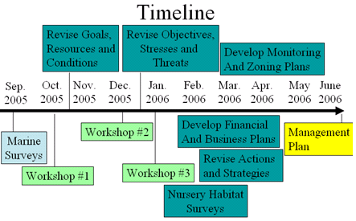
The timeline in the process charter can give a rough idea of when each activity needs to take place, as is shown in the image on the right.

Or it can be a bit more specific about what need sot be done in each phase of the planning process, as in the example below.
Activity/Month | Preparation Phase |  | Core Planning Phase |  |  | Follow-up Phase
Activity/Month | Apr | May | Jun | Jul | Aug | Sep | Oct | Nov
Establishment of core planning team and definition of agreements to develop the planning process
Complete work plan & contract (if a consultant will facilitate the process)
Introduction of all core team members to the planning process method
Information review & compilation
Meeting to select conservation targets & assess target viability
Meeting to assess pressures & opportunities
Information review on active conservation, restoration & monitoring projects in the area
Meeting to conduct situation analysis & design strategies
Meeting to assess capacities & available resources, and develop work plan for first year
Produce final documents established by core team
Complete measures plan & list of research priorities
Conduct consultation meetings & collect comments from public
Address legal requirements for approval & submit management plan for official approval
Produce outreach publication (accessible version of management plan)
Present final products & information in public with key sectors

8. Budget and available resources
  - Considering your products & outcomes, and your timeframe
- do you have the people with the necessary skills on your core team?
- do you have the money or alliances to cover staff time, meeting costs
and products?
- what are your sources of funding & support?

A table like the one below can be included, considering the specific cost categories established by your project:

Activities | Staff time | Consultancies | Travel | Materials & equipment | Meeting costs (including participant travel, meals & lodging) | Funds needed | Funding source  (or in-kind support source)

9. Process documentation, information use and authorship of final products
- What information needs to be stored for future reference and in what formats?
- How will you ensure it is organized, back-ups exist, who will be responsible for this?
- How will publications be referenced (by institutions, by names of those who do the writing, in what order)?
- How does the team want to recognize advisors in publications (list of participants in the back of the document cover, or in acknowledgements, or as co-authors of various sections, etc.)

10. References cited in the process charter
- Keep a list of references cited, this can be helpful for your final products, if you decide to take text portions from your process charter

While maps and their respective databases should be registered in a reliable GIS, some projects have additionally produced a printed or pdf compilation of reference maps.
If official management plan guidelines exist, it is important to consider the recommended structure and to be aware of components which might be legally binding to ensure that those issues are adequately addressed in the process.
If you are completing a management plan, review the guidelines from your country’s management agency, to ensure that your method is adequate.
This does not need to be an exaustive final list, but by including this list in the charter, the core planning team can decide at which points it is important to communicate things to specific stakeholders, considering the expected outcomes & available resources for the planning process.

