Establishing environmental flows for sustainable water management: Upper and Middle Verde River watersheds, Arizona

Background

The Verde Watershed is an essential element of life in central Arizona, sustaining unique biotic assemblages, human communities, industry, and agriculture in a semi-arid environment. Large portions of the watershed remain undeveloped and are administered by the US Forest Service. However, considerable growth is occurring in the Prescott area and in the Verde Valley. Limited water resources have resulted in conflicts between human communities and their needs for water in different parts of the watershed, and between human demands for water and the needs of plants and animals. Impounded flow at the downstream end of the river ultimately supplies a significant source of water to the metropolitan Phoenix communities. The purpose of this study is to provide a rigorous scientific foundation that quantifies the association between hydrologic characteristics and ecological conditions in the Upper and Middle Verde Watersheds. This will provide information necessary for the assessment of hydrologic alteration and effective management of water use.

Project Goals
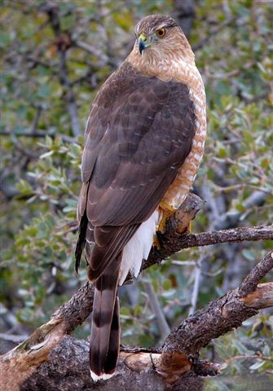
Cooper’s Hawk

- Improve understanding of flow ecology (hydrology and ecological associations) in a semi-arid watershed.

- Develop quantified relations between hydrologic alteration and ecological responses to provide a scientific foundation for ecologically sustainable water management.

- The Verde River watershed will act as a pilot study for developing techniques and methods that can be applied more widely across the Southwest.

This study will improve the understanding of the relations between streamflow and biotic communities of the Verde Watershed. This information is needed by resource managers who must resolve conflicts between competing uses and sustainably provide water to humans while supporting ecological integrity. The USGS will provide the scientific information critical to the process, through an integrated watershed-analysis

Upper and Middle Verde watersheds

approach to define important regional flow characteristics, assess ecosystem water requirements, and model changes in flow regimes (either flow restoration or additional
flow alteration). The USGS will quantify associations between hydrology and ecology, which can then be used to inform the development of environmental flow standards.

Environmental Flows

ELOHA framework

An international group of river scientists have proposed a framework for developing environmental flow standards that address ecosystem water needs. The framework, Ecological Limits of Hydrologic Alteration (ELOHA), is based on a spatially comprehensive hydrologic foundation and generalized flow-ecology relations that can be applied across a region to establish environmental flow standards. The purpose of environmental flow standards is to protect entire ecosystems instead of single species. Once the ecological responses to hydrologic alteration are defined, there can be explicit social decisions about the level of protection (which can vary by river or stream) and administrative mechanisms (water permits, land use planning, water trusts) for implementing flow standards. This proposal addresses the scientific process of defining ecological responses to hydrologic alteration.

Natural Hydrologic Regime

The first step in establishing environmental flows is to develop scientifically credible estimates of flow regimes that sustain properly functioning ecosystems. The natural hydrologic regime of a river or stream can be divided into four components: floods, high flow pulses, base flows, and extreme low flows. Each of these flow components has different ecological functions and, thus, all are likely to be important for ecosystem integrity. The functions of environmental flow components depend on their magnitude, frequency, duration, timing, and variability. As such, hydrologic alteration can refer to
changes in any of these characteristics. Flow regimes in the semi-arid Southwest are highly dependent on groundwater-surface water interactions; as a result, groundwater conditions, such as depth to groundwater and annual groundwater level fluctuations, need to be incorporated in the analysis of streamflow. Southwestern streams, including those of the Verde Watershed, are characterized by large variations in flow magnitude, including large floods originating from high-intensity summer thunderstorms and extended winter frontal precipitation events. However, the Verde River and its tributaries spend the majority of time in a base flow regime, in which groundwater outflow from numerous springs provides the sole source of streamflow.

Study Objectives

- Divide the Verde River Watershed into sub-basins that represent mainstem reaches and major tributaries with distinct base flow sources, biological communities, water use, and streamflow patterns.
- Establish current streamflow characteristics for all major sub-basins of the Verde River Watershed at gaged sites based on available data.
- Establish current biological conditions for all major sub-basins of the Verde River Watershed using species of special concern (e.g., native fishes, songbirds) and indicators of ecosystem integrity (e.g., aquatic macroinvertebrates).
- Analyze interaction of shallow groundwater and surfacewater as it influences the availability of these resources.
- Assess human water uses (diversions and groundwater pumping) and agricultural returns flows.
- Estimate monthly water budgets for current and unaltered conditions for all major sub-basins including monthly high, low, and median streamflow using hydrologic models.
- Analyze relations between hydrologic alteration and ecological responses in the Verde River Watershed.

Study Components and Approach

We will summarize and analyze existing data, as well as collect new data to fill information gaps. A wide variety of established analysis and modeling techniques will be evaluated for applicability to semi-arid southwestern watersheds. In addition, new techniques will be developed when necessary.

Data
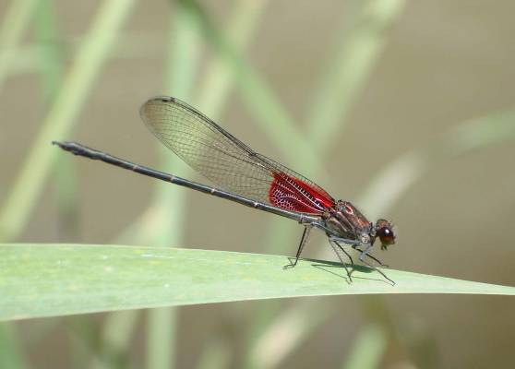
- Streamflow including gains and losses to groundwater
Rubyspot damselfly
- Groundwater levels and gradients
- Aquatic biota (fish, macroinvertebrates) and associated physical habitat, geomorphology, and water chemistry (temperature, turbidity, oxygen)
- Riparian vegetation
- Water use
- Watershed characteristics (elevation, geology)

Approach

Hydrologic Analyses of Streamflow

Streamflow has many essential characteristics from an ecological perspective including frequencies of floods and low flows, duration of flows from high to low, and timing of flows in relation to the life histories of significant aquatic and riparian species. Although some parts of the Verde watershed have stream gages, most do not, and techniques will be utilized to estimate current streamflow characteristics for all major sub-basins. In some cases, streamflow characteristics can be estimated simply by using regression analyses that require drainage-basin characteristics derived from GIS (including geology, rainfall, drainage area, stream length, slope, relief, shape aspect, channel measurements) to estimate flows at ungaged sites. This approach may be adequate for assessing flow-ecology responses where there are nearby stream gages. Development of monthly water budgets, assessing hydrologic alteration, and estimating flow characteristics at sites that are distant from stream gages will require more detailed hydrologic modeling.

Additional extant data will be used to constrain understanding of streamflow including synoptic discharge measurements (seepage runs), diversion locations and volumes, and geochemical information.

Integrated Watershed-Groundwater Models

A USGS MODFLOW groundwater model including the Upper and Middle Verde River Watersheds will soon be completed. The numerical model development was an approximately $1.3M, 3-year study that was built using results from several preceding studies to that characterized the hydrogeologic system. This model will form the basis for analyses of base flow changes resulting from hydrologic alteration. Initial steps at developing a watershed model of the system are underway at Northern Arizona University. An integrated analysis of the two aspects of streamflow, base flow and flood flows, that are essential to the Verde River, would be facilitated with an integrated surface-water/ground-water modeling approach. The USGS GSFLOW model provides an integration framework that links watershed and groundwater processes using the Precipitation-Runoff Modeling System (PRMS) watershed model code and the MODFLOW groundwater code.

Geomorphology and instream habitat characteristics

Geomorphology and instream physical conditions form the habitat structure for riparian and aquatic plants and animals. These characteristics will be quantified in the field, and used in habitat availability models. Field measurements will include surveying transect cross-sections, mapping key features on high-resolution photography, and recording instream conditions of velocity, depth, substrate, and riparian canopy cover.

Established habitat models include PHABSIM and MESOHABSIM. Preliminary analyses will indicate the applicability and also potential modifications to these models for the Verde watershed.

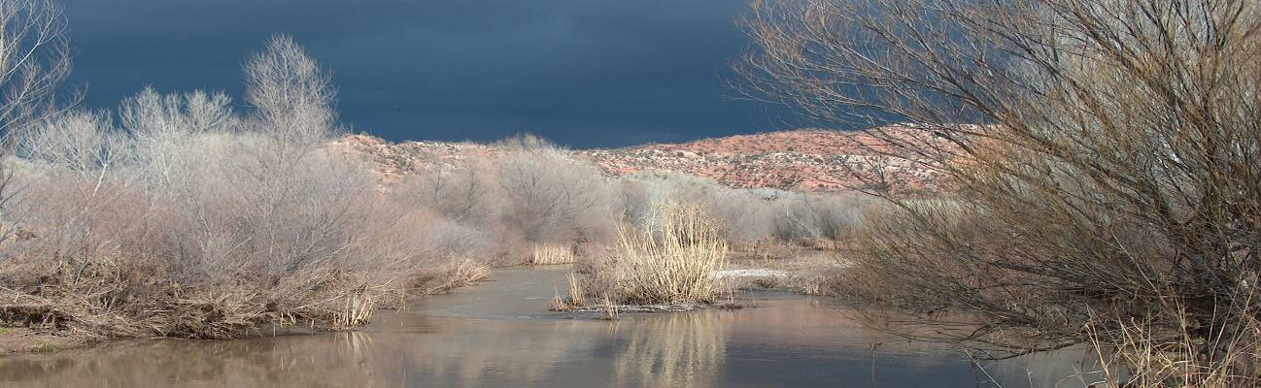

Flow-Ecology Models

The development of flow-ecology models that relate aquatic macroinvertebrate and fish assemblages to flow characteristics is an integral component of this study. Existing models will be evaluated and new analyses and modeling techniques may also be developed. In addition to PHABSIM and MESOHABSIM, three potential models include:

  - Hydrologic Indicators, a technique that uses quantile regression to determine associations between hydrologic metrics and biotic metrics.

  - Multi-variate analyses, a variety of multi-variate statistical techniques exist that can link flow characteristics with community structure.

  - Flow-ecology response models that relate biological condition to flow conditions, and can be used to predict thresholds of response.

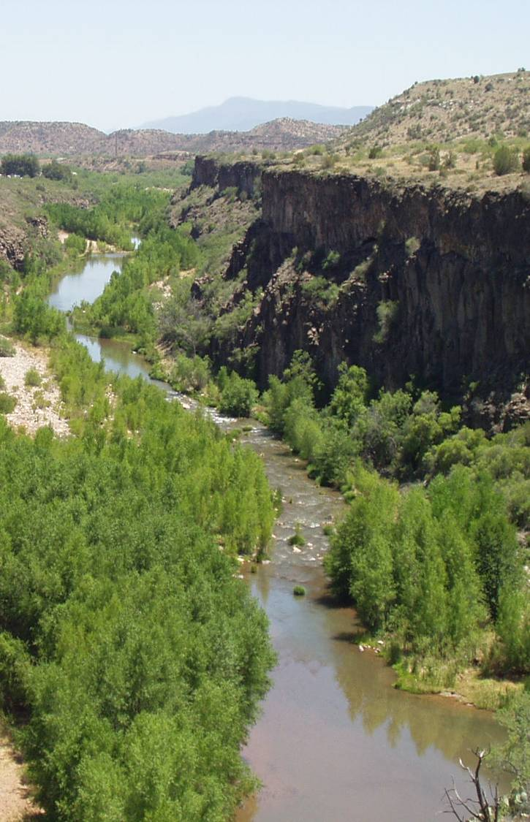
Phase 1
  - Divide watershed into major sub-basins
  - Compile, assess and summarize existing hydrologic and biological data by sub-basin (with emphasis on the Verde Valley) and identify data gaps
  - Perform field reconnaissance
  - Assess biological status by sub-basin with emphasis on Verde Valley
  - Evaluate output from the USGS regional groundwater model for relevance to flow-ecology studies in the Verde Valley
  - Develop monthly streamflow statistics for each sub-basin with additional detail for the Verde Valley
  - Publish summary report from Phase 1

Phase 2
  - Expand analysis to other sub-basins
  - Collect additional hydrologic and biological data to fill in gaps
  - Assess biological status throughout watershed
- Refine regional ground-water model throughout watershed
- Develop models for estimating streamflow characteristics and integrate with groundwater model
  - Evaluate relations of biota to streamflow characteristics and instream habitat
- Complete reports
- Colleague review of reports
- Publish results (reports, journal articles, web products, databases, models, etc)
- Disseminate results (stakeholder meetings, fact sheets, etc.)

Budget

The budget provided is for Phase 1. The budget for subsequent phases will depend upon the final scope of the study, the availability of existing data and models, and other factors. The funding scenario would probably include several different sources contributing to the overall budget. There has been a substantial amount of work done in the Verde Watershed, and this study will leverage and build upon that foundation. Costs presented in this budget incorporate salary, equipment, supplies, travel, and publication costs.

Phase I Year 1

Acquire and compile existing data
- Ecology $27,979
(fish, macroinvertebrates, birds, habitat, riparian vegetation)
- Hydrology $25,629
(streamflow, groundwater levels, pumping, diversions)
- Geomorphology (areal photography and cross sections) $ 6,063
- Geospatial integration $ 6,063
(vegetation, land use, elevation, other geospatial data)
- Phase I database development and review $11,735

Estimated Cost $77,469

Preliminary analysis and model development
- Evaluate status of aquatic and riparian biota, and
identify biological drivers (watershed condition,
instream habitat, hydrologic alteration) $34,820
- Evaluate biotic, abiotic, and stressor relationships $34,820
- Evaluate output from existing regional groundwater model $24,611

Phase I Year 2

- Assess potential surface water models $21,407
- Construct monthly water budgets $41,019
- Evaluate ecological models and assess integration with $52,745
hydrologic models and determine best models to study
eco-hydrological interactions in the Verde River Watershed

Estimated Cost * $209,422
*Costs for analysis and model development as presented here represent the reduced cost resulting from an anticipated inkind salary contribution by the USGS of $135,000 in FY10 and $132,00 in FY11

Summary Report
- Summary of findings
- Verde database
- Conceptual framework
- Science plan of action
Estimated Cost ** $83,675
**Includes publication costs; editing, layout, web serve

Cost share between USGS and TNC for Phase 1

 | Year 1 | Year 2 | Total
TNC | $107,822 | $145,197 | $253,019
USGS | $63,898 | $53,649 | $117,546
Total | $171,720 | $198,845 | $370,565

Phase II detailed scope and cost will be determined in Phase I

Phase II
- Field studies
  - Field collection of needed hydrologic, geophysical, biologic and geomorphic information, to populate selected models

- Statistical analysis
  - Calculate metrics

- Integrate models
  - Develop integrated groundwater-watershed models
  - Develop integrated hydrology-ecology models

- Geospatial models
  - Develop link between models and geospatial data
- Finalize analyses and models
- Report preparation and review
- Publication of results, web products

