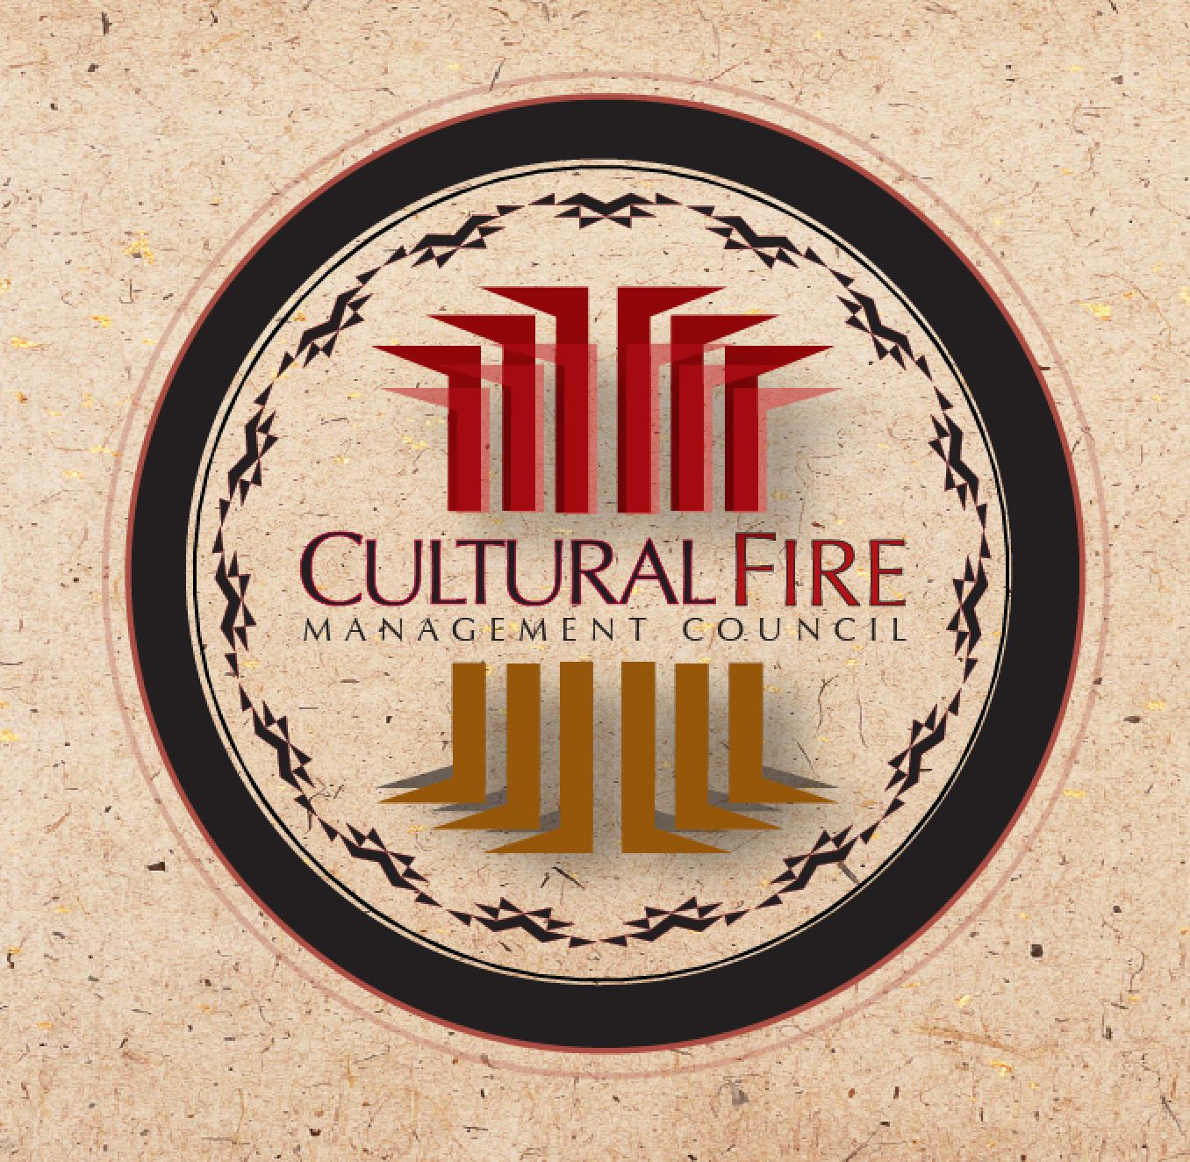

CFMC/Yurok Prescribed Fire Training Exchange (TREX) Application
September 29 - October 5, 2019 ; Weitchpec, CA

1. Participant Information (please print legibly or type responses in space provided)
Full name (first and last):
Organization and position:
Complete work address: |  | Phone: cell ( ) work ( )
 |  | Email:
2. Supervisor Information
Name: | Job title: |  | Phone:
3. Qualifications (all participants must have nwcg wildland firefighter type 2 training):
Qualified positions (current only):
Trainee position requested:
Check here if you require introductory Wildland Firefighter Type 2 training (S130, S190, L180, ICS100b I700a):
Check here for Annual Refresher RT-130
4. Course Expectations
Briefly describe your expectations for this training:
5. Fee: $300
If selected to participate, the non-refundable fee of $300 is due NO LATER THAN September 20, 2019. The fee for university students is $100. Please remit payment to CFMC, P.O. Box 357, Hoopa, CA 95546
6. Personal Protective Equipment
Participants should come with all appropriate Personal Protective Equipment (PPE), including fireline-approved boots (all leather work boots, 8-inches tall, non-slip soles and no steel toe), a Next Generation Fire Shelter, a hard hat, Nomex clothing, all leather gloves, eye protection and canteens for drinking water. For individuals who do not have PPE, it is available for rent for $50 at the beginning of the event. Check here if you require PPE:
7. Equipment Contribution
These Training Exchanges would not be possible without contributions of equipment from participants like you. The equipment we need participants to provide includes engines, UTVs, chainsaws, hand tools, backpack pumps, and PPE (fire shelters and Nomex clothing). If you or your organization can provide any (or any combination) of these items, please e-mail Margo Robbins at Cultural Fire Management Council (margo@culturalfire.org) to discuss the details.
List the equipment you can provide here:
8. Submit Application (Due no later than September 10, 2019)
Please forward any questions you may have and submit this completed application to Margo Robbins at Cultural Fire Management Council (margo@culturalfire.org). Thank you for your interest in TREX!

