
2014 KLAMATH RIVER TRAINING EXCHANGE

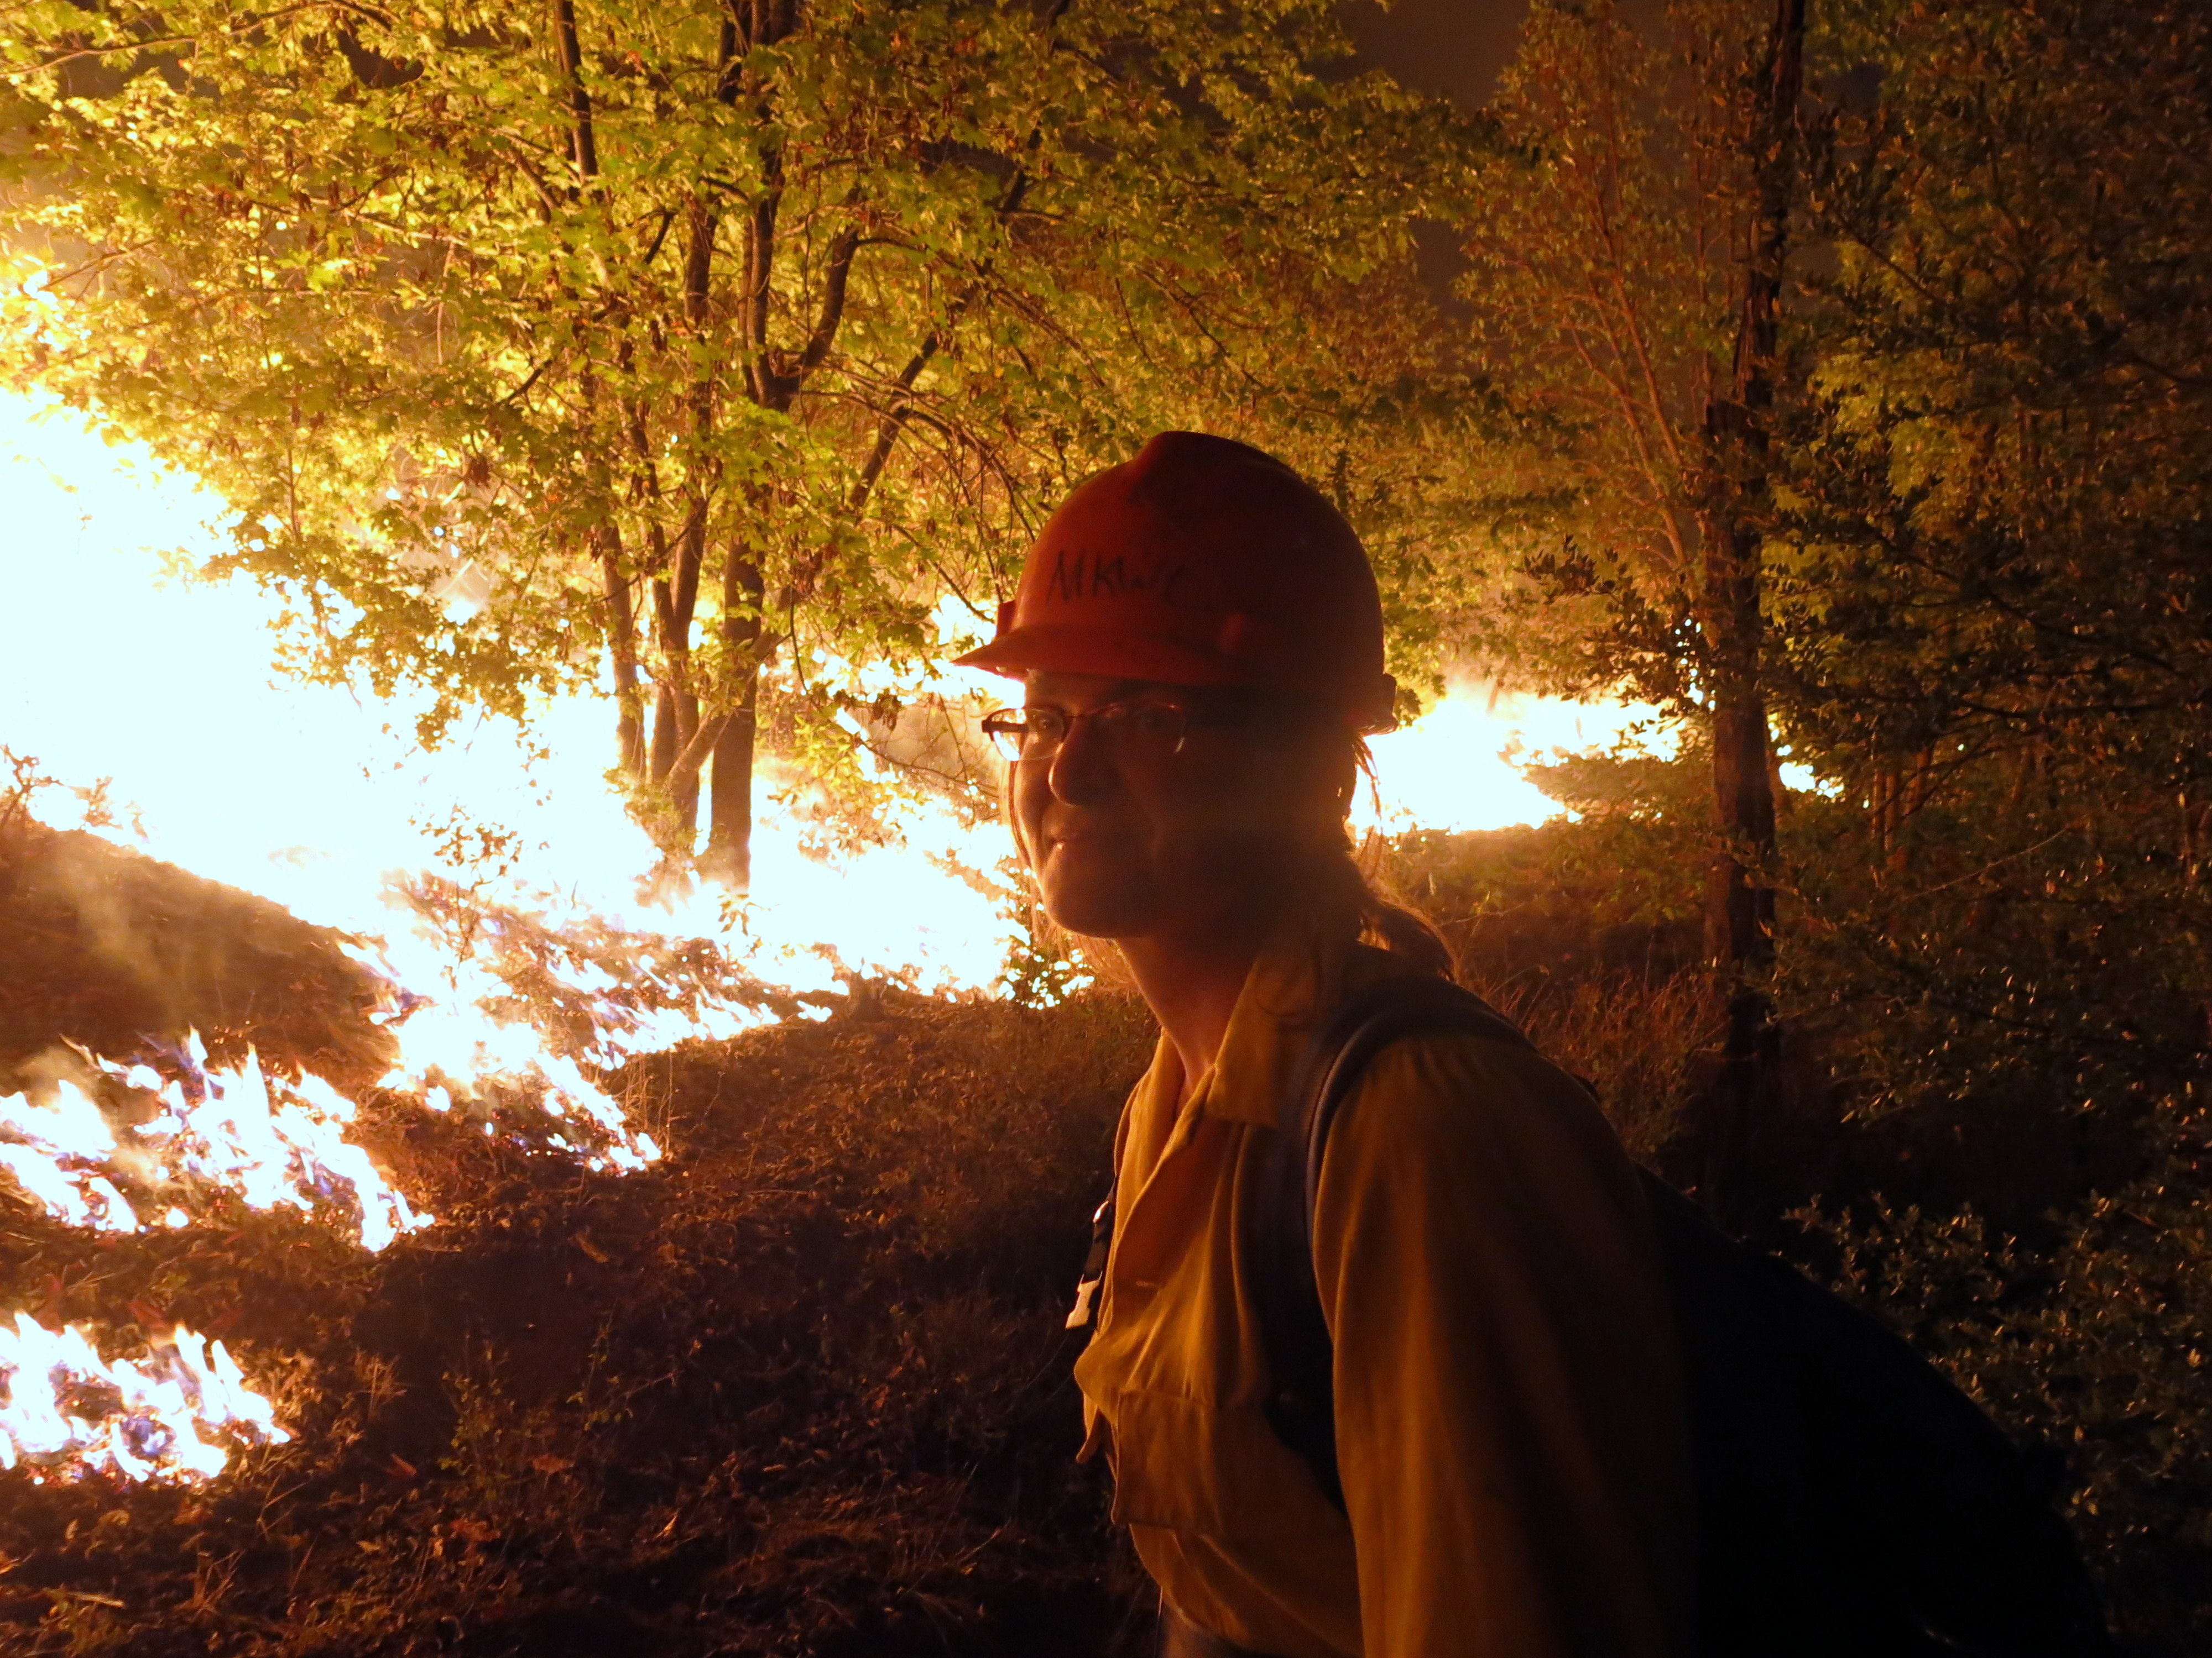
In photo: Karuna Greenberg Credit: Will Harling

INCIDENT ACTION PLAN
DAY 3: 10/03/2014


FIRE LEARNING NETWORK

ICS Form 202

INCIDENT OBJECTIVES | 1. INCIDENT NAME  2014 KLAMATH RIVER TREX |  | 2. DATE  10/03/14 | 3. TIME  07:00
4. OPERATIONAL PERIOD (DATE/TIME)
DAY 3: 10/03/2014 from 08:00 - 20:00
5. GENERAL OBJECTIVES FOR THE INCIDENT (INCLUDE ALTERNATIVES)
- PROVIDE SAFETY FOR FIRE WORKERS AND THE PUBLIC IN ALL OPERATIONS.
- CONTINUE TRAINING.
- IMPLEMENT BURN PLANS.
- CONTINUE TO MOP UP UNITS BURNED DURING PREVIOUS SHIFTS.

6. WEATHER FORECAST FOR OPERATIONAL PERIOD
SKY/WEATHER: PARTLY CLOUDY THEN BECOMING MOSTLY SUNNY. PATCHY FOG IN THE A.M.
MAX TEMP: 75 - 80º
MIN. RH: 30 - 35%.
20-FOOT WINDS: NORTHEAST WINDS 4 - 7 MPH
HAINES INDEX (HIGH): 4 (LOW)
HAINES INDEX (MID): 5 (MODERATE)
LAL: 1
CHANCE OF WETTING RAIN: 0%
7. GENERAL SAFETY MESSAGE
- DRIVING – NARROW ROADS & SPEED
- LCES
- STAY HYDRATED
- MIND FOOTING ON STEEP SLOPES
- HEADS UP FOR SNAGS
8. Attachments (☑ if attached)
Organization List (ICS 203) |  |  | Maps
Assignment List (ICS 204)
Communications Plan (ICS 205)
Medical Plan (ICS 206)

9. PREPARED BY (ASSISTANT PLANNING SECTION CHIEF)  Guy Duffner |  | 10. APPROVED BY (BURN BOSS)  Jim Wills

Organization Assignment List, ICS Form 203

ORGANIZATION ASSIGMENT LIST |  |  | 1. INCIDENT NAME | 2. DATE PREPARED |  | 3. TIME PREPARED
 |  |  | 2014 KLAMATH RIVER TREX | 10/02/14 |  | 23:30
5. INCIDENT COMMAND/STAFF  POSITION |  | NAME | 9. OPERATIONS
IC/BURN BOSS |  | TOM FIELDEN | CHIEF |  | JIM WILLS
BURN BOSS Trainee |  | SCOTT ROBISON/  JAMES TURNER | DEPUTY
SAFETY OFFICER |  | JAMES TURNER | a. DIVISION ALPHA
MEDIA LIASON |  | STORMY STAATS | BRANCH DIRECTOR |  | JAMES TURNER
BASE UNIT MANAGER |  | GUY DUFFNER | DEPUTY
6. AGENCY REPRESENTATIVES |  |  | DIVISION/GROUP
AGENCY | NAME |  | DIVISION/GROUP
TNC | GUY DUFFNER |  | DIVISION/GROUP
Forest Service
MKWC | WILL HARLING
Firestorm Inc. | JESS WILLS |  | b. DIVISION BRAVO
Karuk Tribe | BILL TRIPP |  | BRANCH DIRECTOR |  | SCOTT ROBISON
 |  |  | DEPUTY
7. PLANNING SECTION |  |  | DIVISION/GROUP
CHIEF |  | GABRIEL CORTEZ | DIVISION/GROUP
PLANNING ASSISTANT |  | GUY DUFFNER | DIVISION/GROUP
PLANNING ASSISTANT |  | JOSÉ LUIS DUCE
MAP UNIT |  | ZEKE LUNDER | c. DIVISION CHARLIE
DOCUMENTATION UNIT |  |  | BRANCH DIRECTOR |  | GABRIEL CORTEZ
DEMOBILIZATION UNIT |  |  | DEPUTY
TECHNICAL SPECIALISTS |  |  | DIVISION/GROUP
8. LOGISTICS SECTION
CHIEF |  | NANCY BAILEY | d. DIVISION DELTA
DEPUTY |  |  | BRANCH DIRECTOR |  | JIM WILLS
 |  |  | DEPUTY
 |  |  | DIVISION/GROUP
a. SUPPORT BRANCH |  |  | DIVISION/GROUP
DIRECTOR |  |  | DIVISION/GROUP
SUPPLY UNIT |  |  | DIVISION/GROUP
FACILITIES UNIT
GROUND SUPPORT UNIT |  |  | 10. FINANCE/ADMINISTRATION SECTION
 |  |  | CHIEF
 |  |  | DEPUTY
b. SERVICE BRANCH |  |  | TIME UNIT
DIRECTOR |  |  | PROCUREMENT UNIT
COMMUNICATIONS UNIT |  | GUY DUFFNER | COMPENSATION/CLAIMS UNIT
MEDICAL UNIT |  |  | COST UNIT
FOOD/KITCHEN UNIT
PREPARED BY ASSISTANT PLANS UNIT
GUY DUFFNER AND JOSE LUIS DUCE

Assignment List, ICS Form 204

1. BRANCH |  |  |  | 2. DIVISION/GROUP  ALPHA |  |  |  |  |  | ASSIGNMENT LIST
3. INCIDENT NAME  2014 KLAMATH RIVER TREX |  |  |  |  |  |  |  |  | 4. OPERATIONAL PERIOD - 03
  DATE | 10/03/14 | TIME | 08:00 - 20:00
5. OPERATIONAL PERSONNEL

BURN BOSS |  |  | CREW BOSS
BURN BOSS TRAINEE | JAMES TURNER RXB2(T) |  | CREW BOSS TRAINEE

6. RESOURCES ASSIGNED TO THIS PERIOD
STRIKE TEAM/TASK FORCE/  RESOURCE DESIGNATOR |  |  | Position |  |  |  | Leader | Trainee |  |  | EMT | Vehicles |  |  |  | Notes
JOSHUA BRADLEY CRWB |  |  |  |  |  |  |  |  |  |  |  | E9906
ROMMEL VANCE FFT1
ERIC NELSON FFT2
PATRICIA LAI FFT2
SKIP LOWRY FFT2(T)
RAY NICHOLS FFT2(T)
BRIAN SOUZA FFT2(T)
WILLY WEBB FFT2(T)
JACLYN GOODWIN FFT2(T)
7. CONTROL OPERATIONS

8. SPECIAL INSTRUCTIONS

- MOP UP 50’-- PULL BACK AND UTILIZE HOSE LAYS, AND PATROL ALL BLUE RIDGE UNITS.
- ALLOW 1000 HR FUELS TO BURN.
- RADIO CHANNEL 2 (TAC 1).

FUNCTION | FREQ. | SYSTEM |  |  |  | CHAN. |  | FUNCTION |  |  |  |  | FREQ. |  | SYSTEM |  | CHAN.
PREPARED BY (ASSISTANT PLANNING SECTION)  GUY DUFFNER AND JOSE LUIS DUCE |  |  |  |  | APPROVED BY  BURN BOSS (JIM WILLS)

Assignment List, ICS Form 204

1. BRANCH |  |  |  | 2. DIVISION/GROUP  BRAVO |  |  |  |  |  | ASSIGNMENT LIST
3. INCIDENT NAME  2014 KLAMATH RIVER TREX |  |  |  |  |  |  |  |  | 4. OPERATIONAL PERIOD - 03
  DATE | 10/03/14 | TIME | 08:00 - 20:00
5. OPERATIONAL PERSONNEL

BURN BOSS |  | CREW BOSS
BURN BOSS TRAINEE | SCOTT ROBISON RXB2(T) | CREW BOSS TRAINEE

6. RESOURCES ASSIGNED TO THIS PERIOD
STRIKE TEAM/TASK FORCE/  RESOURCE DESIGNATOR |  |  | Position |  |  |  | Leader | Trainee |  |  | EMT | Vehicles |  |  |  | Notes
TOBEY BEHR FFT1(T) |  |  |  |  |  |  |  |  |  |  |  | E9908
TYSON LOWE FFT2
JILL BECKMANN FFT2
KARUNA GREENBERG FFT2(T)
SAM BERRY FFT2(T)
PRISCELLA KINNEY FFT2(T)
ANDREW GOLDMAN FFT2(T)
KAT NAVARRO FFT2(T)
DYLAN SULLIVAN FFT2(T)
7. CONTROL OPERATIONS

8. SPECIAL INSTRUCTIONS

- MOP UP 50’ -- PULL BACK AND UTILIZE HOSE LAYS, AND PATROL ALL GODFREY/BERRY UNITS.
- RADIO CHANNEL 3 (TAC 2).

FUNCTION | FREQ. | SYSTEM |  |  |  | CHAN. |  | FUNCTION |  |  |  |  | FREQ. |  | SYSTEM |  | CHAN.
PREPARED BY (ASSISTANT PLANNING SECTION)  GUY DUFFNER AND JOSE LUIS DUCE |  |  |  |  | APPROVED BY  BURN BOSS (JIM WILLS)

Assignment List, ICS Form 204

1. BRANCH |  |  | 2. DIVISION/GROUP  CHARLIE |  |  |  |  |  | ASSIGNMENT LIST
3. INCIDENT NAME  2014 KLAMATH RIVER TREX |  |  |  |  |  |  |  | 4. OPERATIONAL PERIOD - 03
  DATE | 10/03/14 | TIME | 08:00 - 21:00
5. OPERATIONAL PERSONNEL

BURN BOSS |  | CREW BOSS
BURN BOSS TRAINEE | GABRIEL CORTEZ RXB2(T) | CREW BOSS TRAINEE

6. RESOURCES ASSIGNED TO THIS PERIOD
STRIKE TEAM/TASK FORCE/  RESOURCE DESIGNATOR |  | Position |  |  |  | Leader | Trainee |  |  | EMT | Vehicles |  |  |  | Notes
JOSE TENORIO RXB2(T) |  |  |  |  |  |  |  |  |  |  | SLIP 200
GABRIEL CAHALAN RXB3(T) |  | SQUAD LDR
ZEKE LUNDER FFT1(T)/FIRB(T)
RICK O'ROURKE FFT2(T)
TANYA CHAPPLE FFT2(T)
MARK DUPONT FFT2(T)
COLLEEN ROSSIER FFT2(T)
ORION MARLEY FFT2(T)
SCOTT HARDING FFT2(T)
MICHAEL ENCISO FFT2(T)
HEATHER RICKARD FFT2(T)
AJA CONRAD FFT2(T)
ANDREW SOMERS FFT2(T)
NIKOLAS BERTULIS FFT2(T)
7. CONTROL OPERATIONS

8. SPECIAL INSTRUCTIONS
- TENORIO, SOMERS, CHAPPLE:
- MOP UP AND PATROL BEAVER UNIT IN THE A.M.
- REINFORCE LINE ON SOUTHERN END OF BEAVER UNIT.
- O’ROURKE AND LUNDER:
- SCOUT YUROK UNITS AND TAKE WEATHER OBS A.M. AND P.M.
- CORTEZ AND REMAINING CREW:
- COMPLETE PREP WORK ON TSHANIK UNIT.
- VEHICLES TO BE ASSIGNED.
- RADIO CHANNEL 1 (COMMAND).
FUNCTION | FREQ. | SYSTEM |  |  | CHAN. |  | FUNCTION |  |  |  |  | FREQ. |  | SYSTEM |  | CHAN.
PREPARED BY (ASSISTANT PLANNING SECTION)  GUY DUFFNER AND JOSE LUIS DUCE |  |  |  | APPROVED BY  BURN BOSS (JIM WILLS)

Assignment List, ICS Form 204

1. BRANCH |  |  |  | 2. DIVISION/GROUP  DELTA |  |  |  |  |  | ASSIGNMENT LIST
3. INCIDENT NAME  2014 KLAMATH RIVER TREX |  |  |  |  |  |  |  |  | 4. OPERATIONAL PERIOD - 03
  DATE | 10/03/14 | TIME | 08:00 - 20:00
5. OPERATIONAL PERSONNEL

BURN BOSS | JIM WILLS | CREW BOSS
BURN BOSS TRAINEE |  | CREW BOSS TRAINEE

6. RESOURCES ASSIGNED TO THIS PERIOD
STRIKE TEAM/TASK FORCE/  RESOURCE DESIGNATOR |  |  | Position |  |  |  | Leader | Trainee |  |  | EMT | Vehicles |  |  |  | Notes
KEN MAPPLES |  |  |  |  |  |  |  |  |  |  |  | E9905
ADAM HICKL FIRB(T)
JOSE LUIS DUCE
SAMUEL COMMARTO FFT1(T)
BROCK LUEDTHE FFT2
WILL HARLING
7. CONTROL OPERATIONS
- RAINBOW UNIT I, II, III, IV, AND V (20.5 ACRES)
8. SPECIAL INSTRUCTIONS

- IMPLEMENT BURN PLAN.
- RADIO CHANNEL 4 (TAC 3).

FUNCTION | FREQ. | SYSTEM |  |  |  | CHAN. |  | FUNCTION |  |  |  |  | FREQ. |  | SYSTEM |  | CHAN.
PREPARED BY (ASSISTANT PLANNING SECTION)  Guy Duffner and Jose Luis Duce |  |  |  |  | APPROVED BY  BURN BOSS (JIM WILLS)

Incident Communications Plan, ICS Form 205

INCIDENT RADIO COMMUNICATIONS PLAN |  |  |  |  | 1. Incident Name |  | 2. Date/Time Prepared | 3. Operational Period Date/Time
 |  |  |  |  | 2014 KLAMATH RIVER TREX |  | 10/03/14  22:30 | 10/03/14  08:00-20:00
4. Basic Radio Channel Utilization
System/Cache | Channel | Rx Frequency | Code Guard | Tx Frequency |  | Code Guard | Remarks
COMMAND | 1 | 151.625 | 000.0 | 151.625 |  | 000.0 | DIVISION CHARLIE
TAC 1 | 2 | 151.7600 | 000.0 | 151.760 |  | 000.0 | DIVISION ALPHA
TAC 2 | 3 | 151.505 | 000.0 | 151.505 |  | 000.0 | DIVISION BRAVO
TAC 3 | 4 | 151.11500 | 000.0 | 151.11500 |  | 000.0 | DIVISION DELTA
KARUK REPEAT CHANNEL | 5 | 156.16500 | 000.0 | 151.11500 |  | 103.5
FOREST RPT | 6 | 168.725 | 000.0 | 170.125 |  | 110.9

Phone List
NAME | TELEPHONE | NOTE
MID KLAMATH WATERSHED COUNCIL | (530) 627-3202
USFS ORLEANS RANGER DISTRICT | (530) 627-3291
CAL FIRE (HUMBOLDT DEL NORTE) | (707) 725-4413
HOOPA FIRE DEPT. | (530) 625-4366
NORTH COAST AIR QUALITY | (707) 443-3093
ORLEANS VOLUNTEER FIRE AND MEDICAL | CALL 911 ASK FOR FORTUNA DISPATCH
WILL HARLING | (530) 509-5017 HOME
TOM FIELDEN
Cadre:
5. Prepared by (ASSISTANT PLANNING SECTION)

GUY DUFFNER AND JOSE LUIS DUCE

Medical Plan (206)
- Name of the Incident:  KLAMATH RIVER 2014 TREX |  |  |  | 2. Operational Period: 03 Date: 10/03/14  Time. From: 08:00 To: 21:00
3. Incident Medical Aid Station:
Medical Aid Stations: |  | Location |  |  |  |  | Phone
Karuk Community Clinic |  | 64236 2nd Ave, Happy Camp, CA 96039 |  |  |  |  | (530) 493 5257
Orlean Medical Clinic |  | 39051 Highway 96, Orleans, CA 95556 |  |  |  |  | (530) 627-3452
Yreka Immediate Care Clinic |  | 534 North Main St. Yreca CA 96097 |  |  |  |  | (530) 842-0606
4. Transportation:
- AMBULANCE SERVICES
Name |  | Address |  |  |  |  | Phone
Happy Camp Ambulance |  |  |  |  |  |  | 911
Mt Shasta Ambulance |  | 120 Oak St. Mt Shasta CA 96067 |  |  |  |  | 530-926-3420 or 2665N ( Paramedics)
Hoopa Ambulance |  |  |  |  |  |  | 911
Mercy Helicopter (Medford) |  |  |  |  |  |  | 911
5. Hospitals:
Name | Address |  | Phone |  | Travel Time | Trauma |  | Burn Center | Helipad
Fairchild Medical Center | 444 Bruce St. Yreka CA |  | 530-842-4121 |  | 1h 30’ | x Yes |  | No | X Yes
Rouge Valley Medical Cntr | 2825 E. Barnette Rd Medford, OR |  | 541-789-7000 |  | 2h 15’ | x Yes |  | No | X Yes
Mercy Medical Center | 2175 Roseline Ave Redding CA |  | 530-225-6000 |  | 1h air amb | x Yes |  | No | X Yes
Mad River Hospital | 3800 Janes Rd. Arcata, CA |  | 707-822-3621 |  | 1h 30’ | X Yes |  | No | X Yes
6.Medical Emergency Procedures:
Stop all operations if safe to do so, contact EMS for for evaluation and transport, notify IC. IC will notify Tribal Chairman or Vice Chairman and Unit safety officer (Set up or use family notification procedures already established).

OTHER EMERGENCY FACILITIES
- Willow Creek Family Health: (707) 826-8633
- St. Joseph’s Hospital: (707) 269-4240
- Shasta Regional Medical Center/Redding Hospital (530) 244-5400
- UC Davis Burn Center (916) 734-2011
7. Prepared by: ASSISTANT PLANNING SECTION: GUY DUFFNER AND JOSE LUIS DUCE
8. Reviewed by: LAUREL PEÑA (EMT)

