Walleye Stream Potential Habitat
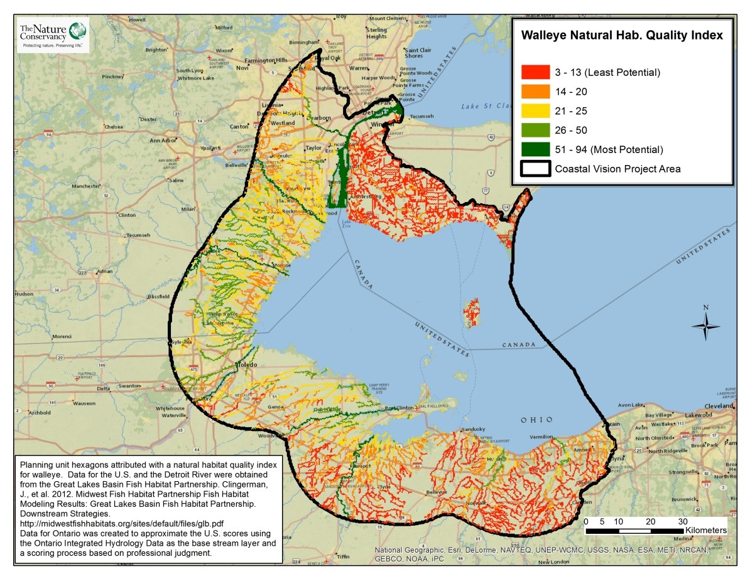
Take Home Points

- High quality stream habitats are crucial to maintaining the fish populations in the WLEB.

- Threats to stream habitats: dams, stream crossings, pollution, sediment contamination, invasive species and climate change.

- Walleye stream habitat is used as a proxy for other native migratory fish.

- The LEBCS established a goal of connecting at least 50% of each stream type to Lake Erie by 2030.
Walleye Stream Potential Habitat: The WLEB analysis area is outlined in black, with the habitat quality score for each stream indicated by a color gradient from red (low quality) to green (high quality).

Walleye stream potential habitat in relation to regional ecological and social values
This data layer uses walleye stream potential habitat as a proxy to represent all native migratory fish in the Western Lake Erie Basin (WLEB). Walleye (Sander vitreus) and other sport fish species are worth tens of millions (US$) to the WLEB economy; walleye and sauger are especially popular, luring 0.6 million of the 1.7 million anglers who contributed US$1.9 billion to the Great Lakes basin’s economy in 2011¹. There are at least 30 species supplying the fishing industry in the Lake Erie basin that rely on streams for spawning; it is essential to preserve the accessibility and overall quality of tributary spawning habitat in order to sustain these fish populations². The vital connection between upstream habitats and Lake Erie has been difficult to maintain due to the installation of hydroelectric dams, poorly designed road-stream crossings, and various structures to alleviate storm and erosion damage, including dams and sea walls³. Other threats to the quality of stream habitats include non-point source pollution from agricultural and urban land, the contamination of sediments with toxic compounds, the presence of competitive or parasitic invasive species (e.g. sea lamprey), and temperature increases from climate change⁴. The Western Lake Erie Coastal Conservation Vision Project recognizes the ecological and socioeconomic importance of maintaining healthy stream habitat for fish populations like walleye, and therefore includes this data layer to ensure that stream habitat quality is incorporated into the optimization of areas for conservation.

Walleye stream habitat layer
The Lake Erie Biodiversity Conservation Strategy (LEBCS) established a goal of having at least 50% of each stream type– based on the Midwest Fish Habitat Partnership classification⁵–connected to Lake Erie in order to provide access to spawning areas for migratory fish⁶. The WLECCV includes this data layer to help stakeholders achieve the LEBCS goal by ensuring that the highest predicted quality stream habitat is included when determining optimal areas for conservation. To create this data layer for the U.S., the National Fish Habitat Partnership (NFHP) assessed fish habitat and identified 19 natural habitat characteristics that were then used to calculate potential habitat quality for walleye species in particular. Natural habitat characteristics that most influenced potential habitat quality were the drainage area of a stream’s watershed, wetland area in the watershed, mean annual precipitation, modeled stream temperature, and slope of the watershed.
Data for the Ontario side of the basin was created to approximate the U.S. index scores using the Ontario Integrated Hydrology data as the base stream layer and a scoring process based on professional judgment. Based on personal communication from Ontario fisheries professionals at a stakeholder workshop held in Essex, Ontario, in October of 2014 all of the streams in this portion of Ontario should receive a “poor” score for walleye habitat. We assigned habitat scores based on steam size by assigning headwater streams a score of 5; creeks a score of 10; and small rivers a score of 15.
Data sources and potential limitations
The data used for this layer on the U.S. side of the basin were obtained from the Great Lakes Basin Fish Habitat Partnership⁷. It should be noted that while walleye are an important migratory species in the WLEB, it would be ideal to include other migratory species in this analysis; such data is currently not available for the WLEB, although a current mapping project underway at The Nature Conservancy may make it available in the future. In addition, the walleye habitat index scores developed for Ontario streams are only an approximation and were not developed with as much rigor as the Great Lakes Basin Fish Habitat Partnership data available in the U.S.

Related Human Well-being layers: Recreational Fishing, Commercial Fishing

References and Links
- 2011 National Survey of Fishing, Hunting, and Wildlife-Associated Recreation. August 2012. USFWS.
http://www.doi.gov/news/pressreleases/upload/FWS-National-Preliminary-Report-2011.pdf
- Pearsall, D., et al. 2012. Returning to a Healthy Lake: Lake Erie Biodiversity Conservation Strategy. Technical Report. A joint publication of The Nature Conservancy, Nature Conservancy of Canada, and Michigan Natural Features Inventory. 340 pp. with Appendices.
http://www.conservationgateway.org/ConservationByGeography/NorthAmerica/UnitedStates/michigan/Pages/lakeerie.aspx
- Clingerman, J., et al. 2012. Midwest Fish Habitat Partnership Fish Habitat Modeling Results: Great Lakes Basin Fish Habitat Partnership. Downstream Strategies. http://midwestfishhabitats.org/sites/default/files/glb.pdf
- Pearsall, D., et al. 2012. Returning to a Healthy Lake.
Clingerman, J., et al. 2012. Midwest Fish Habitat Partnership Fish Habitat Modeling Results: Great Lakes Basin Fish Habitat Partnership. Downstream Strategies.
Contact
Gust Annis
The Nature Conservancy
gannis@tnc.org

