Shipwrecks (Dive Sites)
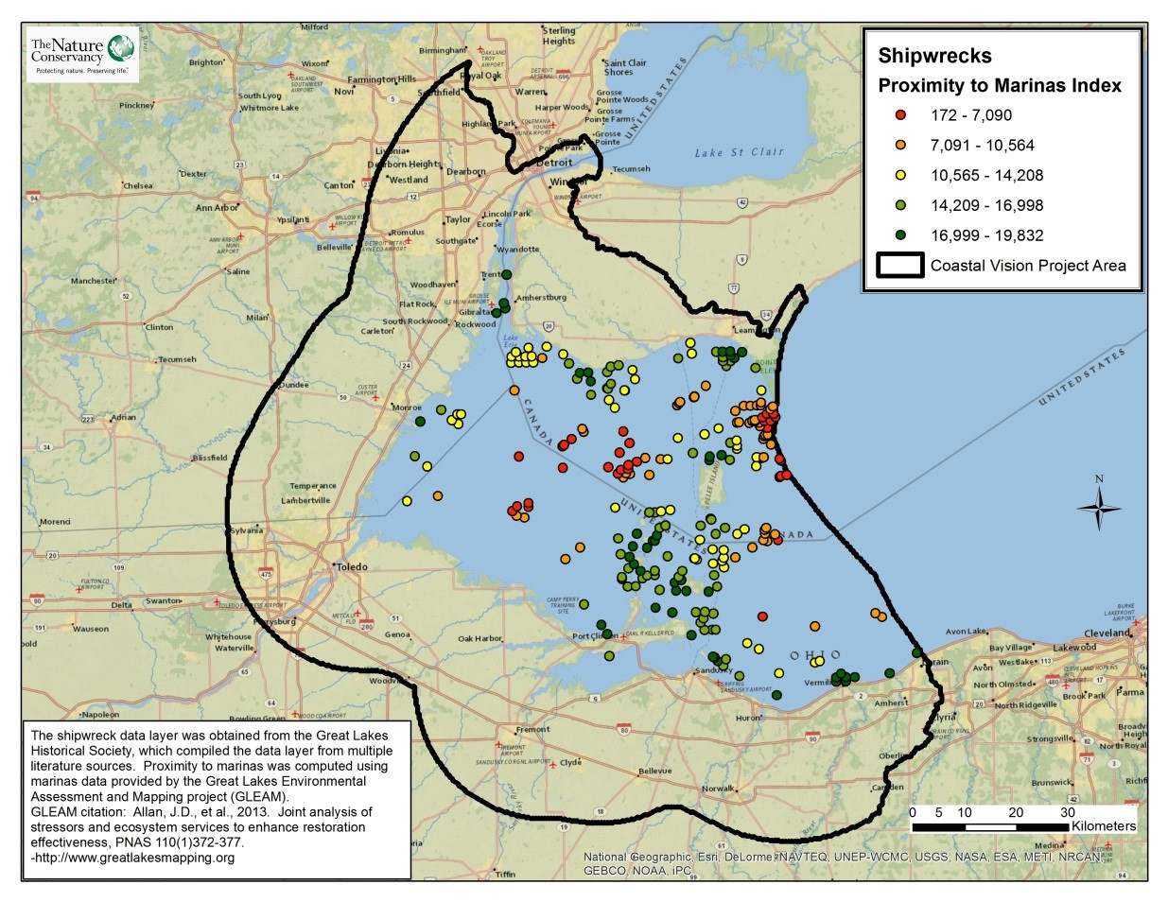
Take Home Points
- There are nearly 300 shipwrecks in the Western Lake Erie Basin, many of which are easily accessible.

- Shipwrecks are managed as a public trust, and serve as an important historical and cultural resource.

- Divers visiting Lake Erie contribute to the local economy.

Shipwrecks (Dive Sites). Here shipwrecks are shown as points colored according to predicted visitation rates based on proximity to marinas, with green indicating high predicted visitation rates and red indicating low rates. The WLEB analysis area is outlined in black.

Shipwreck dive sites in relation to regional ecological and social values
There are more than 6,000 shipwrecks in the Great Lakes, with 286 in the Western Lake Erie Basin (WLEB). Shipwrecks are considered an irreplaceable cultural resource that provides a historical record for researchers and freshwater recreation for residents in the Great Lakes. Shipwrecks include military, commercial, and private vessels and are managed as a public trust. With the strong support of local diving groups, Ontario, Ohio, and Michigan have passed laws that prevent the removal or damage of shipwrecks and related artifacts in the Great Lakes¹. Archaeologists and recreational divers value the pristine condition of shipwrecks in the lakes’ fresh, cold waters relative to those found in salt water. Many of the shipwrecks in Lake Erie are located in shallow, easily accessible waters, which increase the appeal of these sites for divers. Divers drawn to Lake Erie often rent gear, take charter boats to wreck sites, and pay for food and lodging during their trip, which contributes to the WLEB tourism revenue; in 2011, the Lake Erie coastal and island tourism industry as a whole brought $1.6 billion to Ohio alone². A survey of natural resource professionals in the WLEB found that recreation and tourism is the most highly valued service provided by Lake Erie. Shipwrecks have been included in the analysis in recognition of their recreational and historic importance, and their corresponding economic value to the region.
Related Ecological data layers: Walleye Lake Habitat

Shipwrecks (Dive Sites) data layer
This data layer shows shipwreck locations in relation to marinas throughout the Western Lake Erie Basin (WLEB). In the analysis, the shipwrecks included in this layer were valued according to their proximity to marinas, with the assumption that wrecks closest to marinas will have the greatest value to local economies. The shipwreck data layer was obtained from the Great Lakes Historical Society, which compiled the data layer from multiple literature sources. The marinas layer was compiled by the Great Lakes Environmental Assessment and Mapping Project (GLEAM) and used for the valuation of individual shipwrecks.
Data sources & potential limitations
The shipwreck data layer was obtained from the Great Lakes Historical Society, which compiled the data layer from multiple literature sources. Proximity to marinas was computed using marinas data provided by the Great Lakes Environmental Assessment and Mapping Project (GLEAM)³.

References & Links
- http://www.michigan.gov/deq/0,4561,7-135-3313_3677_3701-14514--,00.html ; http://seanags.com/WreckLaw.pdf ; http://www.mynewwaterfronthome.com/shipwrecks.aspx
- Bauer, J. 2012. Economic impact of tourism in Lake Erie shores & islands reveals nearly $1.6 billion in visitor spending. Lake Erie Shores & Islands.
- Allan, J.D., et al. 2013. Joint analysis of stressors and ecosystem services to enhance restoration effectiveness, PNAS 110(1)372-377. <http://www.greatlakesmapping.org>.

Contact
Gust Annis
The Nature Conservancy in Michigan
gannis@tnc.org

