Recreational Boating
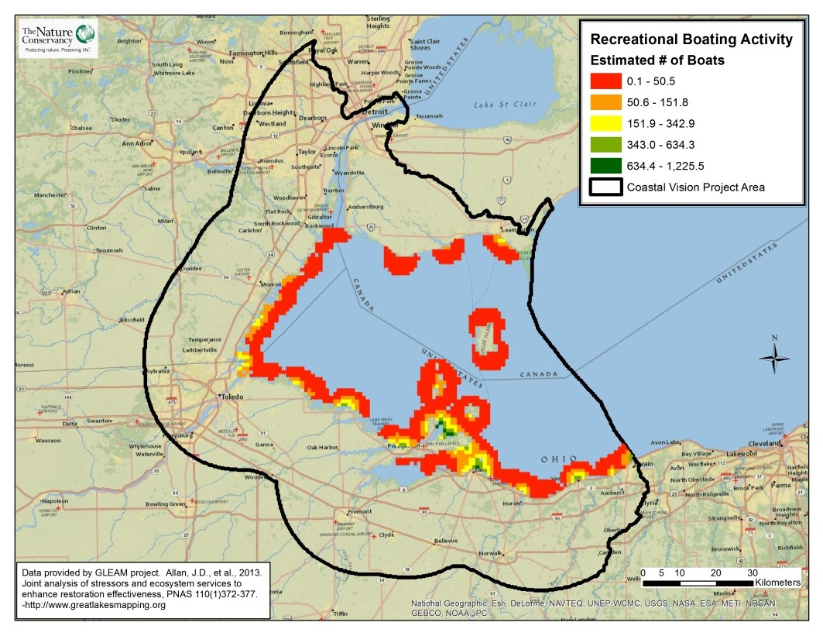
Take Home Points
- Recreational boating opportunities attract visitors from across the country to the WLEB.

- Over 2.56 million boats are registered in the region.

- Average expenditures related to boating activities average over $15,000 per user.

- This layer shows the estimated density of boating near marinas in the WLEB.

Recreational Boating. The estimated number of boats on the water near marinas is shown on a gradient from green to red, with green being the highest density of boats. The WLEB analysis area is outlined in black.

Recreational boating in relation to social and ecological issues
Boating offers individuals a variety of opportunities to recreate on the water, ranging from fishing to waterskiing to sailing. Recreational boating attracts visitors and other sportsmen from across the country to the Western Lake Erie Basin (WLEB). Recreational boating comprises a significant segment of the recreational use of the WLEB, with the Great Lakes Commission estimating that 2.56 million boats were registered in Michigan, Ohio and Ontario alone¹. In total, over one-third of all boats registered in the U.S. call a Great Lakes state home. Pleasure-craft users average $15,626 in annual spending related to boating, directly supporting over 107,000 jobs throughout the Great Lakes². The success of the boating industry in western Lake Erie is highly-dependent on lake levels, as many marinas are connected to the lake by very shallow channels. Since the early 2000’s, Lake Erie has experienced near-record low lake levels, straining already depleted funds for dredging, closing boat slips in marinas and grounding vessels³. In 2016, lake levels have rebounded to more typical levels, however further stress on the ecosystem through climate change could impact lake levels and recreational boaters in the long-term. The recreational boating data layer was included in the Marxan analysis to highlight waters within the WLEB that are considered valuable by boaters.
Related Ecological layers: Walleye Lake Habitat, Migratory Bird Stopover Habitat
Recreational Boating data layer
This layer shows the estimated density of boaters in the WLEB, with the greatest density of boats expected nearest to marinas. The number of boating slips at each marina in the WLEB was obtained from the GLEAM research team, who multiplied by the average slip occupancy rate for 2004, and extrapolated to reflect decreased boating activity as distance from a marina increases.

Data sources and potential limitations
The recreational boating data layer was obtained through the Great Lakes Environmental Assessment and Mapping Project (GLEAM; received August 2013)⁴. This dataset may not be truly indicative of highly valued waters to boaters, as it is consists of predictions based on boat slips rather than on actual data gathered for boating activity. Recreational boating activity within the Detroit River was not available.
References and links
- http://glc.org/files/docs/2007-rec-boating-economic-punch.pdf
- http://www.greatlakes-seaway.com/en/recreational/cruising-the-seaway/cruises_facts.html and http://glc.org/files/docs/2007-rec-boating-economic-punch.pdf
- http://www.glerl.noaa.gov/data/now/wlevels/dbd/
- Allan, J.D., et al. (2013) Joint analysis of stressors and ecosystem services to enhance restoration effectiveness, PNAS 110(1) 372-377. Available online via: http://www.greatlakesmapping.org

Contact
Gust Annis
The Nature Conservancy
gannis@tnc.org

