Commercial Fishing
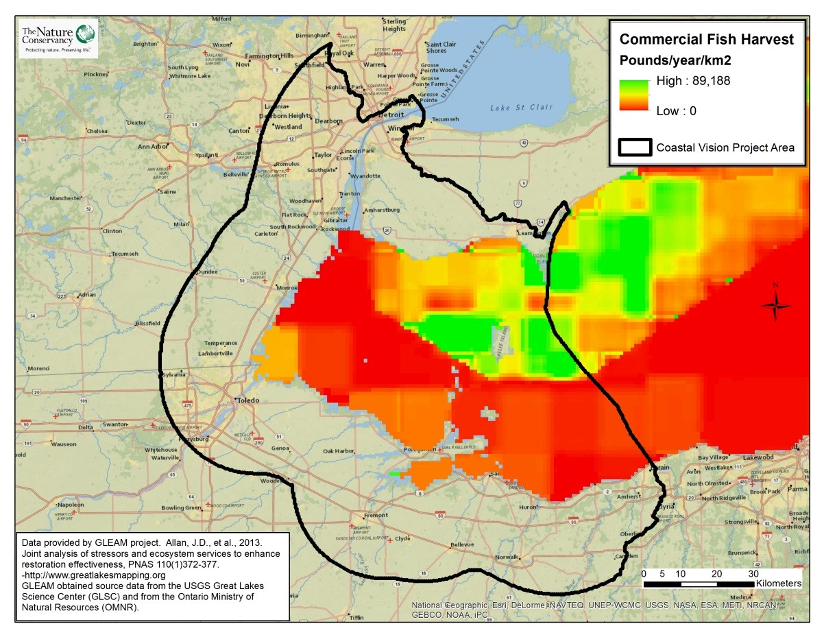
Take Home Points
- Millions of pounds of fish are harvested annually from Western Lake Erie

- This harvest contributes substantially to the region’s economy and is dependent on the proper management and protection of fish populations

- The commercial fishing layer shows the annual catch in different areas of the Western Basin

Commercial Fishing. The density of commercial fishing harvest is shown on a gradient from green to red, with green representing the greatest catch size per km². The WLEB analysis area is outlined in black.

Commercial fishing in relation to regional ecological and social values
The Great Lakes provide commercial fishermen with an annual average harvest of nearly 50 million pounds¹. Lake Erie supports the largest commercial fishery, which consists primarily of walleye (Sander vitreus) and yellow perch (Perca flavescens)². Fishermen from Ohio alone harvested 4.8 million pounds of fish—primarily yellow perch, white bass, white perch, and lake whitefish—worth an estimated US$5.8 million, from Lake Erie in 2012; more than one third of this catch (38.5%) was obtained from the Western Basin³. In 2012, Michigan commercial fishermen caught approximately 1.4 million pounds of fish—primarily carp (Cyprinidae), bigmouth buffalo (Ictiobus cyprinellus), sheephead (Aplodinotus grunniens), channel catfish (Ictalurus punctatus), and gizzard shad (Dorsoma cepadianum)—in Lake Erie, worth US$553,155⁴. The Ontario commercial catch in 2011 was about 26.5 million pounds, worth more than CA$33 million. In general, 80% of the value of Ontario’s commercial fishery is harvested from Lake Erie, where the catch consists mostly of walleye and yellow perch⁵. Although the scale of the fishery in Lake Erie is impressive, it is only three-quarters of its historic size⁶. In the face of pressure from over-fishing, pollution, habitat destruction, and exotic species, it is essential that we effectively manage the health and subsequent yield of remaining fish populations. This layer is included to ensure that the needs of commercial fishing interests are considered in the analysis.
Related Ecological layers: Walleye Spawning Areas, Walleye Lake Habitat, Walleye Stream Habitat, Coastal Wetlands

Commercial Fishing data layer
These data were compiled by the Great Lakes Environmental Assessment and Mapping Project (GLEAM) team using data obtained from the USGS Great Lakes Science Center (GLSC) and the Ontario Ministry of Natural Resources (OMNR). It shows the commercial catch by 10-minute grid cell for the U.S. side of Lake Erie and 5-minute grid cell for the Canadian side. The data for Canada represent round pounds⁷ per year per km² for 2000 through 2009; for the US, the data represent round pounds per year per km² over the years 1998 through 2007⁸. The GLEAM project down-scaled the data to 1-km pixels using the cubic convolution algorithm in ArcGIS and assuming equal distribution of harvest within each reporting unit. We attributed our 10-ha planning units based on the harvest value at the center point of each hexagon. The resulting map above shows that the highest density of commercial fishing occurs on the Canadian side of the lake, as expected given the regulations on U.S. fishing.
Data sources & potential limitations
Data were obtained through personal communication with GLEAM project investigators. There are no data available for the Detroit River.
References & Links
- http://greatlakesmapping.org/great_lake_stressors/3/commercial-fishing
- http://greatlakesmapping.org/great_lake_stressors/3/commercial-fishing ; https://www.walleyecentral.com/articles/?a=1370 3. Ohio Division of Wildlife (ODW). 2013. Ohio’s Lake Erie Fisheries, 2012. Annual status report. Federal Aid in Fish Restoration Project F69-P. Ohio Department of Natural Resources, Division of Wildlife, Lake Erie Fisheries Units, Fairport and Sandusky.
http://www.dnr.state.oh.us/Portals/9/pdf/eStatus2012.pdf
- Michigan Department of Natural Resources (DNR). 2012. State-Licensed Commercial Fishing Data for Michigan. http://www.michigan.gov/documents/dnr/2012_Commercial_Fishing_Data_for_Michigan_414185_7.pdf
- http://www.mnr.gov.on.ca/en/Business/GreatLakes/2ColumnSubPage/STEL02_173913.html#Commercial_Fisheries
- http://www.epa.gov/glnpo/atlas/glat-ch3.html#Commercial Fisheries 7. Round pounds refers to the weight of a catch before processing of fish.
8. http://www.greatlakesmapping.org/great_lake_stressors/3/commercial-fishing

Contact
Gust Annis
The Nature Conservancy in Michigan
gannis@tnc.org

