Birding Visits
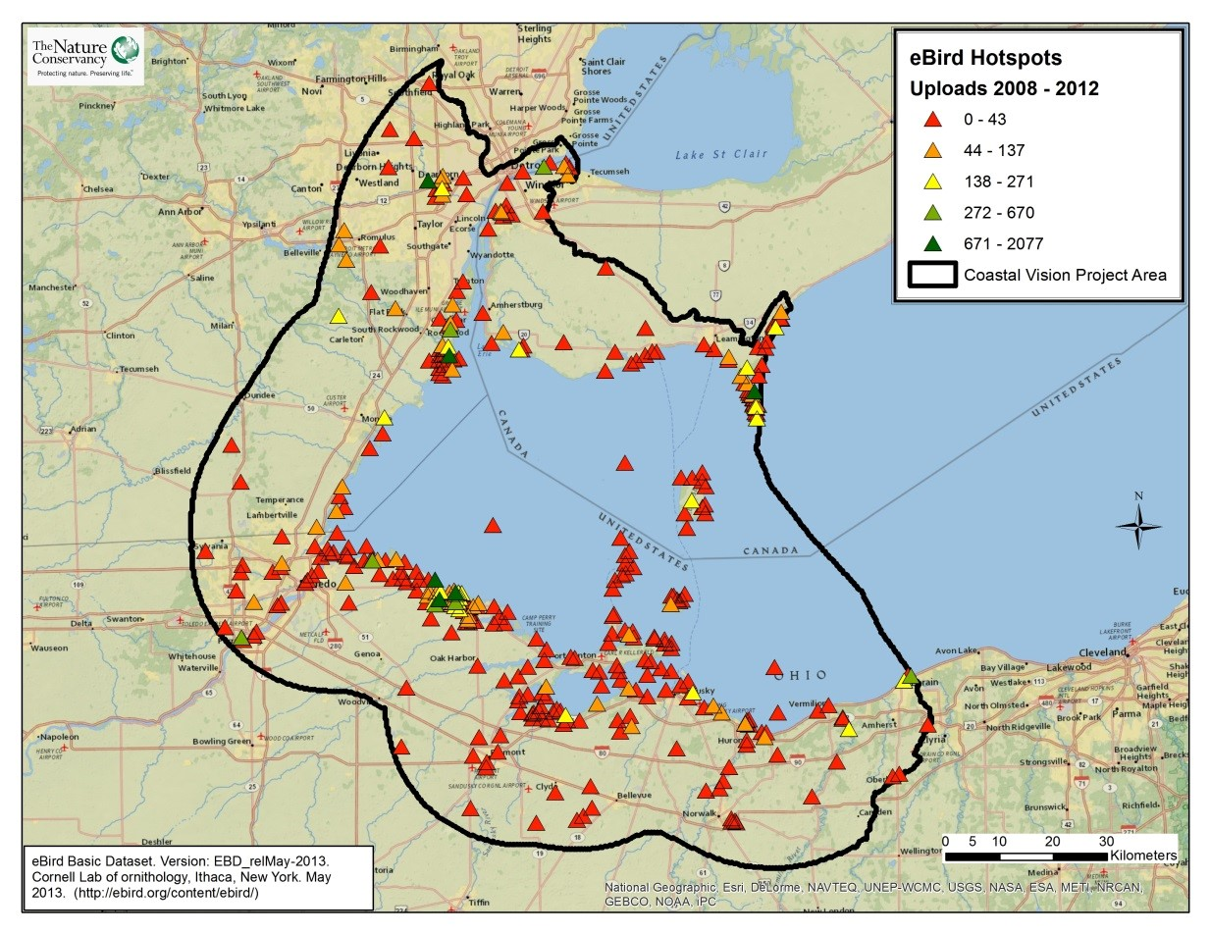
Take Home Points
- Birding contributes significantly to the local economy in the Western Lake Erie Basin.

- Crucial stopover habitat in the basin must be conserved and restored in order to provide continued birding opportunities.

- The eBird data layer can be used as a surrogate for the importance of birding to both local residents and out-of-town visitors.

Birding Visits. Popular birding hotspots are shown as triangles, with dark green indicating the most visited areas and red indicating the least visited. The WLEB analysis area is outlined in black.

Birding in relation to regional ecological and social values
Birding, a popular activity among locals and tourists, links the Western Lake Erie economy to the ecology of the region. In 2012, 71 stakeholders in the Western Lake Erie Basin (WLEB) were surveyed as part of the Lake Erie Biodiversity Conservation Strategy (LEBCS). Results showed that those stakeholders were found to value nature-based recreation, such as birding, as the number one ecosystem service provided by Lake Erie and its coasts. Millions of migratory birds use the Lake Erie coast as stopover habitat, playing an ecologically important role as insectivores and seed dispersers while simultaneously impressing birders with their diversity and large numbers. The Lake Erie coast has consequently become the most popular Ohio birding destination visited by resident and out-of-state birders. In 2006, approximately 120,000 visitors came to Ohio to bird watch¹. Popular birding sites in the region include the Lake Erie Birding Trail in Ohio, Lake Erie Metropark in Michigan, and Point Pelee National Park in Ontario. Six popular Lake Erie birding destinations in Ohio alone were found to bring in approximately $26 million² for the region’s tourism economy, which suggests a potential to grow the tourism sector of the economy of this basin. Birding and recreational activities feed into an $11.5 billion coastal tourism industry in Ohio’s seven coastal counties³ and a $12.7 billion leisure tourism industry in Michigan. This economy relies on the continued health of resident and migratory birds and the habitats they depend on, which closely ties human concerns to the biological conservation of these areas. To represent the level of intensity, and thus the potential importance, of bird watching in different places within the WLEB, we used data collected from eBird, a citizen science program run out of the Cornell Lab of Ornithology.

Related Ecological layers: Migratory Bird Stopover Habitat, Coastal Wetland Restoration

Birding Visits data layer
We used eBird data to represent birding activity in the WLEB. This data layer shows birding “hotspots”, as recorded by bird watchers, and was used to include this valued ecosystem service in the Western Lake Erie Coastal Conservation Vision analysis. The Cornell Lab of Ornithology launched eBird as a citizen science program for the public to keep an online checklist, available for use with smartphone application or the internet. Recreational and professional bird watchers record the method, location, and time of their birding trip, and then list the species heard/observed at that location. An eBird committee can designate public locations as “hotspots,” which are defined as “good birding sites that are accessible and likely to be birded by multiple people.” Users can then note that their observations were taken at these hotspots. This program was launched in 2002 and has become very popular. In August 2013, 428,043 observations of 260 bird species were made in Ohio, and 528,865 observations of 302 species were made in Michigan³
Data quality is checked by regional and local experts, which includes the approval of hotspots, and data is then made publicly available. The WLECCV analysis includes the most recent five complete years (2008 - 2012) of data recording the total number of visits at each hotspot; this data was selected from a downloaded copy of the May 2013 version of eBird data. The total number of recorded visits to each hotspot used in the analysis is proportional to the number of individuals who visited each site.
Data sources & potential limitations
Data for the eBird data layer was downloaded from Cornell University’s eBird website; data from 2008-2012 were taken from the May 2013 version of the eBird hotspot data for our analysis. The website’s data is continually updated with public use, which makes it possible to update this layer over time.
References & Links
- Worrell, Chris M. “Areas east of Cleveland heavily represented along new Lake Erie Birding Trail.” Available at:
http://www.cleveland.com/euclid/index.ssf/2011/10/areas_east_of_cleveland_heavil.html
- http://ohioseagrant.osu.edu/research/economic/?ID=R/ME-033#benefits
- http://www.lakeerieimprovement.org/wp-content/uploads/2012/02/leia-strategic-plan-final-12-17-2012.pdf
- http://tourismplan.anr.msu.edu/docs/Michigan_Tourism.pdf
- http://ebird.org/ebird/eBirdReports

Contact
Gust Annis
The Nature Conservancy
gannis@tnc.org

