Methods and Guidelines for
Assessing Restoration Progress in Prairie Fens Using
Coarse-Level Metrics

Douglas R. Pearsall and Steven S. Woods, The Nature Conservancy in Michigan, September, 2006 (updated January, 2010)

Introduction
Prairie fens in southern Lower Michigan and northern Indiana have long been a focus of conservation efforts. Most, if not all, of these fens suffer from altered hydrology, altered fire regime, and invasive species, and significant resources have been invested in restoring and maintaining fens by public agencies and private organizations. While restoration techniques have improved and there is some monitoring being carried out in individual fens, monitoring procedures have generally required botanical expertise and more time and resources than managers have to spend on monitoring. Additionally, there has been no consistent monitoring of the progress of restoration across multiple fens. Given that there are roughly 130 prairie fens in southern Michigan and tens more in northern Indiana, at least 20% of which are being actively managed, implementation of consistent measures of restoration progress in multiple managed fens would provide a valuable index of the status of fens in this part of their range.

The Nature Conservancy in Michigan has developed a set of coarse-level metrics to provide a relatively quick and inexpensive means to track the progress of restoration in prairie fens. Assessment of these metrics requires basic understanding of the ecology of fens and the behavior of fire in fens, but does not require extensive botanical expertise. They are designed so that land managers and stewards can evaluate them without relying on external botanists or ecological consultants. We first conceived and applied them in 2004 at Ives Road Fen Preserve and have since refined them and applied them also at Grand River Fen Preserve. Initially there were three metrics (percentage cover of native species, percentage cover of herbaceous species, and percent of a management unit that would carry a prescribed fire), but based on discussions in a field workshop with partners in August, 2006, we added a fourth metric: percentage cover of woody plants. This fourth metric recognizes that herbaceous and woody plants can occupy the same area (i.e., there are multiple structural layers) and that the total cover of the two can exceed 100 percent. For consistency, it was agreed that woody and herbaceous plant cover should be evaluated independently. A fifth metric, percentage cover of non-native plants was added in 2008. As with herbaceous and woody plants, the coverages of native and non-native plants are not entirely dependent and the total coverage can exceed 100 percent.

General Methods
- Divide managed area into management units (see more detailed discussion below).
- Walk through each management unit and perform visual assessment of each of the coarse-level metrics. It is recommended that the assessments be performed by at least three people familiar with fen ecology and fire management. Because these estimates are subjective, there will be variation among surveyors. The effects of variation can be diminished by taking the average value of three or more estimates,
- Record each individual estimate on field data sheet (Attachment A) and calculate the average value—this average should be used as the estimate for the individual management unit.
- Determine values for each metric for the entire preserve or managed area using the estimates for each management unit.
  - First, calculate the area of each management unit and determine proportional area of each management unit.
  - Second, calculate weighted value for each metric in each management unit by multiplying the estimated values by the proportional area.
  - Lastly, determine the sum of all weighted values for each metric across all management units.
- Establish a system of categories for rating each metric for a given ecosystem (prairie fen, shrub fen, grassland, savanna, tamarack swamp, etc…). The Conservancy typically uses the categories of Poor, Fair, Good, and Very Good when rating an indicator of viability of a natural community or a population. Therefore, we have determined thresholds for each of these categories for each of the metrics as applied to prairie fens (Attachment B). These thresholds are designed to reflect ranges that are considered meaningful with respect to restoration progress in fens and would not apply well to most upland systems or wetlands characterized by more woody vegetation.

Guidelines for field estimates
- Ensure visual access to entire unit or at least to areas that are representative of all portions of the unit.
- Evaluate each metric independently, i.e., percentage cover of herbaceous species should include plants that occur underneath woody plants. Total percentage cover of herbaceous and woody plant will often exceed 100%.
- Consider even low shrubs, such as shrubby cinquefoil (Dasiphora fruticosa), as woody species.
- The percentage of a management unit that will carry a prescribed fire should be evaluated under the assumption that internal ignition will be used when necessary. Isolated patches of flammable fuels should be included in the total percentage, but areas of homogenously thin fuels that would not carry a fire should not be included.

Establishing Management Units
Management units can be defined based on natural ecosystem boundaries or on imposed boundaries such as trails or burn breaks. Boundaries of disturbed areas, such as a ditched or plowed area, or of dense clumps of invasive species can also be used to define management units. It is recommended that management units be relatively uniform in vegetation composition and structure, and that a goal (or desired future condition) for the unit be clearly articulated. Examples of desired future condition include prairie fen, shrub fen, tamarack swamp, and hardwood swamp, and the metrics described here may be applied differently, or not at all, in units having a goal other than prairie fen.

Supplies and Equipment
This approach requires little equipment, but the following items are helpful.
- GPS unit (both for mapping unit boundaries and then relocating boundaries during field surveys)
- Aerial photographs depicting management unit boundaries.

Attachment A – Field Data Form
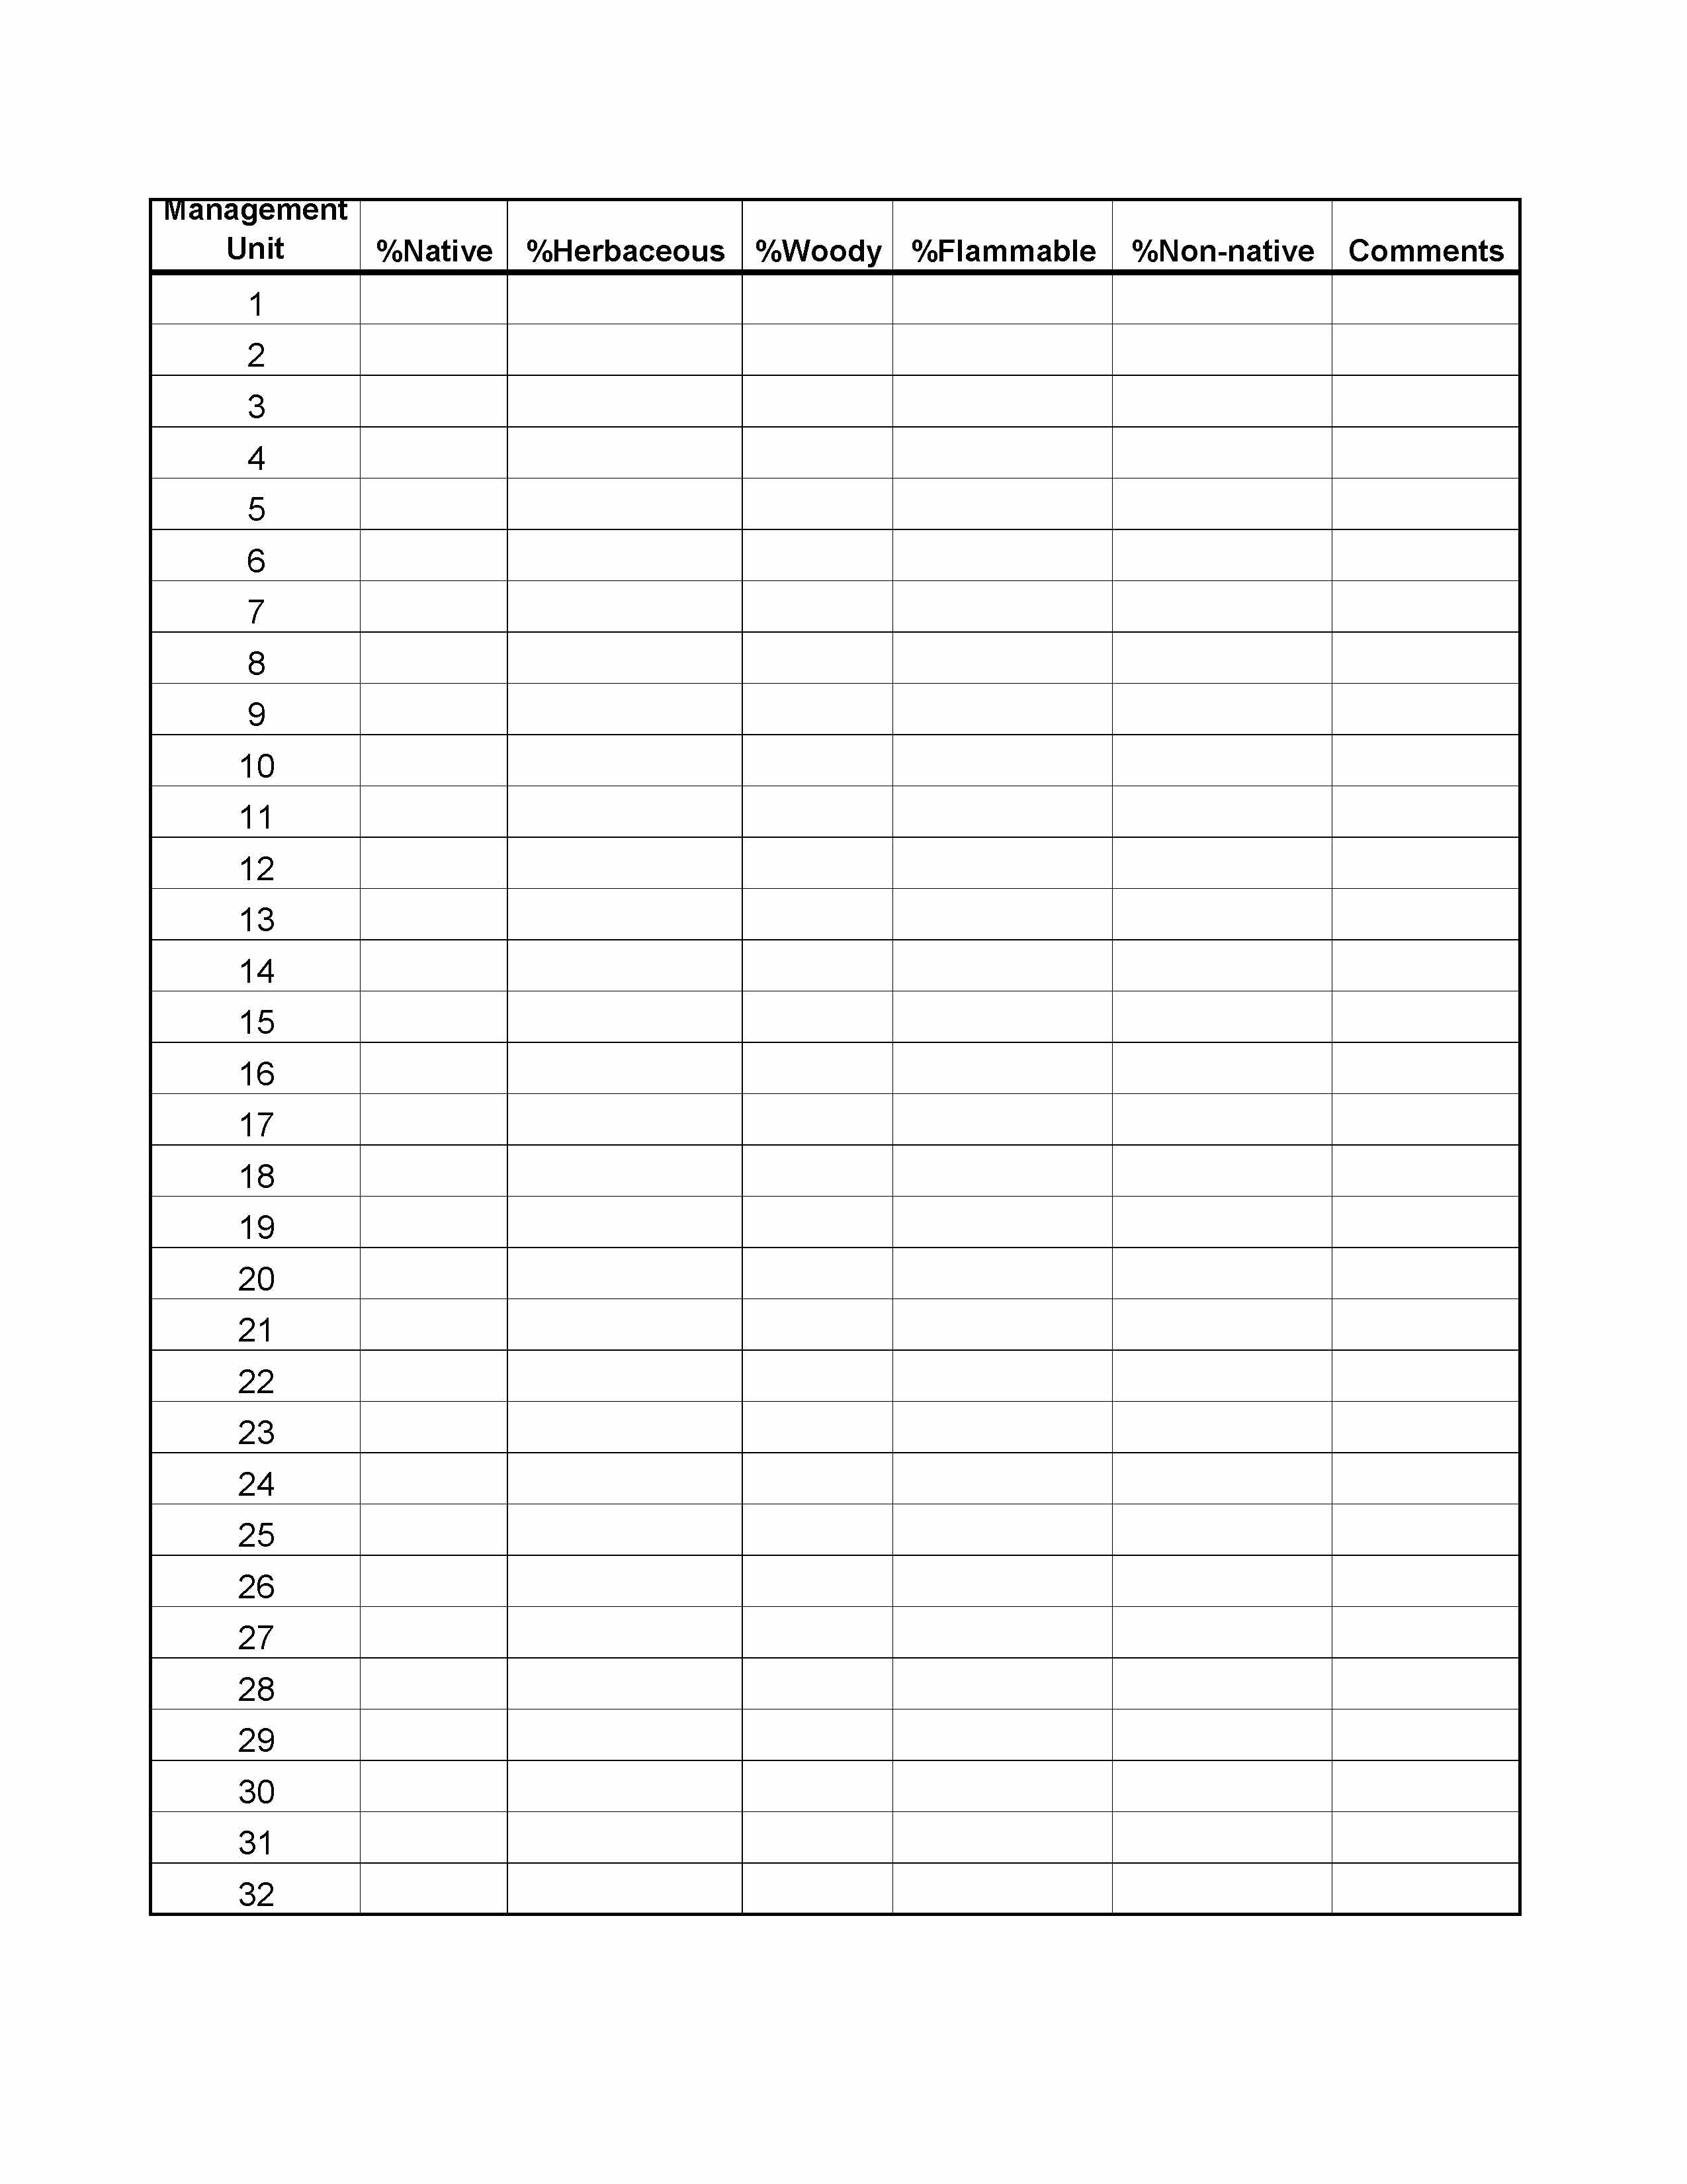
Attachment B – Category Thresholds

Classes
 | Poor | Fair | Good | Very Good
%HERB | <10 | 10 - <60 | 60 - <80 | 80 - 100
%NAT | <25 | 25 - <60 | 60 - <90 | 90 - 100
%FLAM | <10 | 10 - <60 | 60 - <80 | 80 - 100

