LANDFORMS

Introduction
Stanley Rowe called landform "the anchor and control of terrestrial ecosystems." It breaks up broad landscapes into local topographic units, and in doing so provides for (more detailed) meso- and microclimatic expression of (more general) macroclimatic character. It is largely responsible for local variation in solar radiation, soil development, moisture availability, and susceptibility to wind and other disturbance. As one of the five "genetic influences" in the process of soil formation, it is tightly tied to rates of erosion and deposition, and therefore to soil depth, texture, and nutrient availability. These are, with moisture, the primary edaphic controllers of plant productivity and species distributions. If the other four influences on soil formation (climate, time, parent material, and biota) are constant over a given space, it is variation in landform that drives variation in the distribution and composition of natural communities.

Of the environmental variables discussed here, it is landform that most resists quantification. Landform is a compound measure, which can be decomposed into the primary terrain attributes of elevation, slope, aspect, surface curvature, and upslope catchment area. The wide availability and improving quality of digital elevation data has made the quantification of primary terrain attributes a simple matter. Compound topographic indices have been derived from these primary attributes to model various ecological processes. We adopted the Fels and Matson (1997) approach to landform modeling. They describe a metric that combines information on slope and landscape position to define topographic units such as ridges, sideslopes, coves, and flats on the landscape. That approach is described here: feel free to skip over the details, to the set of defined landforms that emerges from the process (Figure 1 below).

Model construction
The parent dataset for the two grids used to construct the landforms is the 1 arc-second (30 meter) National Elevation Dataset digital elevation model (DEM) of the USGS. Step one was to derive a grid of discrete slope classes relevant to the landscapes of ecoregions in the Northeast. We remapped slopes to create classes of 0-2˚ (0.0-3.5%), 2-6˚ (3.5–10.5%), 6-24˚ (10.5–44.5%), 24-35˚ (44.5-70.0%), and >35˚ ( >70.0%) (vertical axes of Figure1). Ground checks have shown that, because slopes derived from the NED dataset are averaged over 30 meters, raster cells in the 2 steepest elevation classes contain actual terrain slopes of from about 35 to 60 degrees (in the 24-35˚ class) and 60 to 90 degrees (in the steepest class).

The next step was the calculation of a landscape position index (LPI), a unitless measure of the position of a point on the landscape surface in relation to its surroundings. It is calculated, for each elevation model point, as a distance-weighted mean of the elevation differences between that point and all other elevation model points within a user-specified radius:

LPIo = [ ∑1,n (zi - zo) / di ] / n,

where zo = elevation of the focal point whose LPI is being calculated,
zi = elevation of point i of n model points within the specified search radius of
the focal point,
di = horizontal distance between the focal point and point i, and
n = the total number of model points within the specified search distance.

If the point being evaluated is in a valley, surrounding model points will be mostly higher than the focal point and the index will have a positive value. Negative values indicate that the focal point is close to a ridge top or summit, and values approaching zero indicate low relief or a mid-slope position (Fig. 1).

The specified search distance, sometimes referred to as the "fractal dimension" of the landscape, is half of the average ridge-to-stream distance. We used two methods to fix this distance for each subsection within the region, one digital and one analog. The "curvature" function of the ArcInfo Grid module uses the DEM to calculate change in slope ("slope of the slope") in the landscape. This grid, when displayed as a stretched grayscale image, highlights valley and ridge structure, the "bones" of the landscape, and ridge-to-stream distances can be sampled on-screen. For our analog approach we used 7.5' USGS topographic quadsheets. In each case, we averaged several measurements of ridge-to-stream distances, in landscapes representative of the subsection, to obtain the fractal dimension. This dimension can vary considerably from one subsection to another.

There is a third approach to fixing the landscape fractal dimension. A semivariogram of a clip of the DEM for a typical portion of the regional landscape can be constructed— it quantifies the spatial autocorrelation of the digital elevation points by calculating the squared difference in elevation between each and every pair of points in the landscape, then plotting half that squared difference (the “semivariance”) against the distance of separation. A model is then fitted to the empirical semiovariogram “cloud of points.” (This model is used to guide the prediction of unknown points in a kriging interpolation.) The form of the model is typically an asymptotic curve that rises fairly steeply and evenly near the origin (high spatial autocorrelation for points near one another) and flattens out at a semivariance “sill” value, beyond which distance there is little or no correlation between points. Though the sill distance, in the subsections where we tried this approach, was 2 or 3 times the “fractal distance” as measured with the first 2 methods, the relationship between the two was fairly consistent. The DEM semivariogram could prove to be a useful landscape analysis tool with a little more experimentation.

The next step was to divide the grid of continuous LPI values into discrete classes of high, moderately high, moderately low, and low landscape position. Histograms of the landscape position grid values were examined, a first set of break values selected, and the resulting classes visualized and evaluated. We did this for several different types of landscapes (rolling hills, steeply cut mountainsides, kame complexes in a primarily wet landscape, broad valleys), in areas of familiar geomorphology. The process was repeated many times, until we felt that the class breaks accurately caught the structure of the land, in each of the different landscape types. Success was measured by how well the four index classes represented the following landscape features:
High landscape position (very convex): sharp ridges, summits, knobs, bluffs
Moderately high landscape position: upper side slopes, rounded summits and
ridges, low hills and kamic convexities
Moderately low landscape position: lower sideslopes and toe slopes, gentle
valleys and draws, broad flats
Low landscape position (very concave): steeply cut stream beds and coves, and
flats at the foot of steep slopes

We assigned values 1-5 to the five slope classes, and 10, 20, 30, and 40 to the four LPI classes. Following Fels and Matson (1997), we summed the grids to produce a matrix of values (Fig. 1), and gave descriptive names to landforms that corresponded to matrix values. We collapsed all units in slope classes 4 and 5 into "steep" and "cliff" units, respectively. The ecological significance of these units, which are generally small and thinly distributed, lies in their very steepness, regardless of where they occur on the landscape.

Fig. 1: Formulation of landform models from land position and slope classes.
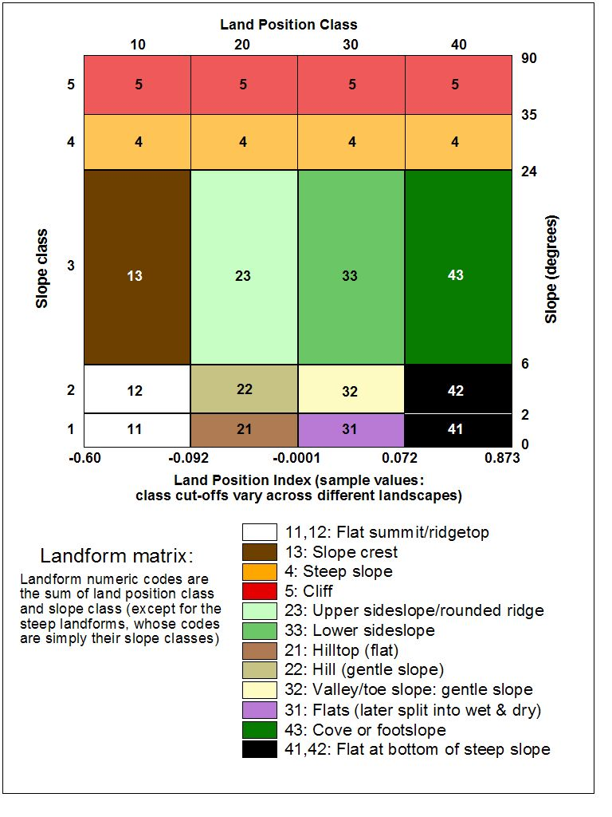

Recognizing the ecological importance of separating occurrences of “flats” (0-2˚ slope) into primarily dry areas and areas of higher moisture availability, we calculated a simple moisture index that maps variation in moisture accumulation and soil residence time. We used National Wetlands Inventory datasets to calibrate the index and set a wet/dry threshold, then applied it to the flats landform to make the split. The formula for the moisture index is:
Moist_index = ln [(flow_accumulation + 1) /(slope + 1)]
Grids for both flow accumulation and slope were derived from the DEM by ArcInfo Grid functions of the same names.

For the ecoregional ELU dataset, upper and lower sideslopes are combined, and a simple ecologically relevant aspect split is embedded in the sideslope and cove slope landforms (Figure 2 and Table 3).

Last, waterbodies from the National Hydrography Dataset (NHD), which was compiled at a scale of 1:100,000 and is available for the whole region, were incorporated into the landform layer with codes 51 (broader river reaches represented as polygons) and 52 (lakes, ponds, and reservoirs). Single-line stream and river arcs from the NHD were not burned into the landforms-- only those river reaches that are mapped as polygons.

Landform units for an area of varied topography in southeastern New Hampshire are shown in map view in Figure 2.

Fig. 2: Landforms in Pawtuckaway State Park, NH
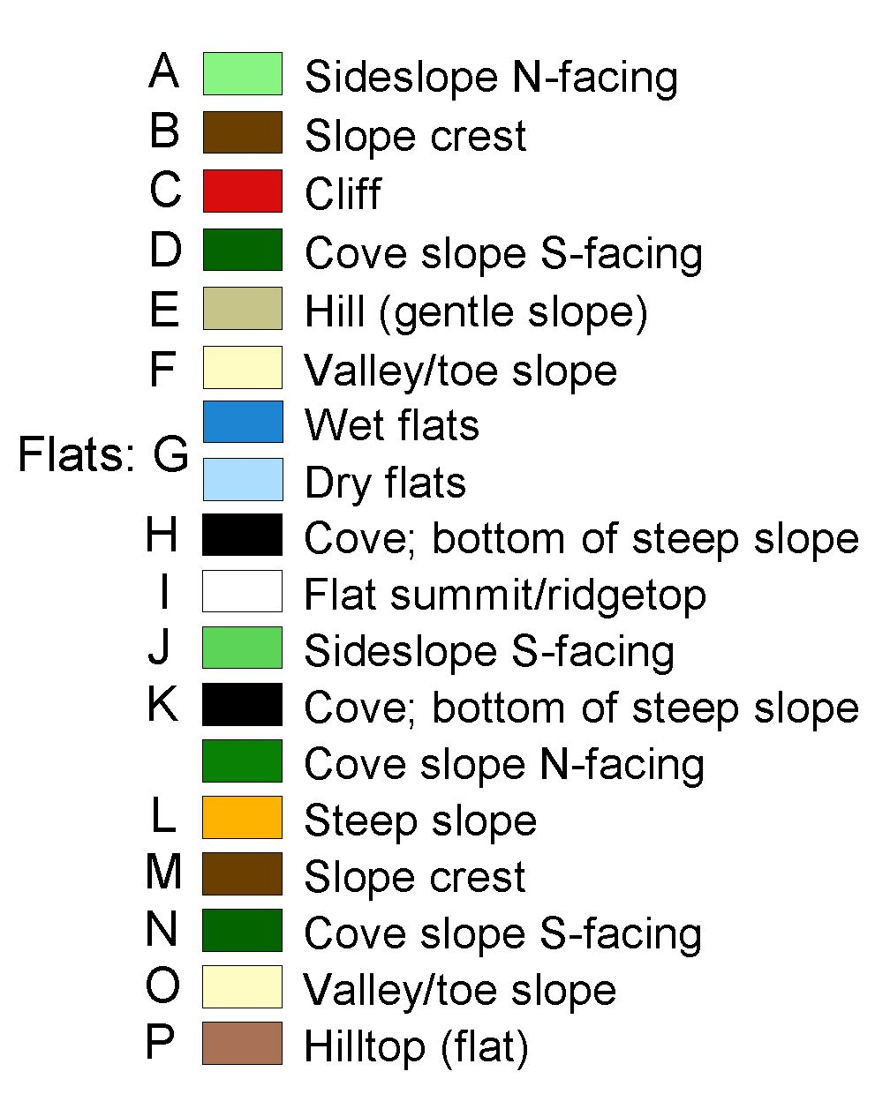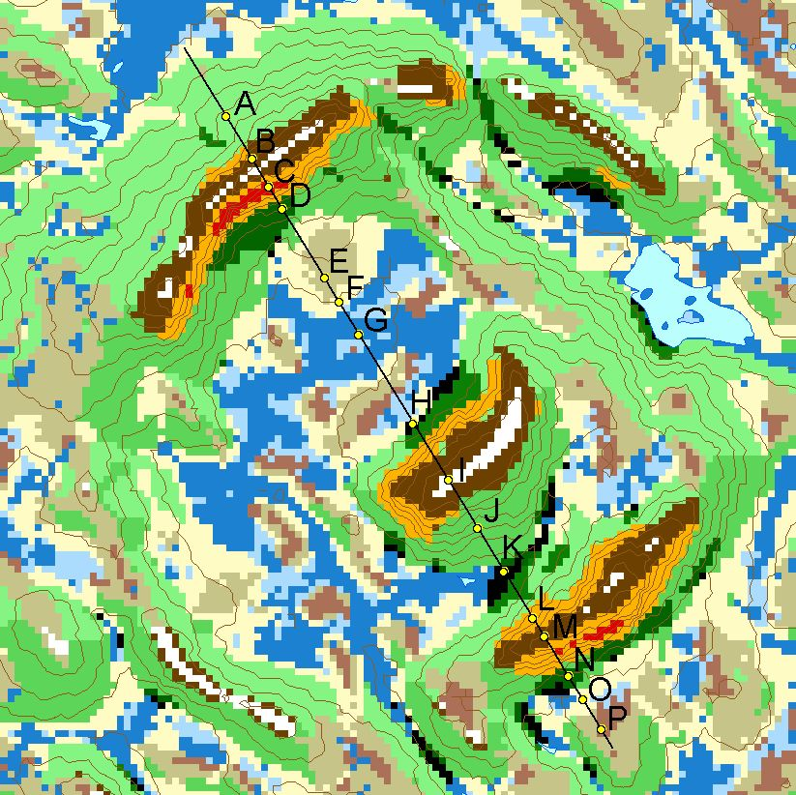

Figure 3: 3-d view of landforms in the Sandwich Range, New Hampshire

