APPENDIX 3A to 3D: Coastal Tidal Creek Analysis Methods

The following summaries are included:
Appendix 3A: Tidal System Stratification Methods
Appendix 3B: Draft Key Ecological Attributes for Coastal Size 1 Ecosystems
Appendix 3C: Details on Condition and Conservation Status of Tidal Systems in NAC
Appendix 3D: EDU Goal Distributions

Appendix 3A: Tidal System Stratification Methods

Salinity
The salinity gradient is the key attribute defining variation in the communities found within the coastal-tidal stream ecosystem. Particularly strong differences in the plant and animal communities are found above and below the fresh vs. tidal threshold point (see biological description above). It was not possible to measure salinity directly along coastal streams for the entire ecoregion; however, the land area <20ft (~6m) consistently corresponds to the maximum tidal/brackish extent of influence known in the NAC ecoregion (Anderson, Feree, Bowden, Olivero 2005). Although it is noted that plant communities vary along the salinity gradient from brackish to saline within the tidally influenced sections of these streams, it was not possible to more finely model the tidal vs. brackish extent in coastal streams (M. Anderson, C.Ferree, A. Bowden, M. Carabetta date).

Given the strong ecological importance of the fresh/tidal salinity threshold point, the land area of size 1 watersheds within this tidal elevation range was chosen by the team as the key classification variable. Using the “% tidal” variable, watershed occurrences were placed into 3 categories: 1. < 25% tidal, to represent dominantly freshwater coastal stream communities (low salinity system: fresh to oligohaline) 2. 25-75% tidal, to represent coastal stream communities with some tidal/brackish communities and some freshwater communities (moderate-salinity: mesohaline to polyhaline system), and 3. >75% tidal, to represent coastal stream communities with primarily tidal/brackish communities (high-saline: polyhaline to marine). Results indicate that watersheds with over 75% of the area tidally influenced are the most common coastal-tidal size 1 watershed class, making up 45% of all watersheds and 55% of all size 1 direct to ocean connected watersheds.

Watershed Size
Although the expected plants and animal species found in a coastal size 1 system are primarily driven by the salinity zonation in available stream reach habitat, the total area of habitat available will be much larger in larger size 1 watershed occurrences than in smaller size 1 watershed occurrences. The team felt it was important to make sure we were not selecting for the portfolio only very small watersheds as larger watersheds were likely more resistant and resilient to disturbance. The watersheds were thus divided into three size classes: <2 sq.mi., 2-10 sq.mi., and 10-30 sq.mi. to represent very small watersheds, small-medium watersheds, and large watersheds. The team felt examples of watersheds in all size classes should be sought for adequate representation. Results indicate the most common of the three watershed size classes is the very small watershed size (<2sq.mi.), making up 55% of all watersheds and 58% of all direct ocean connected example.

Salinity + Watershed Size Classification Types
Combining the three % tidal and three size classes yielded nine primary types of size 1 coastal watersheds for stratification of the target in NAC (Table 1). Because priority was being given to evaluating for portfolio status the direct to ocean connected examples, the direct to ocean connected watersheds are reported separately below. Patterns in the distribution of the 9 types across the direct to ocean examples vs. the large tidal river mainstem connected examples differ in that the direct to ocean examples contain more small highly tidal (>75% tidal) and less highly freshwater ( <25% tidal) examples, particularly in the larger watershed size classes (Chart 1).

The most common of the nine primary types are the small (< 2 sq.mi.) >75% tidally influenced systems, making up 33% of all watersheds and 40% of all size 1 direct to ocean connected watersheds. The second most common size 1 coastal-tidal watershed type differed between the total population and the directly ocean connected population. This difference reflected the stronger tidal influence on the direct to ocean connected examples as the second most common type was the medium 2<10 sq.mi. > 75% tidally influenced system for directly ocean connected watersheds. The second most common type in the non-direct to ocean population was the small < 2 sq.mi. < 25% tidal watersheds.

Although the number of small <2 sq.mi. watershed occurrences is very high (924, 55% of all watershed occurrences), considering the total area covered by all coastal-tidal size 1 watersheds, the less common larger size 1 watershed occurrences account for the majority of the areal coverage of the coastal-tidal size 1 watershed ecosystem type (Chart 2). For example, the type of size 1 coastal watersheds that cover the greatest areal extent are the <25% tidal 10-30sq.mi. watersheds which cover 40% of all coastal-tidal size 1 watershed areas and 24% of all direct to ocean coastal-tidal watershed areas.

Table 1. Nine Primary Size 1 Coastal-Tidal Watershed Types, Based on Salinity Class and Watershed Class

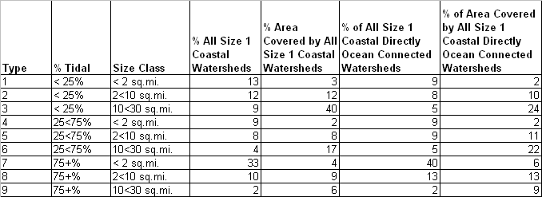

Chart 1. Frequency Distribution of NAC Size 1 Coastal-Tidal Watershed Occurrences by Nine Primary Types

Chart 2. Percent Areal Coverage Distribution of NAC Size 1 Coastal-Tidal Watersheds by Nine Primary Types

Geographic Stratification: Ecological Drainage Units
Ecological Drainage Units EDUs) were adopted as a sub-freshwater ecoregion stratification level. EDUs are a standard TNC Aquatic Ecoregional Planning stratification unit and are used delineate areas within a freshwater ecoregion that are likely to have a distinct set of freshwater assemblages and habitats associated with them. EDUs were developed by TNC aquatic ecologists through aggregating the watersheds of major tributaries (8 digit HUCs) that share a common zoogeographic history as well as local physiographic and climatic characteristics. The team felt that stratifying NAC portfolio occurrences across EDUs was critical to ensure adequate geographic distribution to address the large scale zoogeographic processes operating within the freshwater ecoregions.

The EDU stratification of the NAC coastal stream analysis area includes parts of 9 EDUS: Androscoggin/Kennebec/Penobscot, Saco/Merrimack/Charles, Cape Cod, Lower Connecticut, Long Island, Lower Hudson, Upper Hudson, Lower Delaware, and Delaware Bay Coastal (Map 1). Review the distribution of the 9 primary classification types across the different EDUs indicates that some of the types are much more common in certain EDUs than others. For example, considering direct to ocean connected examples, the distribution pattern reveals that the more highly tidal types 7, 8, and 9 are much more common in the Delaware Bay Coastal, Long Island, and Cape Cod EDU, while as you go further north in the Saco-Merrimack-Charles and Androscoggin-Kennebec-Penobscot EDU the less tidal types 1-6 increase in their proportion of the total population within that EDU (Chart 3).
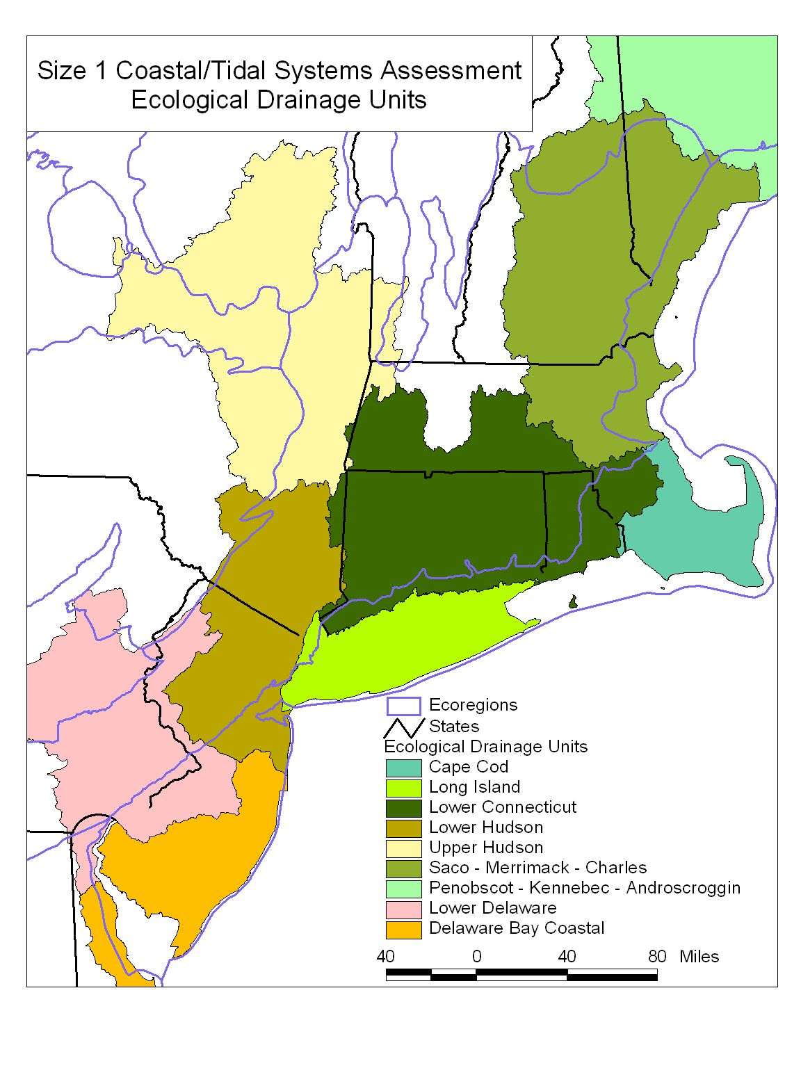
Map 1. Ecological Drainage Units
Chart 3. Frequency Distribution of NAC Size 1 Coastal-Tidal Direct to Ocean Connected Watershed Occurrences by EDU and Nine Primary Types

Appendix 3B
Draft Key Ecological Attributes for Coastal Size 1 Ecosystems

Appendix 3C
Details on Condition and Conservation Status of Tidal Systems in NAC

Land Use
The land use in the watershed and 100m stream buffer area were sampled to classify each watershed into one of 4 impact ranks, with being 100 most intact and 400 being more impacted. The ranks were rooted in characteristics of watershed impervious cover, watershed agriculture, and natural cover in the buffer. For example, literature has shown degradation of stream ecosystems appears to occur early in the process of watershed urbanization. A recent report on coastal streams in New England showed macroinvertebrates species such as mayflies, stoneflies, and caddisflies which are sensitive to urban contaminants and habitat disturbance are reduced where as little as 3 percent of the land cover in the watershed is urban (USGS 2004). Many additional studies have also classified stream biota as seriously “impacted” at greater than 10% watershed impervious cover, and “fully degraded” where urban areas cover about 20% of the watershed or impervious cover reaches 25% of the total watershed area (CWP, 2003, USGS 2004). Many studies have also found that agricultural land-use has a negative impact on aquatic biological integrity (Lenat and Crawford 1994, Richards et al. 1996, Roth et al. 1996, Harding et al. 1998, Lammert and Allen 1999). Although similarly strong thresholds for coastal streams health and % watershed agriculture have not been developed, agriculture is associated with a number of serious impacts to streams such as nutrient enrichment, sediment/bank erosion, and pollution with pesticides. Agriculture is thus usually considered (by unit area) to be more harmful than natural cover, but less harmful than urban areas (Fitzhugh 2001).

Although the NAC ecoregion is one of the most developed ecoregions in the eastern U.S., the majority of the portfolio watersheds (68%) located by the team fall into the most intact 100 or 200 ranking categories. 40% of portfolio watersheds are in the most intact category (100) with Total Impervious in Watershed < 5%, Intensive Agriculture in Watershed < 10, Buffer 90% Natural. These watersheds appear extremely intact in both their watershed and buffer characteristics. 28% of portfolio watersheds are in the second most intact category (200) with Total Impervious Watershed < 10, Intensive Agriculture Watershed < 10, Buffer 80% natural. These watersheds have a little more roads and development in watershed and buffer but still remained below the 10% watershed impervious cover threshold and had intensive agriculture under 10%. A very small number of watersheds (2%) fell in the next most intact category (300) with Total Impervious Watershed < 15, at least 30% of streams with less than 10% Total Impervious, Intensive Agriculture Watershed < 10, and Buffer 80% natural. Although these watersheds had overall watershed % impervious values beyond the 10% threshold level, they were not above 15% indicating the biotic system was not yet “fully degraded” and at least 30% of the individual reaches were still below the 10% impervious cover threshold indicating at least 30% of the reaches were still in good condition. These watersheds also had again little agriculture and quite intact buffers. Lastly, 30% of watersheds did not meet the above three category conditions (400) and thus had more severe problems with either watershed impervious cover, agriculture, or buffer intactness. It will be important to review these watersheds for conservation and restoration activates.

Across the 9 system types, the distribution of portfolio watersheds in the land use classes is relatively similar with all types having >50% of their portfolio examples in land use category 100 or 200. However Types 1, 7,8, and 9 have most of their examples (all over 40%) in the most intact category (100), while types 2, 3, 4, 5, and 6 have most of their examples in the second most intact category (200). It is interesting to note that all the highly tidal systems (7,8,9) dominantly fall in the most intact category (100) indicating that development pressure has likely been less in these system types allowing more very intact examples to remain. Across EDUs, results reveal that the Penobscot-Kennebec-Androscoggin EDU has the highest percentage of most intact portfolio examples, while the Long Island EDU and Lower Connecticut have the lowest percentage. Considering intact categories 100 and 200 together, the Saco-Merrimack-Charles and Lower Hudson also appear particularly intact with over 70% of portfolio examples falling in the 100 or 200 categories.

Chart 4: Land Use Rank by Type

Chart 5: Land Use Rank by EDU (EDUs ordered from north to south)

Land Use Rank: Outstanding in Watersheds in Watershed Impervious Cover, Watershed Agriculture, and Buffer Intactness
100: Land Cover Rank: Total Impervious Watershed < 5, Intensive Agriculture Watershed < 10, Buffer 90% Natural
200: Land Cove Rank: Total Impervious Watershed < 10, Intensive Agriculture Watershed < 10, Buffer 80% natural
300: Land Cover Rank: Total Impervious Watershed < 15, At least 30% of streams have less than 10% Total Impervious, Intensive Agriculture Watershed < 10, Buffer 80% natural
400: Land Cover rank: all other watersheds

Connectivity
Dam and road-stream crossings with improperly sized culverts are noted as key threats in NAC given the high number of existing dams and road crossings and the particularly strong importance connectivity to the ocean plays in the life history of the diadromous fish species targets in NAC. For example, a 1998 study of stream habitat for diadromous fish in the U.S. Atlantic coast watersheds found dams caused the restriction or loss of 91% of stream habitat within the historic unrestricted range of the North Atlantic region from Maine to Connecticut and a loss of 88% of habitat in the Mid-Atlantic region of New York through Virginia (Busch et al. 1998). In addition to creating barriers to upstream and downstream migration, dams and improperly sized culverts also cause changes in flow, temperature, and water clarity and can sever important terrestrial/aquatic linkages critical for maintaining the flooding regime of riparian and floodplain communities. In tidal creeks, tidal flushing is a particularly important part of the hydrologic regime and dams and/or improperly sized culverts often restrict the natural tidal flushing leading to changes in water volume and salinity which result in associated tidal marshes being reduced in size or more prone to invasive species invasions.
Within the portfolio size 1 coastal watersheds, dam and road/crossing impacts are pervasive, with 74% of portfolio occurrences having a dam or road crossing within the tidal section of the river (rank 40). Of those 25% without fragmentation in the tidal zone, 3% have no dams or road crossings in the tidal zone (rank 30), 4% have no dams in the entire watershed and at least no road crossings in the tidal zone (rank 20), and 19% appear to have no dams or road crossings in the entire watershed (rank 10).
Looking across the 9 watershed types however reveals that 7 or the 9 system types have >80% of their portfolio watersheds in rank 40, with a dam or road crossing in the tidal portion of the watershed. The 19% of portfolio occurrences across the ecoregion without any barriers in the watershed (rank 10) are overwhelmingly found in the very tidally influenced system types 7, 8. For example, of these 65 unfragmented portfolio watersheds, 77% are found in the very small (<2 sq.mi.) and very tidally influenced (>75% tidal) system type 7 and 20% are found in the small (2-10sq.mi.) very tidally influenced (>75% tidal) system type 8. We would expect these systems to be less impacted because they are very low gradient systems where power from dam runs would be limited and where road building was likely difficult due to the tidally influenced and flooded land area. Across EDUs, the Upper Hudson and Lower Hudson appear to have the highest proportion of unfragmented watersheds, with 67% and 33% respectively, however the highest raw number of unfragmented watersheds occurs in the Delaware Bay Coastal EDU (19), the Saco-Merrimack-Charles (14), and Cape Cod ((13). The EDUs with the lowest percentage of unfragmented watersheds occurrences are the Lower Connecticut (4%) and Long Island (9%).

Chart 6: Connectivity Rank by Type

Chart 7: Connectivity Rank by EDU (EDUs ordered from north to south)

Connectivity Rank: Outstanding in Watersheds in lack of dams and road-stream crossings, along particularly the tidal section of river
10: No dams in watershed, no road crossings in watershed
20: No dams in watershed, no road crossings in 0-20ft tidal zone
30: No dams in 0-20 zone, no road crossings in 0-20ft tidal zone

Point Source
Although point source contamination in rivers from sewage and industrial wastes has improved since 1970, point source pollution is still a significant factor lowering IBI values in heavily used rivers (Arya 1999). Specifically many of NAC’s small coastal watersheds still contain elevated levels of nutrients, persistent organic chemicals, and trace elements such as chromium, copper, cadmium, led, mercury, and zinc (USGS 2004) which may have originated in current or historic point sources releases.

68% of portfolio size 1 coastal watersheds have no mapped point sources, including EPA Basins 1999 Industrial Facilities Discharges to water, Permit Compliance System Discharges to water, Toxic Release Inventory Releases to water, and Superfund sites. Across system types, the proportion of watersheds with no point sources decreases significantly with the size of watershed, with 80-95% of the 3 types < 2 sq.mi., 62-78% of the 3 types 2-10 sq.mi., and 20-27% of types 10-30 sq.mi. in size. The most tidally system types, 7-9 also appear to have slightly more watersheds with no point sources across all size types. Across EDU, the Penobscot-Kennebec-Androscoggin and Upper Hudson have the highest % no point sources (81% and 83% respectively), while the Lower Connecticut and Lower Hudson had the lowest % no point sources (54% and 58% respectively).

Chart 8: Point Source Rank by Type

Chart 9: Point Source Rank by EDU (EDUs ordered from north to south)

Conservation Land
Land ownership within watersheds was summarized to identify tracts of lands that have permanent legal protection against conversion to development. 17% of portfolio watersheds currently had 50+ or more of the watersheds already in conservation land status, while 47% of portfolio watersheds had very little or <10% conservation land. Across types, most highly protected types include type 1, 7, and 8 which all had over 25% of portfolio watershed with >50% in conservation land. These types include two of the smallest highly tidal types (7,8) and the smallest dominantly freshwater type (1). Least protected types included types 2, 3, and 4 which had 60+% of watersheds with <10% conservation lands. These types include the two larger dominantly freshwater types (2,3) and the smallest moderately tidal type (4). Across EDU, the EDUs with the highest percent of portfolio watersheds in the 50+% conservation land area include the Lower Delaware (67%) and the Lower Hudson (42%) however goals were not met in the Lower Delaware which would require additional watersheds be added. EDUs with the highest proportion of watershed in the low protection 0-9% conservation land category include the Penobscot-Kennebec-Androscoggin EDU (75%) and the Upper Hudson (67%).

Chart 10: Conservation Land Status by Type

Chart 11: Conservation Land Status by EDU(EDUs ordered from north to south)

CONDITION ATTRIBUTES:

- Notation for Highlighting Outstanding Quality Watersheds in terms of Land Use, Connectivity, and Point Sources: Preliminary Portfolio Recommendations Based on GIS Alone

1. LCRANK: Outstanding in Watershed and Buffer Land Use / Impervious Characteristics:
Use this to skim the very best watersheds for land cover/road/land use/impervious character. Will likely weight these variables/land use rank more than connectivity and point sources in final portfolio decisions.
100 Land Cover Rank: Total Impervious Watershed < 5, Intensive Agriculture Watershed < 10, Buffer 90% Natural
200 Land Cove Rank: Total Impervious Watershed < 10, Intensive Agriculture Watershed < 10, Buffer 80% natural (a little more roads and development in watershed and buffer, kept intensive agriculture under 10%)
300 Land Cover Rank: Total Impervious Watershed < 15, At least 30% of streams have less than 10% Total Impervious, Intensive Agriculture Watershed < 10, Buffer 80% natural (a little more roads and development but good percentage of streams are still less than 10% impervious, very little intensive agriculture as well)
400 Land Cover rank: all other watersheds

2. CNRANK: Outstanding in Watersheds in lack of dams and road-stream crossings, along particularly the tidal section of river so tidal flushing functionality is intact for these tidal dependent communities (note lack of consistency in mapped dams across state)
10 Connectivity Rank: No dams in watershed, no road crossings in watershed
20 Connectivity Rank: No dams in watershed, no road crossings in 0-20ft tidal zone
30 Connectivity Rank: No dams in 0-20 zone, no road crossings in 0-20ft tidal zone

3. PTRANK: Outstanding Watersheds in lack of point sources
1 Point Source Rank: No point sources

4. COMBRANK: Concatenate Land Cover Rank, Connectivity Rank, and Point Source Rank

B. Further Sorting of Watersheds
To further put the watersheds in a general order of “Best to worst”, all watersheds were sorted on the following variables.
1. Class Sorts:
a. Land Cover Rank Class (as described above: 100, 200, 300, with 400 assigned for all other watersheds; ascending)
b. Minimum Dam Elevation Zone Class (First Elevation Zone where a dam is encountered; higher zones are better/further up before barrier encountered; descending)
c. Minimum Road-Stream Crossing Elevation Zone Class (First Elevation Zone where a road crossing is encountered; higher zones are better/further up before a barrier is encountered; descending)
2. For watersheds with the same values in the above sort: sub sort on
1. Impervious Surface in Watershed Class (ascending)
2. Natural Buffer % Class (ascending)
3. Intensive Agriculture % within Watershed Class (ascending)
3. Ranking order was assigned from 1-1674

C. Flagging for Special Characteristics
SPECIAL: sp = watershed had one or more of the following 7 special characteristics
SPECIAL: included a primary aquatic species element occurrence
SPECIAL had >= 10% managed area
SPECIAL had >= 30% wetlands in watershed and/or >= 30% wetlands in streams' 100m buffer
SPECIAL: had a salt marsh/tidal wetland EO within or had a >= 50 acres of wetland in the tidal elevation zone area (area <20ft elevation)
SPECIAL: had calcareous or moderately calcareous geology present within the watershed
SPECIAL: size 1 watershed connects to a selected portfolio size 2,3,4 river
SPECIAL: % of watershed in NAC site

D. Translation of above A, B, C, data into a Potential Viability Rank:
1s = Total impervious less than 5%
Y-1a: COMBO RANK is 111, 110; means they are top in land use (100) and dams (10) and may or may not be top in point sources (1), LIKELY ACCEPT
Y-1b: COMBO RANK is 120, 121, 130, 131; means they are top in land use (100) and 2nd or 3rd in dams which is still quite good, LIKELY ACCEPT
Y-1c: COMBO RANK is 100; top in land cover and impervious (100) but problem with dams or road crossings in tidal section, need to review
Y-1d Total Impervious is <= 5 but doesn’t meet other criteria to be a LCRANK of 100, thus has issues with buffer natural cover or intensive agriculture which were also part of a score of 100, need to review)

2s = Total impervious >=5 and < 10%
Y-2a: COMBO RANK is 211, 210; 2nd tier in land use and top in connectivity, LIKELY ACCEPT, still very good
Y-2b: COMBO RANK is 220, 221, 230, 231; 2nd tier in land use and 2nd or 3rd tier in connectivity, LIKELY ACCEPT but should review
Y-2c: COMBO RANK is 200; 2nd tier/good land cover and impervious but problem with dams or road crossings in tidal section, need to review
Y-2d: Total Impervious is >=5 and < 10 but doesn’t meet other criteria to be a LCRANK of 200, thus issues with buffer natural cover or agriculture, need to review)

3s = Total Impervious is >=10 and < 15%: getting above the 10% threshold but maybe still fair or restorable, all need review
MY-3a: COMBO RANK is 311, 310, 3rd tier in land use and top in connectivity
MY-3b: COMBO RANK is 320, 321, 330, 331, 3rd tier in land use and 2nd or 3rd tier in connectivity
MY-3c: COMBO RANK is 300; 3rd tier land cover and impervious but problem with dams or road crossings in tidal section, need to review
MY-3d Total Impervious is >=10 and < 15 but doesn’t meet other criteria to be a LCRANK 300 –thus issues with buffer natural cover or agriculture)

MY – conn; Did not meet above queries but does have Connectivity Rank of 10, 20 – meaning no dams in watershed and no crossings in tidal section which is a very good situation.

SubSorting on Sorted Best-Worst Rank to highlight best watershed within in stratifications that did not already come up in 1s, 2s, or 3s for some reason. Note: the ranking within stratification eliminated the smallest watersheds which were flagged in the field LS5LENSZ for those watersheds less than 0.5 sq.mi. in size or less than 0.5mi in stream length. Often these smallest watersheds had better land use, dam, point source ranks but we did not feel they were representative of their ecosystem type because they were such small system examples.
MY – 4a Top 20% per EDU and Connectivity class that are not already in above
MY – 4b Top 20% or top 1 or 2 ranked shed per EDU, Landform, Geology that are not already in above (i.e. not best in EDU connectivity class)
MY – 4c Top 20% or top 1 or 2 ranked shed per EDU, Landform, Geology, and Connectivity Class that are not already in above (i.e. not best in EDU by connectivity class or EDU by environmental setting LF/GEO but best of further subtype of watershed)

Appendix 3D
EDU Goal Distributions

Table 1. Androscoggin, Kennebec, and Penobscot EDU Goal Summary.
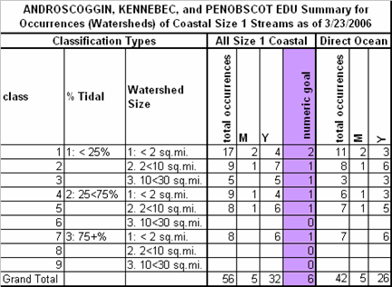

The proportional numeric goal (6) was very low in this EDU because only a very small number of watersheds (56) out of the total NAC population of 1674 occur in this EDU. Given the watersheds in this EDU are in very good condition, the portfolio Y recommended examples exceed the goal across all types.

Table 2. Saco, Merrimack, Charles EDU Goal Summary.

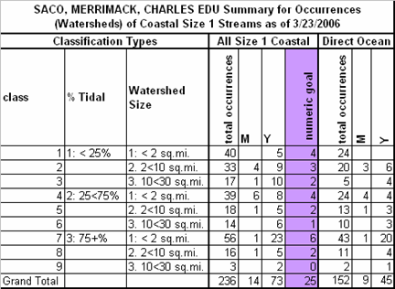

The proportional numeric goal (25) was low in this EDU because only a small number of watersheds (236) out of the total NAC population of 1674 occur in this EDU. Although more impacted than the Androscoggin, Kennebec, Penobscot EDU, the portfolio Y recommended examples exceed the goal across all types.

Table 3. Cape Cod EDU Goal Summary.

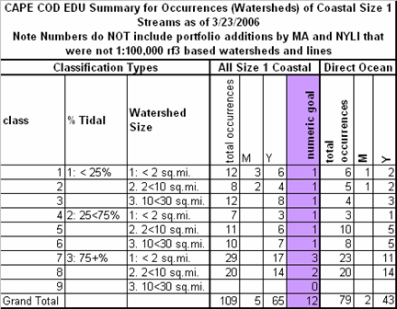

The proportional numeric goal (12) was low in this EDU because only a very small number of watersheds (109) out of the total NAC population of 1674 occur in this EDU. Although development pressure threatens the Cape, the number of currently viable watersheds recommended for the portfolio far exceeds the numeric goal across all types.

Table 4. Lower Connecticut EDU Goal Summary.

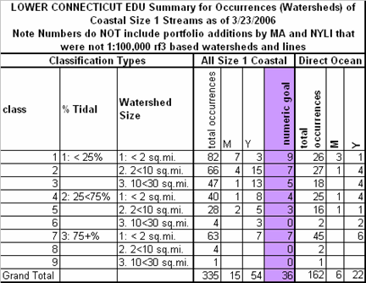
The proportional numeric goal (36) was higher in this EDU than previously reported EDUs because of the larger number of size 1 coastal-tidal watersheds occurring in this EDU. Large sections of the Connecticut, Rhode Island, and Massachusetts coastline are highly developed in this EDU. Although finding portfolio examples was more difficult in this EDU, the overall EDU goal of 36 was exceeded and the distribution by type goals were exceeded for all types except the smallest <2 sq.mi. < 25% tidal watersheds. It is likely that goals were not met for this type because much of the non-tidal coastline is heavily developed in this EDU.

Table 5. Long Island EDU Goal Summary.

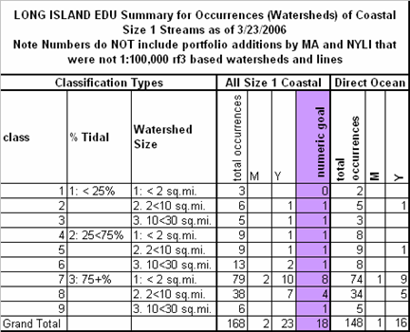
The proportional numeric goal (18) was small in this EDU because only a small number of watersheds (168) out of the total NAC population of 1674 occur in this EDU. This EDU is highly developed with only the northeastern third of Long Island remaining more intact. Although coastal streams over much of the island are highly impacted, portfolio quality examples were identified to meet both overall EDU goal and numeric goal across all types. These portfolio examples are more prevalent in this eastern third of the island although a few examples were found further west on the island.

Table 6. Lower Hudson EDU Goal Summary.

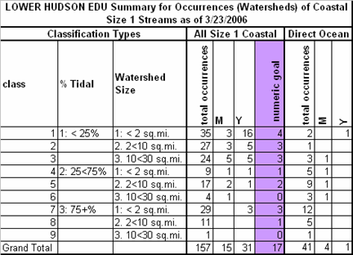
The proportional numeric goal (17) was small in this EDU because only a small number of watersheds (157) out of the total NAC population of 1674 occur in this EDU. Although the Lower Hudson EDU is also highly developed, particularly around New York City, portfolio quality examples were identified to meet overall EDU goals. Numeric goals across all types were met except for the large 2-10sq.mi. >75% tidal occurrences.

Table 7. Upper Hudson EDU Goal Summary.

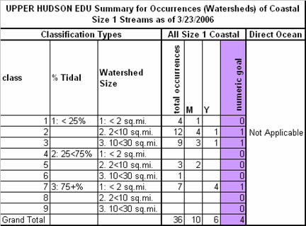

The proportional numeric goal (4) was very small in this EDU because only a few watersheds (36) out of the total NAC population of 1674 occur in this EDU. No direct to coast examples occur in this EDU as all tidally influenced watersheds connect directly to the large tidal Hudson River mainstem. The portfolio Y recommended examples exceed the goal across all types.

Table 8. Lower Delaware EDU Goal Summary.

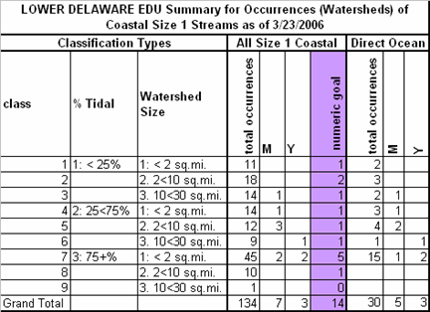
The proportional numeric goal (14) was very small in this EDU because only a few watersheds (124) out of the total NAC population of 1674 occur in this EDU. Fewer direct to coast examples occur in this EDU as most tidally influenced watersheds connect directly to the large tidal Delaware River before it reaches the Bay. This EDU is heavily developed all along much of the Delaware River mainstem. The portfolio Y recommended examples do not meet the EDU overall goal or the distribution across types. This result is primarily due to fact that Pennsylvania was not able to collect expert review during this iteration and the team did not feel comfortable putting watersheds along the Pennsylvania side of the Delaware river into the portfolio without expert verification.

Table 9. Delaware Bay Coastal EDU Goal Summary.

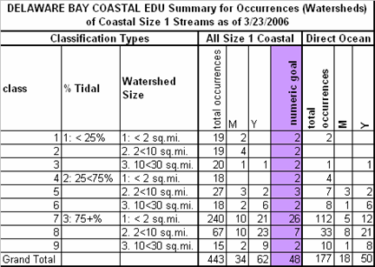
The proportional numeric goal (48) was the highest of any EDU in NAC because this EDU contained more watersheds (443) out of the total population (1674) than any other EDU. This EDU is extremely low elevation and flat leading to extensive tidal influence of its coastal streams. Given the large number of directly coastal connected watersheds (177) NJ focused portfolio review upon this subset. Although total EDU numeric goals were exceeded by the 62 portfolio watershed examples, the distribution by type goals were not met in 4 of the 9 types. The 4 types lacking enough portfolio examples were all less tidally influenced types. These 4 types are much more commonly found draining into the tidal sections of larger rivers than to the coast directly in this EDU. Particular attention will need to be made to address these non-ocean connected examples in the next iteration of the plan to address filling this portfolio gap.

References

Cooperative Research Centre for Coastal Zone, Estuary and Waterway Management. Tidal Creeks 2005. http://www.ozestuaries.org/oracle/ozestuaries/conceptual_mods/cm_tc.htm Brisbane, Australia.

Hale, S.S., J.F. Paul, and J.F. Heltshe. 2004. Watershed Landscape Indicators of Estuarine Benthic Condition. Estuaries 27(2): 283-295

Holland, A. F., D. M. Sanger, C.P. Gawle, S. B. Lerberg, M. S.Santiago, G. H. M. Riekerk, L. E. Zimmerman and G.I. Scott 2004. Linkages between tidal creek ecosystems and the landscape and demographic attributes of their watersheds Journal of Experimental Marine Biology and Ecology 298:151-178

Mallin, M.A. and A.J. Lewitus. 2004. The importance of tidal creek ecosystems. Journal of Experimental Marine Biology and Ecology 298:145-149.

Mallin, M.A., D.C. Parsons, V.L. Johnson, M.R. McIver and H.A. CoVan. 2004. Nutrient limitation and algal blooms in urbanizing tidal creeks. Journal of Experimental Marine Biology and Ecology 298:211-230.

Reschke, C. 1990. Ecological Communities of New York State. New York Natural Heritage Program. NYS Department of Environmental Conservation Latham, NY.

